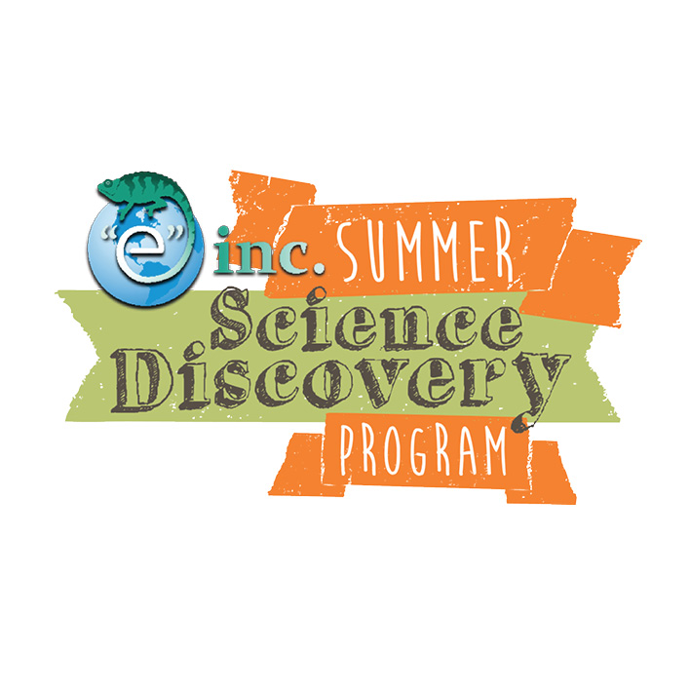

**“e” inc.’s Summer Science Discovery Program**

**2016 Acknowledgement of Risk and Assumption of Personal Responsibility Waiver**

Camper Full Name: _____________________________________________________

“e” inc. staff make every effort to conduct safe programming and risk management is an essential element of all offered activities. While we anticipate that these efforts and considerations will ensure the safety of each child, we are also aware that it is neither possible to foresee nor eliminate all risk.

I understand that program activities may include, but are not limited to: playing active games and participating in activities near water.

I acknowledge that such risks exist, and I hereby agree on behalf of my child to assume such risks. Further, on behalf of my child, I hereby release and forever discharge, and agree not to sue, and agree to indemnify and hold harmless “e” inc., and its employees from and against any and all liabilities and obligations of every kind and description, which I shall or may have against them or any one or more of them arising out of, or in connection with, my child’s participation in the “e” inc. program and activities, including, but not limited to, for any personal injury that my child may suffer while participating in the “e” inc. program, excepting in the case of gross negligence.

I understand and agree on behalf of my child that my child shares the responsibility for safety during “e” inc. program and activities, and I personally assume on behalf of my child that responsibility.

Parent/Guardian Signature: ___________________________________________________ Date: ____________

****Print Name: ________________________________________________ Relation to Camper: _________________