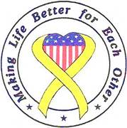

Hurlburt Spouses’ Club
Charity Request Questionnaire

Please provide your answers in this column.
Name of organization:
Make check payable to:
Name of person completing this request:
Contact information:
Mailing address:
Amount requested:
Justification for request:
Will this money be used locally?
Will the use of this money benefit military families?
What percentage of your clients are military?
What alternate sources of funding are available to you?
How many years has your organization been in existence?
What activities does your organization engage in to enhance the local community?
Do you have any further comments which would help us to make a determination?

