  - By:
L I G H T
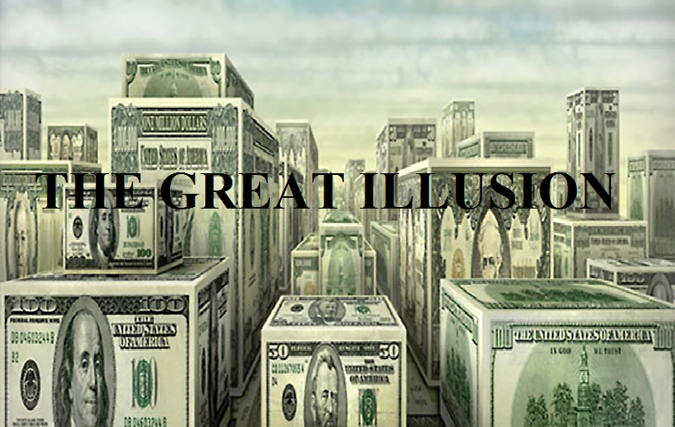
Money the Great Illusion

If you reach your hand into your pocket in the hope of finding money, if you’re lucky, you’ll probably either pull out paper bills, or metal coins. This is how most money is manufactured today. Money gained its notoriety of being valuable solely because the people in the society in which it is used believe, and confidence in it. But why do we believe in money? And just what purpose does our collective faith in the value of money serve? Money is a shared illusion and may be the greatest of shared illusion of all time. Its very existence creates some interesting psychological effects. It gives people a sense of power; it makes them feel more independent, more self-sufficient, and somehow if they have “enough” of it they feel all the more important. These skewed perceptions only feed and strengthen the great illusion. One reason why the love of money is considered to be the root of all evil is because it subtly creates a wedge between humanity and their Creator. This is done by deceiving people into believing in an alternate power – one that can be seen, felt, and used as one sees fit. It changes the nature of social relationships, by giving a false sense of greater worth to the one who has more, and diminished worth to the one who has less. It causes many to become more selfish, and less altruistic toward others. However, as we do for others we also do for our Creator. Therefore, the love of money has the potential to cause an individual to forsake his maker through a perception that more often than not corrupts the heart. Let’s face it: we are sentient creatures; susceptible to having faith in what we can relate to with our five senses. In the case of money, we can see and feel this worthless piece of inked paper that our governments have slowly over time programed the masses to accept as having value. This programming has also done its part in causing great separation from true values. Values, which when practiced, enhance the mind, body, and soul. Sadly there are those who understand what this illusion have done, but are in it to enslave their fellow man by controlling their minds and will. These are the very ones who stealthily change sacred universal principles. Over time, we as a culture, slowly adopt the changes of sacred laws in our day to day lives, picking up the consequences that come along with changing those very laws. This happens as we collectively create, through our thought patterns, destruction by attracting and activating negative energies into our reality. The result: of this manipulation, a great curse that has devoured the whole earth through the collective mindset of its inhabitants.
What is Money?

Money may best be defined in terms of its functions. Money as we know it is anything accepted to pay for goods and services or to settle a debt. It is a medium of exchange which allows the barter system to take place in an abstract manner. Centuries ago, the world operated primarily on the barter system. The most valuable promises were few and were backed mostly by gold, silver, land, or a herd of horses or cows. Basically, they were backed by something solid. Villages and towns, farmers and those in the trades, all operated primarily by a barter system. A chair built by a carpenter was paid in a quarter of a slaughtered cow. A bushel of figs was paid by getting a tooth pulled by a dentist. You get the point. Financial sophistication developed slowly, based on the growing confidence that the backer of a money system, could be counted upon to deliver something of solid value. Until recently precious metals, especially silver and gold were considered the backing. Paper money was introduced and had the backing of gold. When the time came to phase in the global debt system of the dark ones, to plunge the world into debt, the gold backed monetary standard was abandoned worldwide. A paper money debtor economy ran the paper and ink beyond the supply of gold. Consequently, we now have fiat currencies all over the world – money that is backed by nothing except the confidence of a people in slavery. Those who have enslaved the populous are the same ones controlling the legalized gambling system of the world: the Stock Exchange, Commodity Market, and the Bond Market. These are the true benefactors of this system of money today. Today people labor to acquire this medium of exchange. Some invest in order to acquire more, and to store up their earthly riches. However, everything in the physical world is subject to the order of entropy –break down and decay, therefore it cannot last forever.

What is Debt?

One of money’s primary functions is to settle debts. Today we have been herded into a credit card using society, therefore many of us acquire our goods and services with the mindless sweep of a little plastic card. Little do some know that all of this plastic swiping is part of a clandestine operation of debt creation by way of plunging the consumer further into debt. The concept of credit is built on nothingness. The value of currency built into credit is created out of thin air and used as a function that establishes debts in every society. Many in a society driven by the desire to constantly accumulate more, and more, establish debt. This debt becomes somewhat of a monster who can only be satisfied by using money – the very tool which has been marketed to control the people’s will. One of the issues with all developed and developing nations today is that they systematically finance spending through unsustainable levels of borrowing from central banks. These central banks conspire together to bring forth a global debt agenda. Eventually all nations will find themselves in a crisis made by design. The crisis is just ahead of us and will be triggered because:
1. Economic growth is deliberately being slowed through various laws, even though we keep hearing about economic recovery, and
2. After initially lowering interest rates, central banks will eventually find themselves out of options and be forced to raise interest rates. Raising interest rates will lead to a vicious cycle of larger and larger interest payments. This will devastate the middle class, and jobs which that will cause the nations in debt to not be able to satisfy their interest or principal payments..

This will lead to what is called a national default on government debt. At this time there will not be enough money in the world to bail out the United States and she will be abandoned economically. When this happens to the United States all nations will be brought down with her economically. Make no mistake about it, the federal government along with many counterparts in other nations are preparing for this collapse. The money that we think is safely tucked away in the bank is no longer insured by the Federal Reserve (FDIC), but by the good faith, and credit standing of the American Government. The United States for all intent and purposes is bankrupt. Therefore the people’s bank accounts are backed by a bankrupt government that will not be able to replace the value of any accounts. New credit cards are being designed with an R F I D microchip technology. If the US government sneezes too hard the whole system will come crashing down creating a disastrous debt situation for the people. After that impending doom, the microchip currently being tried out in new credit cards will still be used, only not in a card, but in the individual.

Collapse of the Great Illusion

That which is truly valuable causes light to emanate, eventually exposing all illusions, including the great monetary illusion. Things are looking great, the recession is over, the unemployment rate is back down towards pre-recession rates, banks are lending again, and the stock market hitting all-time highs. However, this is all part of the great illusion. These indicators are skillfully manipulated by those who have been ordained, and foretold by the prophets to do just that. The global society has been snookered and seduced by this monetary illusion and now we have been lulled into a false sense of normalcy. Those who have cast this spell on humanity understand dark sentences and have been given the authority to cause man to exile his Father from within. This is part of the abomination that makes desolation. YHWH is now rejected by humanity, and without the knowledge of our Father, the earth has become desolate. Therefore a great depopulation awaits humanity at the hands of those who have enslaved the earth as the prophet Isayah wrote in Isaiah 24:1-6.

All variables are now in place for the plug to be pulled on this great false sense of normalcy that we have been herded into. This will usher in ushering a great collapse which will set up the kings of the east for a short time. When this takes place, everyone who is not prepared to function outside of this economic normalcy syndrome will find that there will be great change and even great suffering for some. It is time for YHWH’s people to come out of the dependency of this system so they do not partake in the great plague that is upon us. This plague is not simply a disease of the physical body it is a great calamity, that will include the human body, the human mind, and the human spirit. It will be the likes of which has never been seen in our recorded history. Great events have taken place. There are still those yet scheduled to occur in the cosmos which have alerted those in charge to know that they only have a short time to implement their plan. Knowing time is short, they have sped up the timetable to executing their plan. They have sought to seize control of many governments who would have established their own agendas. Others, not up for the fight, have joined them because of intimidation, and promises which will later prove to be empty. We have seen these occurrences in many nations especially the Middle East. Many believe that this has destabilized the Middle East however these actions will prove to have destabilized much more as we will soon see that peace has been removed from the whole earth us (Rev. 6:4). There are those who are due east, and north of Jerusalem who are proving to be disruptive to the plan (Daniel 11:44). This is just role playing for the people, as they are all part of the overall plan for the end of the age. Some of these were in the game, but didn’t like or were to give the impression that they did not like, how it was being played. Their part is to stray from the agenda, and display that they have now become resistant along with others who never bought into the plan to begin with. Now utter annihilation looms as the elite of this world continue to manipulate their handles on their right to strong arm governments, while at the same time manipulate their handles on their left to resist in order to force this plan to move forward, before time runs out. Their itinerary is injected into the consciousness of the general public through media, video games, sports and entertainment, etc. Every venue that attracts great amounts of money is under their control. The public is then manipulated through these very means as our will is generally wrapped up in the matrix like culture that has been stealthily created for us.

The Foundation of True Riches

Contrary to popular belief, true riches are not based upon the amount of valuable stuff that an individual possesses. True riches, is a state of mind. In this state we harness health, prosperity, and total peace of mind. This state of mind can only be measured by content of character. Not our own character, which is pretty much worthless, but a much greater character. What we’re talking about here is a higher character which does not lose value, but continually yields more values as it gives of itself. This character is referred to in the bible as a “well of living water.” In the Book of John 4:14, Yahshua said to a woman by Yaaqob’s well: “…whoever drinks of the water that I will give him will never become thirsty; for the water that I will give him will become in him like a well of living water springing up into everlasting life.”

The foundation of true riches comes from a well or a source other than us. Whoever partakes, or drinks of the water from this source becomes filled with true worth. This worth is like a universal currency which is able to be expended anywhere on the earth, and in any region of consciousness, be it physical, etheric, mental or spirit. It cannot be stolen, it cannot be lost, it cannot lose its value, and it can be used to acquire peace, joy and, health. As it is written in Matthew 6:20: “…store up for yourself treasures in heaven, where neither moth nor rust consumes, and where thieves do not break in and steal.”

True Riches and How to Receive it

A wise man once wrote in Proverbs 8:11 that: “Wisdom is better than rubies.” The same wise man wrote in Proverbs 16:16: “How much better it is to get wisdom than gold!” He also wrote in Proverbs 9:10 that: “The reverence of YHWH is the beginning and chief part of wisdom.” If we were to put what he wrote in a nutshell, we would see that to reverence YHWH is how one receives wisdom. We would also see that wisdom has much more value than the riches of this world. In essence, wisdom is the universal currency that is able to be expended anywhere, be it in the physical world, etheric world, mental world, or spirit world. We can only store up true riches through acquiring wisdom, and we can only acquire her through our reverence of our Heavenly Father.

The wise man to whom we referred to earlier is Sholomo, or Solomon. He was considered to be the wisest man who ever lived. His father was King David, a man after YHWH own heart. King David wrote a song in which he also said: “The reverence of YHWH is the beginning and chief part of wisdom.” (Psalm 111:10). So we have two witnesses; one considered to be the wisest man ever, and the other, a man who sought after YHWH’s own heart, telling us that the reverence of YHWH is essential for acquiring wisdom. We have also established that wisdom is true riches.

When we reverence YHWH He opens our understanding to many things. Sholomo said in Proverbs 22:3 that: “A wise man sees trouble coming, and hides himself.” In other words we can say that the individual who reverences YHWH will be shown trouble coming and will be able to prepare in order to escape it. “Bad things” don’t just happen to bad people; they sometimes happen to people who were unaware, or did not believe that they were coming. Those who lack knowledge of the impending disaster may very well be destroyed, simply because they didn’t know.

A wise person stores up their riches in heaven, through their right thoughts, true intents, productive words, and just actions. This person works to owe no man anything except to love him. Eventually this individual will lend, and give to others, and borrow from no one, simply because he, or she, respected and lived according to life attaining principles.

When disaster hits, and for those of us who read and believe holy books, know is sure to come at some point, it won’t be a fat bank account, or any other monetary system that will save us. Living a life in truth and sincerity as Yahweh has inspired to be written in holy books is the ticket to peace and abundant living. Even if we lose our physical life, we will be at peace with our Father, and abundantly experience the bliss of true riches. The objective and great secret is to not perish. Everyone who has lived before this generation has died, but not everyone has perished. To perish one must die in ignorance, erring from the path. A LIGHT has come to those who are in need of direction. In this LIGHT we are able to recognize the great illusion that has enslaved our world. Receive the LIGHT. Waking up is more than a religious gathering. We encourage you to support us by sharing our publications and site with others. Please join us as a collective instrument of light by helping to spread this message to the world.

