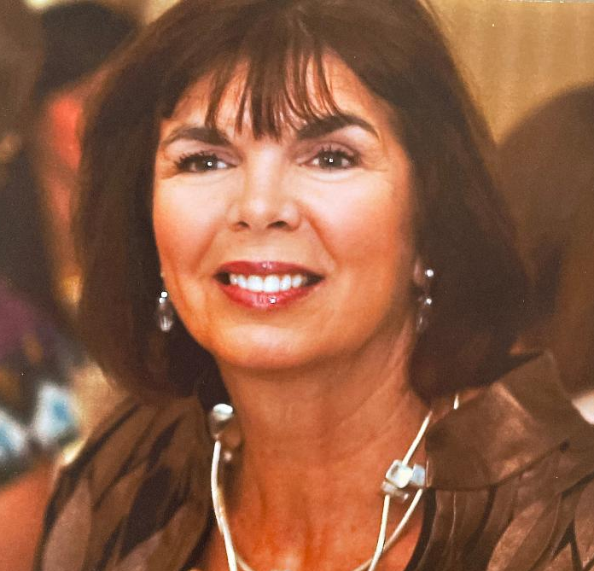
Cathy Matthews

Cathy moved to Raleigh from Florida in 1976 to become a learning disabilities teacher in WCPSS. That position led to her involvement with Project Enlightenment. After nearly eight years of teaching, she chose a different career path. In 1991 Cathy began her practice as a psychologist working with children and adolescents. In March 2020 she retired and now devotes her full time to her husband of 44 years and to her four grandchildren.

