Pleasant Township Board of Trustees Meeting Highlights
Date __October 25, 2022 Next Resolution No.__ 57-----10-25-2022_______

- Call to Order -- The meeting tonight will also be on WebEx.
- Please stand for moment of silence. --Pledge of Allegiance-----Roll Call
- Minutes to approve- none
- Financial Reports – Motion to pay expenditures.
- Visitors –
- Hanna Poling with the Southwest Messenger via WebEx.
- David Reutter is an Urban Conservation Specialist at Franklin Soil and Water Conservation District, where he works with county, township and municipal partners to manage and maintain the technical aspects of the NPDES storm water permit requirements and issues within their community and with their residents. David is involved with the review of construction plans, ordinance reviews, and comprehensive plan and master plan development for the inclusion of sustainable development practices that will protect the existing ecosystem services our natural resources provide. David is a Certified Erosion, Sediment and Storm Water Inspector (CESSWI) and is a member of the International Erosion Control Association, the Water Management Association of Ohio and the Water Environment Federation. Mr. Reutter gave a presentation about what his office provides to the township and a recap of Storm Water Awareness Week.
- Department Reports
- Franklin County Sheriff’s Report- Deputy Hamilton
  - Total calls for service for 10-12--22 to 10-25-22 were _121__
  - Total reports – 2
  - Arrest – 1
  - Tickets-3
  - Burglary-0
  - Thefts – 2
  - Accidents – 7
  - Suspicious Activity –14
  - Alarm Drops –17
  - Traffic Stops –17
  - Disabled vehicles –9
Notes-Two thefts, one cancelled by the caller the other theft was a text scam for banking information. Working with Oak Hills Trailer Park residents on setting up a block watch.
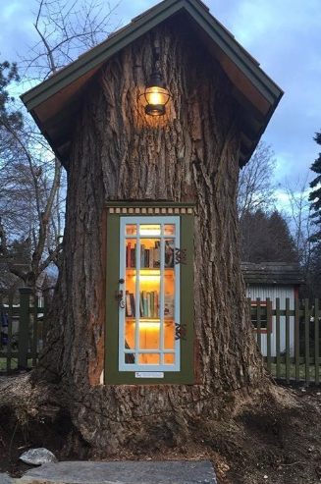
- Road Department- Superintendent, Robert Bausch
  - Truck 22 at ELW
  - 3 drive tile installations
  - Mowing road ditches
  - Tree estimate for the dead oak tree at Ebenezer Cemetery. Had a suggestion from a resident through social media for possible estimate from Gidgets on Lambert Rd. Robert said he had estimates from Davie’s Tree Service for $3,300 and Peterman’s for $2,977. Robert said for safety reasons the tree should come down soon. He recommended to use Davie’s Tree Service as their quote included extra items to cut the tree in a way to accommodate the Free book exchange Tree Library that Bill Dawson has applied for a grant to construct. (See the picture to the side) Resolution 57 to hire Davie’s Tree Service to take down the dead oak tree at Ebenezer Cemetery.
- As mentioned last meeting, next year is the last year of the one-year contract extension with Clarke Mosquito. The following is from an email from Charlie Broschart, Environmental Health Division Manager, Franklin County Public Health about the pricing for next year-----
As you may recall, we have exercised the last of our one-year contract extensions will Clarke Mosquito that includes a 1.5% increase. Below you will find the contract extension pricing cost for your jurisdiction for the 2023 Franklin County Public Health Mosquito Management Program. Please review the pricing and let me know if you have any questions. It is required that a contract extension be signed by each participating jurisdiction for 2023. We are working on using DocuSign for this contract extension so signatures can be obtained electronically and paper copies do not need to be mailed back and forth. There are two very important questions that we need answered in order to proceed with the contract extension process:
Does your jurisdiction intend to participate in the mosquito program for 2023?
Who is the authorized person for your jurisdiction to sign the contract, what is their title, and what is their email address?
Please reply to this email with confirmation that your jurisdiction will participate in 2023, and provide the name, title, and email address of the person that is authorized to sign this contract. 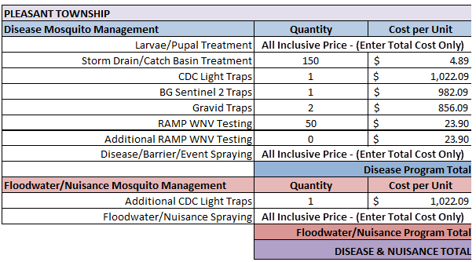
Resolution_58_ to authorize Robert to sign the Clarke Mosquito contract extension for 2023 in the amount of $9,268.61.
Resolution__59_requesting the services of Franklin County Engineers for the services of the vactor truck to clean two tiles.
- Fire Dept. – Fire Chief, David Whiting
- Staffing
- Interviewing for the position of firefighter November 1st thru 3rd
- Payout of Accrued time
Recommending that we pay one individual over the contracted approved hours (252 vs 96)
Resolution_60__to pay Lt. Wihl who went over the contract approved 96 hours by 156 for a total of 252 due to a manpower problem existing the past year.
- Equipment
Grass Fighter battery issues required replacement
Replacing front tires on E-231
- Community Risk Reduction
Fire Safety Presentation @ Darbydale School
- Miscellaneous
Station-weather stripping over bay doors
- Resolution_61_ to authorize an additional $500 for painting the bay doors-painters need more materials.
- Resolution__62_to hire Joseph Casa as a parttime firefighter/EMT.

- New Business –
  - Franklin County Engineer will be hosting his annual meeting of the Township and County authorities on Thursday, November 17, 2022. Please RSVP to Terri Pritchard at your earliest convenience. We are looking forward to seeing you there.
- Clerk Updates- Paula
- Misc. emails and correspondence
- Received $1,574 back from the Legal Defense Fund.
- Adjourn- at 7:30 p.m.

