Home Grown Gel Electrophoresis

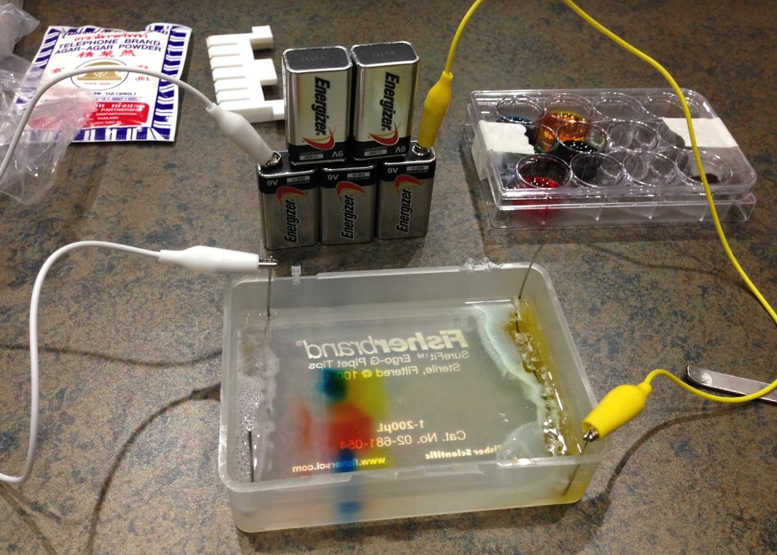

Adapted from:
Micro World Investigate Lab - North Carolina Museum of Natural Sciences - November 2015

Objective: To separate macro-molecules in a mixture. The separation of macro-molecules by size, shape, and/or charge is one of the most commonly used technologies in molecular biology. This usually involves separation of DNA/RNA or proteins for subsequent analyses and/or purification.
Requires:
- A matrix (gel) for molecules to travel through; usually agarose or polyacrylamide
- A constant electrical current forcing molecules to move in one direction
Apparatus for doing these separations are expensive and not generally available outside of research labs.
Solution: a home-made apparatus demonstrating the principles of electrophoresis that is affordable and safe for classroom use.

North Carolina Essential Standards Bio.3.3.1
- Summarize the process of gel electrophoresis as a technique to separate molecules based on size. Students should learn the general steps of gel electrophoresis – using restrictions enzymes to cut DNA into different sized fragments and running those fragments on gels with longer fragments moving slower than faster ones.
- Interpret or “read” a gel.
- Exemplify applications of DNA fingerprinting - identifying individuals; identifying and cataloging endangered species.

Materials (unless specified, all materials are included in the kit)

Ingredients

Agar-agar (for the food color demo) or agarose (for actual DNA gels); agar-agar is supplied in the kit
Baking soda; user supplied

Baking soda gel running buffer (0.2%, 0.5 g baking soda for 250 ml buffer); need 100 ml for making gel and rest for running gel
1% agar-agar gel (1 g of agar-agar in 100 ml of 0.2% baking soda solution)

Electrophoresis Unit & Power Supply (supplied in kit)

• Used micropipette tip box lid
• Four 20 gauge stainless steel wires (15 cm)
• 3 clip leads
• 3-5 9V batteries

Samples from Food Color kit (red, blue, yellow, and green, from the McCromick Food Color provided in the kit or other brand)

Per sample:
• 0.5 ml corn syrup (high fructose or Karo; supplied by user)
• 3 ml water
• 1 drop food color

Mix all 3 ingredients in a single well of the 12-well plate (provided in the kit) with a large transfer pipette (use one pipette per sample)
Use separate small transfer pipettes to load each sample

Miscellaneous Supplies

Supplied with kit unless noted in bold as user supplied

• Plastic transfer pipets (large with gradations and small; large for sample preparation and small for gel loading)
• Gel comb (6 well for agar-agar gel)
• Metal spatula (to scoop out agar-agar; for cutting the gel; razor blade also ok)
• Digital scale; user supplied – jewelers’ scale suggested (eBay, $10-15)
• Small weigh boats
• 12-well tissue culture plates (for holding samples)
• Microwave; user supplied
• Glass flask; 250 ml
- Conical tubes; 15 ml and 50 ml
• Glass beaker (or Mason jar with volume markings) for measuring buffer; user supplied
- Oven mitt; user supplied

Procedures

I. For making running buffer (0.2% baking soda solution)

1. Weigh out amount of baking soda required to make and run gel (for example, 0.5 g of baking soda for 250 ml of solution).
2. Pour baking soda into a beaker
3. Use a 250 ml flask (provided in the kit) to measure out enough water (distilled or tap).
4. Pour water into the beaker that contains the weighed-out baking soda.
5. Gently swirl water in the beaker until baking soda dissolves.

II. For making 1% agar-agar gel

1. Weigh out amount of agar-agar required to make a gel (1 g for a 100 ml gel).
2. Use a 50 ml conical tube (provided in the kit) to measure out enough baking soda running buffer to make gel (100 ml per gel).
3. Pour running buffer into 250 ml glass flask.
4. Add agar to flask, swirl.
5. Place the 250 ml flask (with agar-agar and running buffer) in microwave and heat until boiling; stop before it boils over. Remove and gently swirl flask.
6. Return flask to microwave until boiling, remove and swirl.
7. Repeat the above once or twice until most of agar is dissolved in the running buffer.
8. Allow the agar-agar solution to cool until about 55 °C (or until cool enough to hold flask to the count of five).
9. While the agar-agar solution cools, prepare Electrophoresis Unit by positioning the appropriate Gel Comb about 3 cm away from one end of the used tip box (provided in the kit).
10. When the agar-agar solution is cool enough, pour 90-100 ml of it into the gel box. (If the agar-agar solution solidifies before pouring, gently re-melt it in the microwave.)
11. Allow the agar-agar gel to cool and solidify in the tip box.
12. When gel has solidified, gently remove the gel comb vertically. The empty spaces in the gel left by the comb are called "wells."
13. The agar-agar gel is ready to be loaded with samples and run.

III. For making Food Color Samples

1. Use (and re-use) the 12-well tissue culture plate supplied in the kit.
2. Decide which colors you would like to test (suggested samples below).
3. For each color to be tested:
a. Put 0.5 ml light corn syrup into each well needed. Corn syrup is used to add density to sample so it will sink into the well and stay,
b. Add 3 ml water to the same wells. For step a and b, use large transfer pipette with gradations.
c. Add one drop of food color to the same well with small transfer pipette.
d. Mix with small transfer pipette; also use this to load wells in the comb; use separate pipette for each color

IV. Suggested samples for agar-agar gel electrophoresis

1. Red
2. Blue
3. Yellow
4. Green
5. Purple (mix one drop of blue and one drop of red)

V. For loading and running samples in the 1% agar-agar gel

1. Make two buffer reservoirs by using a thin metal spatula or razor blade to carefully cut and remove a 5 mm-wide strip of gel material from the top and bottom of the gel.
2. Use two of the steel wires (provided in kit) and bend each into a U shape that has two vertical short ends of approximately equal length and a longer straight horizontal piece. The horizontal piece should be as long as the tip box is wide on its short end. Alternatively, paper clips can be used. Paper clips degrade in quality and are only useful for running one gel. Anode (+) end clip also discolors gel if run is long enough.
3. Place a U-shape wire in each reservoir, making sure the horizontal piece of the wire touches the bottom of the tip box.
4. Pour enough running buffer into the tip box to cover the gel and fill the reservoirs.
5. Use a small transfer pipette, fill a well with one of the samples to be tested. Avoid puncturing the bottom of the well with the pipette tip.
6. If there are multiple samples to be tested, repeat Step 5 but use a clean pipette for each sample.
7. After all samples have been loaded into the wells, clip either end of each U-shape wire with a separate clip lead and prepare to run the gel. Samples will diffuse out of the well if they are idled for too long (check the picture on p.1).
8. Using their own positive (+; anode) and negative (-; cathode) terminals, snap three-five 9V batteries together into a pyramid.
9. Place the 9V battery tower near the tip box.
10. Attach the free end of the clip lead that is connected to either end of the U-shape wire nearest the wells to the negative (-) terminal of the 9V battery tower.
11. Attach the free end of the clip lead that is connected to the U-shape wire farthest away from the wells to the positive (+) terminal of the 9V battery tower. Samples will move toward the anode (+).
12. Look for small bubbles forming along the submerged vertical piece of the U-shape wire that is connected to the negative terminal of the battery. If no bubbles are forming, check the clip connections to the U-shape wire and the batteries' terminals. Also, make sure that the batteries are charged.
13. Allow the gel to run for about 45-60 minutes or until samples have moved through the gel as far as desired.
14. To stop the gel from running, unclip the leads from the batteries and U-shape wires.
15. Gently pour off the running buffer and examine the gel.
16. Document result with a picture.

VI. Troubleshooting

- Mistakes will be made, run at least one trial gel before showing this to students to make sure the procedure runs smoothly.
- If the dyes are running towards the cathode (-), you have connected the leads backwards. Reverse, re-load wells and try again.
- If the dyes do not migrate very far within 30 min, the batteries may be getting old. A pyramid of five 9 V batteries is only good for 3-4 hrs.
- If you want the gel to run faster, chain together more batteries, any odd number over 3 is ok.
- If your wire electrodes look discolored, try new ones, this especially applies to the positive +; anode) end of the gel.
- If your samples appear to leak out of the bottom of the well before you apply the current (you will see them spreading out around the well), it is likely that you removed the gel comb too quickly and ruptured the gel, causing a leak. There still should be enough dye in the well for a successful run. If not, try a new gel.
- Try to load the well as full as possible. If you don’t see any colors during the course of the run you may not have loaded enough sample.
- It is ok if you overload the wells a little, the overflow will simply diffuse away.
- If you can’t see the wells clearly, put a piece of dark paper under the gel, this can highlight the wells more.

VII. Questions to ask your students or other things to try:

- Which sample moved the farthest and why?

- What does the direction of the movement say about the charge of the dyes?

- Which sample is made up of the smallest molecule?

- Did any of your samples have more than one color?

- Can you tell the composition of green and purple from the migration patterns?

- What do you think would happen if you used more batteries?

- Add additional samples as unknowns, such as brown M&M or colored candies; ask students to predict the separation results.

