FIFTH SUNDAY
IN ORDINARY TIME
FEBRUARY 3 & 4, 2018
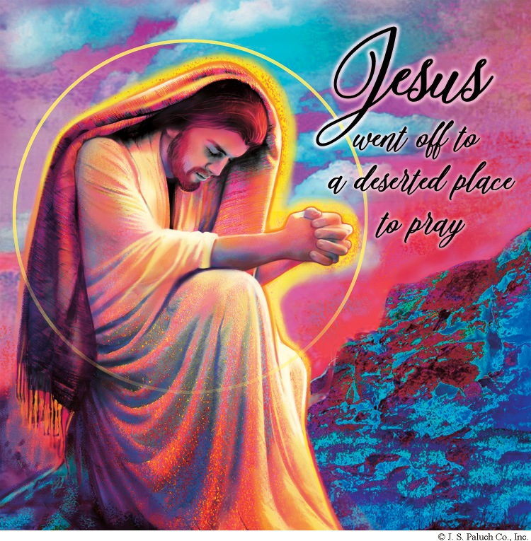
TIRELESS DISCIPLESHIP

The stories we’ve been hearing these weeks come from the very first chapter of Mark, and they show us the public ministry of Jesus in its infancy. Today’s account shows some of the strain or adjustment of his life of preaching the reign of God, healing the sick, and casting out demons. Notice that after sunset, when darkness ended the workday, people brought the sick and possessed to Jesus. The following day he rose before dawn to get away by himself to pray, but to no avail. Simon Peter and the others don’t just look for him, they pursue him, filled with the fervor that his ministry has incited. With the self-sacrificing example he gave until the end of his earthly life, he tells his followers that this is the whole purpose. Through Mark, he is also telling the early church, and he is telling us, that this is our purpose. Through Mark, he is also telling the early church, and he is telling us, that this is our purpose, our vocation: to be tireless in our pursuit of proclaiming the Good News, and in bringing the healing, reconciling touch of Christ to the world.

CONSCIENCE 1
Submitted by: Dennis Tavares

God’s natural law and revealed law are the only real foundation for the moral law of right and wrong; humans are not wise enough or objective enough to make up the rules for living on their own. This has always been a consequential fact of human existence because our decisions on moral issues have big consequences. Our inner conscience guide has to be up to the task of choosing rightly; it needs to be informed. And our will has to be capable of following an informed conscience; capable of making tough decisions against the sometimes unruly inclinations of our body. If you possess both these assets, an informed conscience and a disciplined will, you have had a good personal character formation. Good character is most easily developed within the natural family rooted in religious practice and connected to God. Sadly, many young miss out on this.

IT’S ALL AROUND US!
Submitted by: Jane Vartanian

At Harry Potter’s school, Hogwartz, every teacher and student is armed with a deadly weapon, a wand, and they know how to use it. But there are no murders, or terrible injuries perpetrated by them. They live in a culture of respect, dedication to study and enjoyment of games.
The latest school killing, in Marshall County High School in Kentucky, on Jan. 18, 2018, aroused the state’s governor to speak to his state. Governor Bevin asked his audience to consider the history and culture behind the act.
In the 1800’s, there were probably more guns in every household than today, and students could carry them to school. There were less regulations and laws to control their use. Yet there was less inclination to use them violently against a fellow man. Our culture was family centered, and the family worked together to survive.
Governor Bevin said that our culture has changed. Entertainment is a more constant factor in our lives now, and eye-catching screens in our homes and hands now glorify killing every day. Death by gunfire or some other violence is accepted entertainment. Children do not understand the permanence of death, and accept the dropping of bodies as natural and of small consequence.
He implored the writers and producers, movie house and arcade owners, to rethink their product and profits. They have enveloped us in what has evolved to be a culture of death. Entertainment, such a big part of our daily lives now, can be funny , challenging, and instructive and can bring about a healthier social structure, but we have to demand it. It won’t happen by itself, and it will take a long time.
Does anyone today remember the Legion of Decency? A 1933 organization, which encouraged its members to boycott any movie it deemed too sexually explicit, or, by seeing it, commit a mortal sin? It was created by the Catholic Church, which worked with the film industry, and previewed every film before it was released. Then, it was judged acceptable, or condemned. A condemned vote was feared by the box office, as it would mean lost profits.
It was challenged as an attack on the freedom of speech several times over the years and finally Paramount Studios won, in the Supreme Court, and the organization was dissolved.
Today, perhaps, a united front of churches, temples and mosques, could form a panel which would preview films, and games, and give their opinion. Their followers could decide whether to accept their decision, and either buy, or refuse to buy.
Profits are the only motivators of the producers of this material.

PRAY FOR OUR FAMILY AND FRIENDS IN THE MILITARY

Edgar Toscano, Marina González, Jacob Lazio, Alondra Jara,
Sonia Jara, Jason Lorenz, Matt Mills & Jared Schroeder.

PALM BURNING

OLD BLESSED PALMS WILL BE COLLECTED FROM
FEBRUARY 5TH -11TH, 2018
THESE OLD PALMS WILL BE BURNT ON
SUNDAY, FEBRUARY 11TH AFTER THE 10AM MASS
FOR ASH WEDNESDAY.

PLEASE PLACE THEM IN THE BASKET THAT IS IN THE VESTIBULE OF THE CHURCH OR BRING THEM TO THE OFFICE.
IT IS AN OLD CATHOLIC CUSTOM FOR THE LOCAL PRIEST TO COLLECT THE OLD PALMS, BURN AND BLESS THE ASHES. PALMS SHOULD NOT BE DISPOSED OF AS WASTE MATERIAL.

PLEASE PRAY FOR OUR SICK PARISHIONERS
Ana García, Antonio Cazares, Evelyn Costa, Ryan Moore, Steve Beeman, Eileen Seeman, Marianne Brannan, Lilia Parrish, Nancy Smith, Peter Lopez, Julián Palomar, Luisa Martínez, Jennifer Vera, John Braet, Graciela Morales, Ana María López, Kim Koskinen, Margaret Valencia, Matthew Marcoulier, Dennis Tavares, Jose Freitas, Alfredo Sousa, Joel Morales, Manuel Muñoz Mendoza, Juana Arreguín, Aron Yasskin, Victoria Walzer, Fidela Yáñez Jara, Erika Ramos, Bill Gibson, Carla Tomas, Erasmo Yáñez, Memo Soria, Patricia Vargas, Fidela Yáñez, Rogelia Serrano, Elvia Flores, Camila Blanco-Cherrez, Yonel Ruíz, Angie Freitas, Russel Bryant, Derrick Heater, Luis Angel, Juan Barrera-Terán, Gabriel Hurtado, Gerald Butler, Helen Reynolds, Ruth Cimolino, Toni Clark, Ann Gallagher, Brianna Lopez, Margaret Milliken, Gina Pivirotto, Nick Quin, Mary Servis, Denis Sousa, Victor Venegas, Matty Walker, Charles Lorenz, Rebecca Lorenz, Ofelia Ibarra, Leonardo Naal, Gina Leal, & Ernest Nuñez.

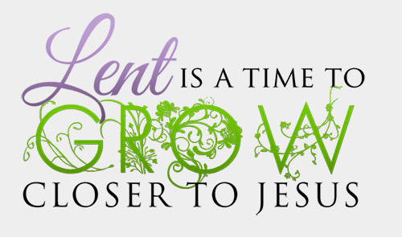
PLEASE JOIN
MARIA HURTADO AND JULIE EDWARDS
FOR AN EVENING LENTEN STUDY.
ON MONDAY, FEBRUARY 12TH AT 6:30 PM
IN CLASSROOM #5.
TOGETHER WE WILL STUDY AND GROW IN OUR CATHOLIC FAITH AND LIVE MORE FULLY AS MISSIONARY DISCIPLES OF JESUS.
FOR MORE INFORMATION, CALL THE OFFICE AT 707-964-0229.

WEEKLY COLLECTION

JANUARY 27 & 28, 2018…….$1,979.50
ANNUAL MINISTRY APPEAL (AMA)…….$892.00
THIS WEEKEND’S SECOND COLLECTION:
LIABILITY INSURANCE
NEXT WEEKEND’S SECOND COLLECTION:
MAINTENANCE FUND
THANK YOU FOR YOUR SUPPORT & CHRISTIAN GENEROSITY

ATTENTION
ALL FORT BRAGG HIGH SCHOOL CLASS OF 2018 GRADUARING SENIORS.
Knights of Columbus Educational Grant application forms will be available in the parish office, beginning March 5th.
Application’s deadline is: April 18, 2018.
For additional information call 707-480-4614.

ATTENTION
Should you need a letter from the parish regarding your 2017 donations for income tax purposes? Please call 964-0229 or stop by the office.

MASS INTENTIONS
FEBRUARY 5 - 11, 2018
Monday (05)  Tuesday (06)  Wednesday (07)  Thursday (08)  Friday (09)  Saturday (10)  Sunday (11) | 11:45am  12:05pm  12:05pm  12:05pm  12:05pm  5:00pm  6:30pm  8:00am  10:00am | Communion Service  Communion Service  Gloria, Mark & Marita Barbaro †  James Braga Melo †  Dorothy & Eurico Carolo †  Maria R. Valadao †  Fred & Clara White †  Margarito Martin †  Esperanza Barba (sick)  Domenico D’Acquisto †  James Braga Melo †  Maria Alda Melo †

WEEKLY READINGS

Monday: 1 Kgs 8: 1-7, 9-13; Ps 132: 6-7, 8-10;
Mk 6: 53-56
Tuesday: 1 Kgs 8: 22-23, 27-30; Ps 84: 3-5, 10-11;
Mk 7: 1-13
Wednesday: 1 Kgs 10: 1-10; Ps 37: 5-6, 30-31, 39-40;
Mk 7: 14-23
Thursday: 1 Kgs 11: 4-13; Ps 106: 3-4, 35-37, 40;
Mk 7: 24-30
Friday: 1 Kgs 11: 29-32; 12: 19; Ps 81: 10-11ab,
12-15; Mk 7: 31-37
Saturday: 1 Kgs 12: 26-32; 13: 33-34;
Ps 106: 6-7ab, 19-22; Mk 8: 1-10
Sunday: Lv 13: 1-2, 44-46; Ps 32: 1-2, 5, 11;
1 Cor 10: 31—11: 1; Mk 1: 40-45

OLGC’S MEMORIAL TREE
In the vestibule of our church, on the southern wall, is a beautiful Memorial Tree.
Its bright leaves represent permanent memorials to the
departed of our parish.
For the sum of a onetime payment of $200.00, you can give to the parish secretary, the correct spelling and dates of the departed and in due time the leaf is printed and attached to the tree: a permanent reminder of a loved one who is gone.
For more information, call the parish office at 964-0229.

YOUTH OF OUR LADY OF GOOD COUNSEL:
You are invited to come join Don Bosco Youth Group.
We meet every Wednesday from
6:00pm - 8:00 pm in Classroom #1.
Come have some fun while growing in Faith!
All are welcome!
Young people who have just received Confirmation
are most welcome.

