Kennedy High School
Advisor: Barry Wilson
4545 Wenig Rd. NE, Cedar Rapids, IA, 52402
319-784-7697
bwilson@cr.k12.ia.us
Jamie Voorhees, Grade 12, Driver/Crew Chief
John Tedesco, Grade 10, Crew Chief
Molly Sullivan, Grade 12, Documentation Writer
S30 Car: January 24th, 2018 – February 27th, 2018
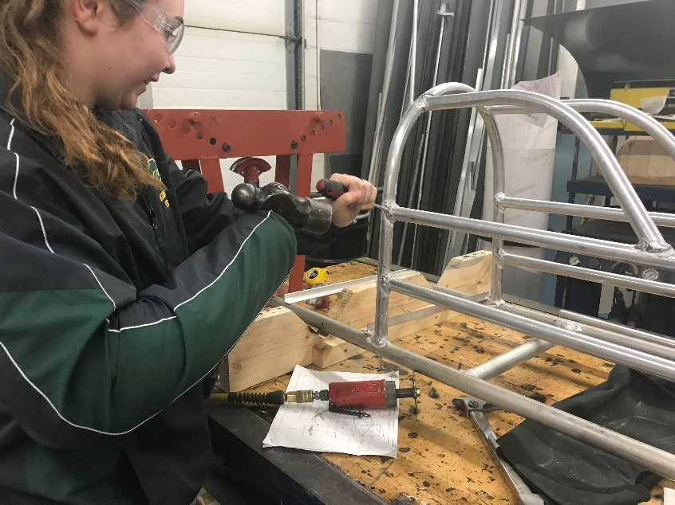
Over the last month, the 30 car team has worked hard to get the chassis assembled so that it can be tested over spring break. While a lot of progress has been made, the team has faced daily struggles, preventing them from being as far along as they had hoped. Some of these struggles are due to only having one welder (our advisor). Others are due to the crew chief only having one usable arm as her dominant arm is in a cast. Due to Jamie being handicapped, John has stepped in and tried to get the work done. His initiative is appreciated, but since he is still learning, mistakes have been made that resulted in the team being set back. The goal for the car is to have the chassis fully assembled and hopefully be covered in plastic by spring break in mid-March so that testing can begin.

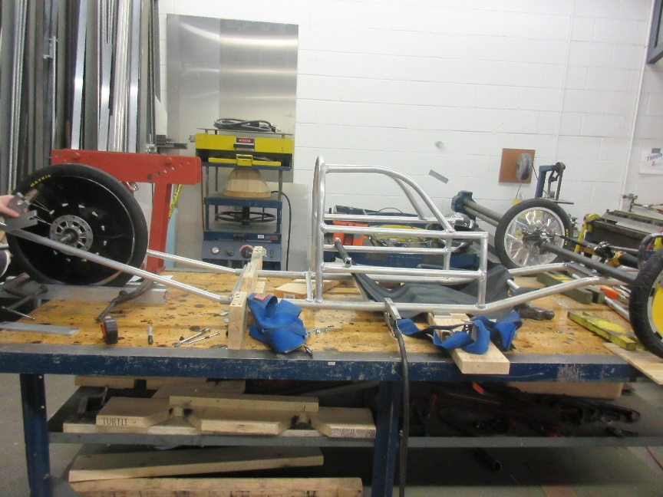
Kennedy High School
Kennedy High School
Advisor: Barry Wilson
4545 Wenig Rd. NE, Cedar Rapids, IA, 52402
319-784-7697
bwilson@cr.k12.ia.us
Derek Severson, Grade 11, Crew Chief
Molly Sullivan, Grade 12, Driver/Documentation Writer
A40 Car : January 24th, 2018 – February 27th, 2018
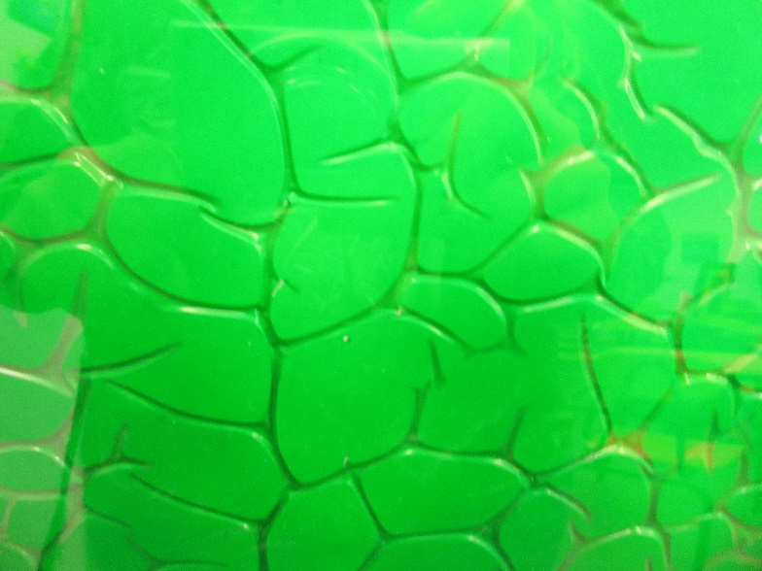
Over the last month, Derek has worked on painting the body panels for the car. Normally, this process does not take a month to do, but we had to share the painting area with the 50 team and were also struggling with how our paint was turning out. The goal was for a green car, but the color we initially chose was too dark and slightly transparent. The plan was then to back it with white. We quickly learned that the white would eat the green and give us a funky, reptile-skin looking paint job. With not many options left, we decided to role with it. Part of the initial plan was to have farm animal graphics on the car as well, because why not? Since the green had a mind of its own, those plans have changed. However, you will have to wait until the first race to see what the car looks like. The plan for next month is to test the car and make any adjustments needed so that it is ready to go for race season as the start of April.

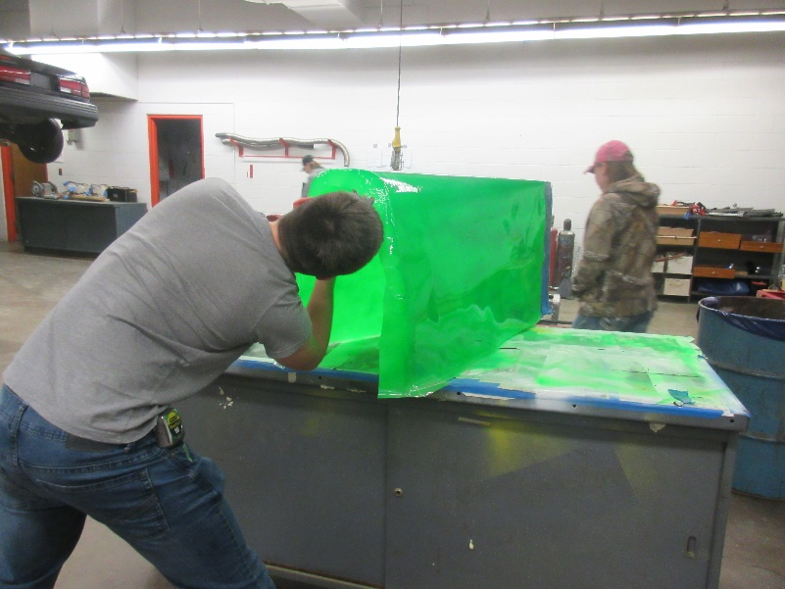

Kennedy High School
Kennedy High School
Advisor: Barry Wilson
4545 Wenig Rd. NE, Cedar Rapids, IA, 52402
319-784-7697
bwilson@cr.k12.ia.us
Natalie McAllister, Grade 12, Driver/Documentation Writer
Noah Matthews, Grade 12, Crew Chief
Lillie Wood, Grade 11, Maintenance
S50 Car: January 24th, 2018 – February 27th, 2018
The 50 team has worked hard to paint their tail this month, and have started to work on adjusted their steering acremen. Their tail took so long to paint because it was meant to match their wheel covers and nose, which are covered with holographic glitter. Their initial means of securing the glitter was a sparkly fail, so they attempted again, using an actual adhesive and succeeded. They then decided to back the glitter with black paint to help reduce some of the reflection of the glitter and make the tail darker. They too have come up with a cool design idea for the car which will be revealed at the first races.
