JSB Capital Management, LLC
Pro-active Wealth Management

December 16, 2015

Earlier today the Federal Reserve Open Market Committee (FOMC) decided to raise the federal funds rate target by 0.25 percentage points moving the administered rate to a range of .25 to .50%. The decision to raise rates “recognizes the considerable progress that has been made toward restoring jobs, raising incomes and easing the economic hardships that have been endured by millions of ordinary Americans,” the Fed’s chairwoman, Janet L. Yellen, said at a news conference after the decision was announced. Interestingly, this rate increase comes exactly, to the day, 7 years from December 2008 when the FOMC first set rates at near zero.
The graph below shows how this important rate has fluctuated since 2000 and the second graph show how the interest paid on U.S Treasury debt will likely grow over the next three years, which is one of the most significant outcomes from today’s decision.

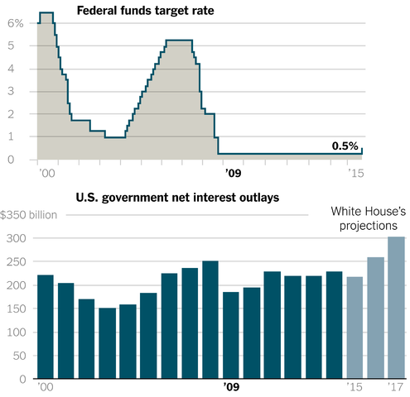

Historically rates on mortgages and other kinds of loans tend to rise with the Fed’s benchmark rate, the relationship doesn’t always hold true. For example, mortgage rates declined during the housing boom, even as the Fed raised short-term rates because of increased foreign real estate purchase demand. That pattern could recur if investors once again conclude the United States is a better investment than other parts of the world. However, interest rates on mortgages and other kinds of loans, and on savings accounts and other kinds of investments, are likely to remain low by historical standards for years to come.
Why Hike rates at this time?
- To give the Fed room to respond to an unexpected shock to the economy or financial markets,
- To stave off the need for future abrupt tightening,
- The realization that FOMC policy action has a long lag time before the effects are felt,
- To slightly reduce “accommodation,” but still remain very simulative in the interest rate structure.
What does this mean over the next year or so?
First of all, the FOMC promised to raise rates very gradually in 2016. There is a consensus that there will be three or four, at most, rate increases next year leaving the benchmark rate at around 1%, still an historically low rate. Consumers may be able to find slightly higher-yielding savings accounts and certificates of deposit, though the returns will still be meager. The cost of borrowing is expected to rise, but only slightly, with variable effects on what banks charge for credit cards, home equity lines of credit, adjustable-rate mortgages, student loans and some car loans.
Future rate increases will still be dependent on economic conditions such as U.S. unemployment, inflation, and GDP growth. Chair Yellen also highlighted global conditions as something the Committee will be monitoring.
The initial market reaction was a strong rally as investors expressed relief that the FOMC had finally made the long awaited decision to end the zero interest rate policy. There remains substantial underlying weakness in the economy and we expect investors may now focus more on company profitability in their investment making decisions and less on monetary policy.

