Desk Plates, The Artful Classroom,
Primary Grades 1-3 Version
Use these colorful desk plates to set up a place for each of your students. There are enough for 23 students. If you need more, click on page 12. Go to Insert-Blank Page. Insert as many blank pages as you need for the size of your class. (There are 2 desk plates per page.) Then go to page 2. Right click on the image and select Copy. Then go to each blank page, right click and select Paste. If you need to move the image, click and hold onto the image while you drag it wherever you want it on the page.
Select “Student Name” (double click on it) and retype the names of each of your students. Run them off on heavy white drawing paper, cover stock, or tag. Laminate and trim them, and they’re ready to go!
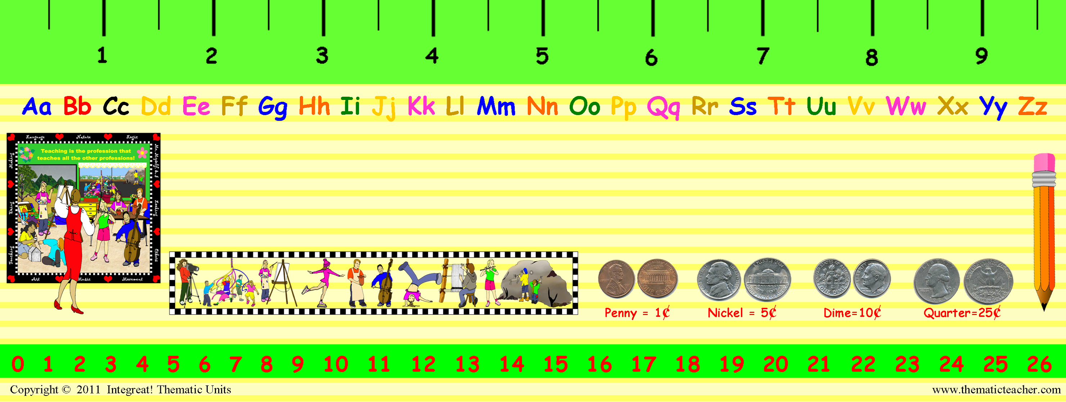
Suzy Que
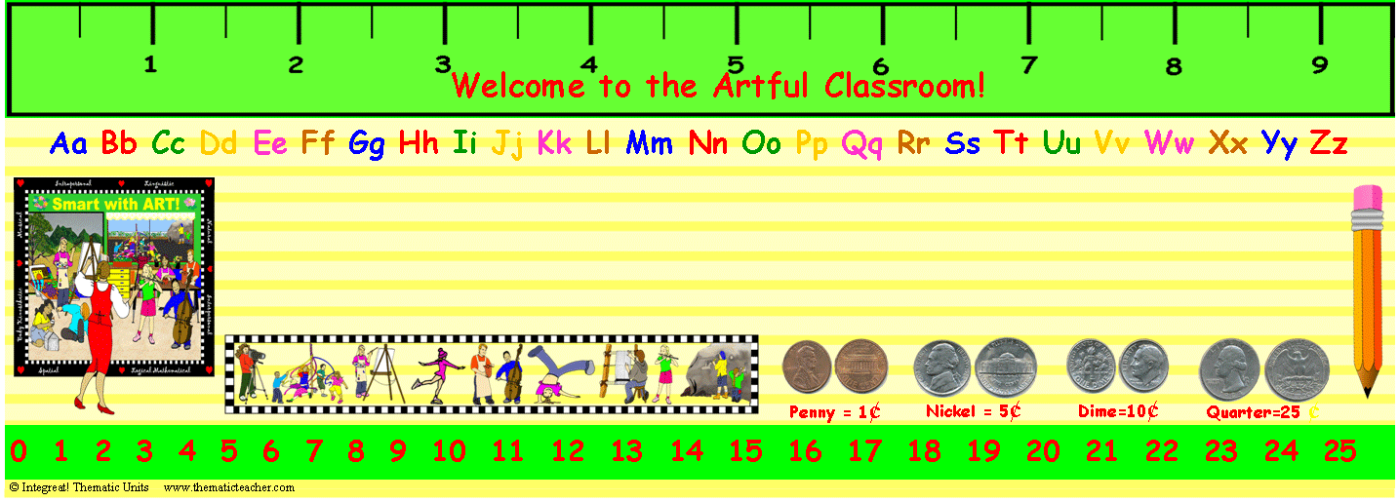
Student Name
Student Name
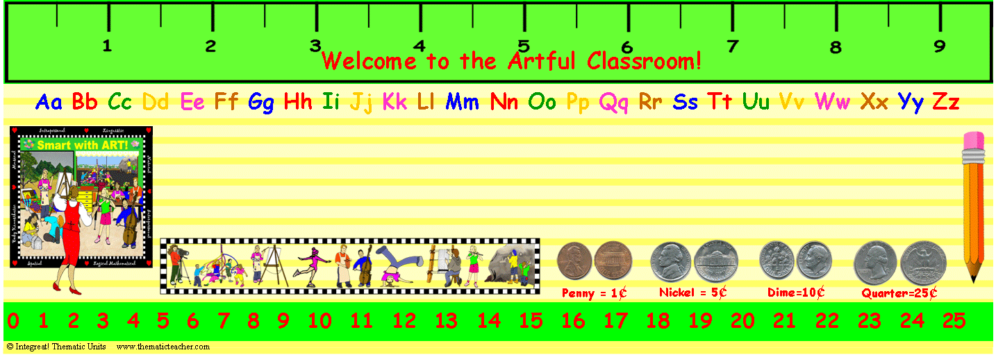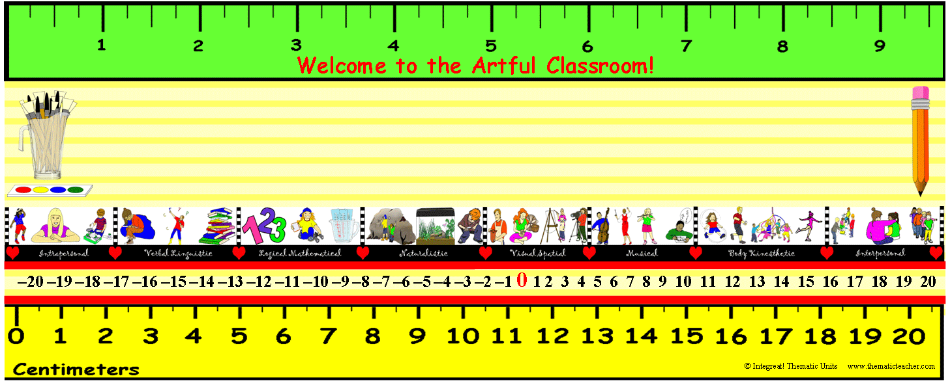
Student Name
Student Name
Student Name
Student Name
Student Name

Student Name
Student Name
Student Name
Student Name

Student Name
Student Name

Student Name
Student Name

Student Name
Student Name

Student Name
Student Name

Student Name
Student Name

Student Name
Student Name

Student Name
Student Name

