Southampton
American Legion POST 526 Fundraiser

Held @ DIPaolo’s Red Lion Inn & Cocktail Lounge
Home–Cooked Italian Cuisine @ Home-Town Prices
101 Red Lion Rd, Southampton, New Jersey
1(609) 859-9813
Wednesday April 25 & Thursday April 26, 2018
From 3:00 – 9:00 P.M. both days
Eat-in or Take-Out!
Come and GO as you please!
Order from the Menu.
The Post Receives 15% of all sales!
Except Alcoholic Beverages

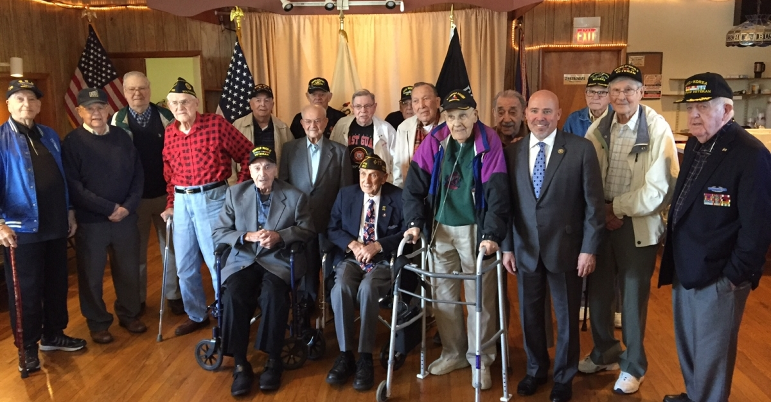
There will be a 50/50 drawings each night @ 9:00 P.M. You don’t need to be present to win!
Funds will be used to support our local area middle schools & high school scholarships, Area high school Girl’s States & Boy’s States sponsorships and The Veteran’s Home. FOR GOD & COUNTRY

