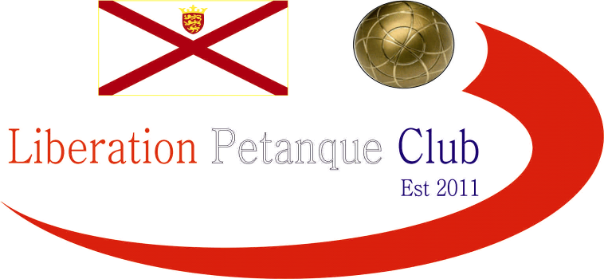

2022
DOUBLES OPEN

Just twelve teams entered this year, one of the lowest on record.

Round one saw a shock as last year’s finalists and previous winners Andrew Bellamy-Burt & Callum lost 13 – 6 to Lorna & Tony.

Big for holders Geoffroy & Matt Buesnel beating Mo & Callum 13 – 3 and a whitewash for Matt Pinel & Andrew Limbrick 13 – 0 over Daniel & James.

Club Doubles holders Laurent & Toby started off well winning 13 – 7 over Cassie & Jean and Neil & Ross beat Colin & Jim 13 – 4.

One match did not make the distance and no surprise as Brian & Gary just edged out Keith & Graeme 9 – 8.

Round two saw Brian & Gary only make it to nine points again, but another win 9 – 7 against holders Geoffroy & Matt. Andrew & Matt beat Laurent & Toby with ease.

Neil & Ross made light work of Lorna & Tony 13 – 1 and Andrew & Callum got their tournament up and running winning 13 – 3 over Mo & Callum.

Cassie & Jean won a close match against Colin & Jim and Keith & Ellis got their first win over Daniel & James.

Round three saw Brian & Gary only get to nine points again but this time a loss 9 – 13 to Toby & Laurent. Neil & Ross lost heavily to Andrew & Matt and big wins also for Geoffroy & Matt and Andrew & Callum.

Two wins on the bounce for Ellis & Keith beating Colin & Jim, another 13 – 10 loss. Connor & Mo beat Daniel & James 13 – 3 for a big win.

In the final round of the Swiss Qualifiers Andrew & Matt finished top with four wins from four, handing Geoffroy & Matt their second loss, despite this the holders went through in sixth place.

Laurent & Toby beat Keith & Ellis 13 – 5 to finish second with Keith & Ellis still going through on two wins in eighth place. Brian & Gary lost 13 – 12 to Andrew & Callum to finish fifth with the latter finishing one place above them in fourth.

Neil & Ross beat Callum & Mo to finish third and Lorna & Tony beat Cassie & Jean to finish seventh. Colin & Jim got their first tournament win over Daniel & James who finished bottom.

FINAL SWISS RANKINGS

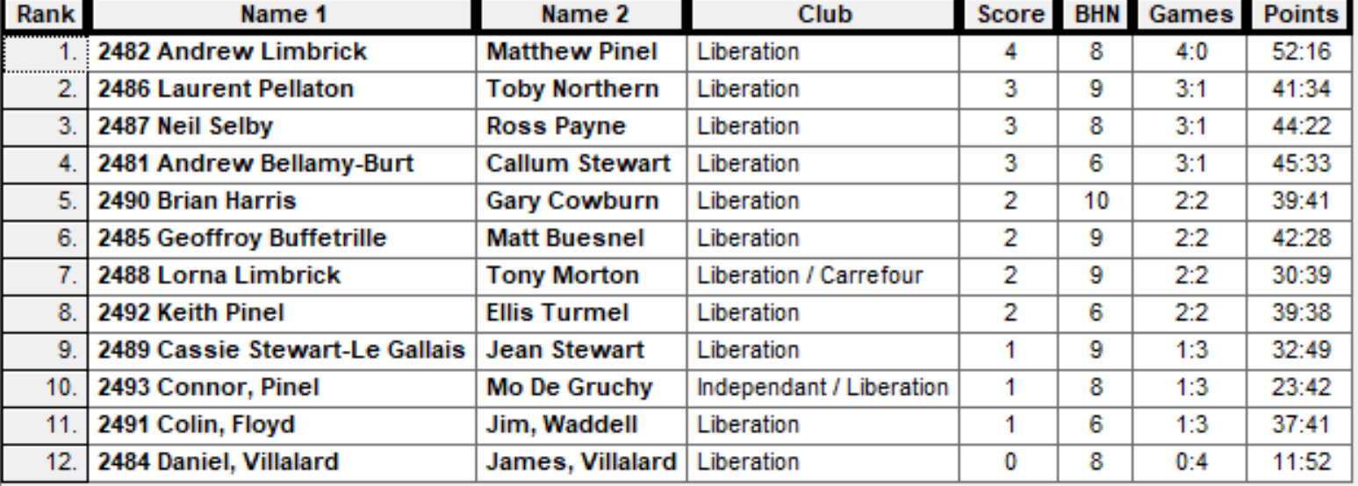

Quarter Finals

Ranked 1st Andrew & Matt v Ellis & Keith Ranked 8th

Ranked 2nd Laurent & Toby v Lorna & Tony Ranked 7th

Ranked 3rd Neil & Ross v Geoffroy & Matt Ranked 6th

Ranked 4th Andrew & Callum v Brian & Gary Ranked 5th

No shocks in the first quarter final as Andrew & Matt made light work of Ellis & Keith 13 – 4, this was the same score as Laurent & Toby beat Lorna & Tony.

Neil & Ross knocked out the holders Geoffroy & Matt 13 – 7 and Andrew & Callum also lost to Brian & Gary 13 – 11 as both last years winners and finalists went out.

Semi Finals

Ranked 1st Andrew & Matt v Brian & Gary Ranked 5th

Ranked 2nd Laurent & Toby v Neil & Ross Ranked 3rd

A big shock as Brian & Gary built up a big lead and with time running out Andrew & Matt need a host of points on the last two ends to either tie or win, despite still being in it on the last end and with Matt hitting some perfect fires gave them a chance but Andrew unfortunately failed to get either of his last two boules in which meant Brian & Gary won 10 – 9.

In the second semi final Laurent & Toby despite not on top form went 8 – 2 up but missed fires and Ross finding his form in the second half of the match saw Neil & Ross win 13 – 9 with a perfect fire to seal the win.

Well Brian & Gary had used up all their energy in the semi finals as they ran out of steam completely losing to Neil & Ross 13 – 0 but a great tournament still.

Andrew & Matt beat Laurent & Toby for third place.

2022 - Winners

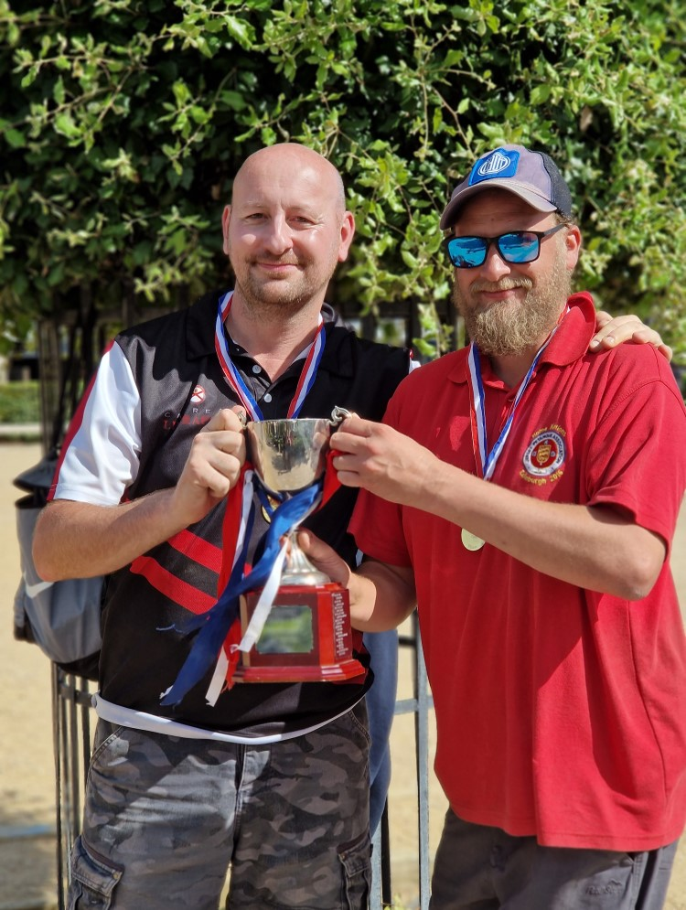

Thanks to all those who helped out on the day to make it another great competition.

Sponsored by



CoinShares | Digital Asset Investment Strategies for Professionals 🚀

Club email address - liberationpc@gmail.com

Club Website - www.liberationpetanque.co.uk

Kind Regards

Toby Northern

Chairman

Liberation Petanque Club

