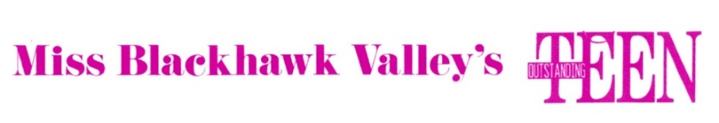

Miss Blackhawk Valley Scholarship Program, Inc.

Outstanding Teen Sponsor Form Pageant Year 2020

Sponsor(s} Name: _____________________ ________________________ ______________

Address: _______________________________ _____________________________ _____

City: _________________ _________________________ State: _________ Zip: _______

Phone: (____)____________ ____ ____ ____ ____ ____ ____ ____ ___  
 Signature

I agree to sponsor a 2020 Miss Blackhawk Valley’s Outstanding Teen contestant for $100.00.

I understand this fee is not refundable and enables the teen to compete in the Miss Blackhawk Valley’s

Outstanding Teen Pageant.

This will entitle me or my firm to these:

* Sponsor designation on the contestant’s page in the program book
* To be part of the poster display in the lobby on pageant day
* To be thanked by the contestant during the opening number at the pageant.

I would like to sponsor: ____ ____ ____ ____ ____ ____ ____ ____ ____ ____ ____

Make checks payable to Miss Blackhawk Valley Scholarship Program, Inc.

Return this form with check to: Mary Snyder, Treasurer

3550 Tam-O-Shanter Drive

Bettendorf, IA 52722

_ _ _ _ _ _ _ _ _ _ _ Detach the section below for your records _ _ _ _ _ _ _ _ _ _



Outstanding Teen Contestant Sponsor

Miss Blackhawk Valley Scholarship Program

Thank you for helping the teens of Western Illinois Counties of Rock Island, Henry, and Mercer to obtain scholarships to improve their talent.

Sponsorship fee receipt $________

Pageant representative or Contestant: ____ ____ ____ ____ ____ ____ ____ ____ ____ Date: ____ ____ ____

Revised 10/05/2019