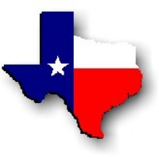Texas History with Mr. Brown Name ____________________ Period _____
Chapter 7.1 Review Life in the Missions and Presidios

Directions: Use your Study guide to answer the following questions
1) Many of the Spanish colonists came to Texas to escape cruel conditions on the ______________in New Spain.
2) Name three other reasons Spanish people moved to Texas:
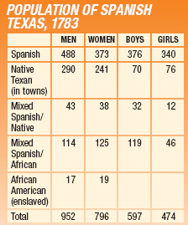
3) Were there more males or females in 1783 Spanish Texas?
4) How many enslaved African Americans lived in 1783 Spanish Texas?
5) Name the four kinds of Spanish frontier settlements:
6) The ______________________ was Spain’s main tool for colonizing Texas.
7) One purpose of the mission was to convert Native Texans to:
8) Spaniards hoped they would become skilled laborers who could be ______________________ for Spain.
9) What purpose did the towers of a mission wall serve?
10) Inside the compound, most missions had ______________ for the priests.
11) What type of trade skill shops were inside Spanish missions?
12) What were the lands surrounding the mission used for?
13) The ___________________ supervised all activities in the mission.
14) They would often _____________________________ uncooperative natives.
15) What did the daily routine in the missions begin with?
16) What did children do all day in the Missions?
17) ____________________ were essential to the colonization of Texas.
18) What was the purpose of the Presidios?
19) How many entrances did a Presidio have?
20) Most presidio soldiers enlisted for ten years.
21) Many soldiers had to take ___________________________ in the community to be able to buy food, clothing, and supplies for themselves and their families.

