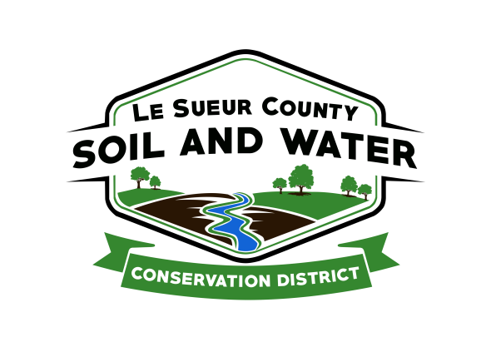

Le Sueur County Soil & Water Conservation District

Le Sueur County SWCD Tel. (507) 357-4879 Ext. 3
181 W Minnesota St Website: www.lesueurswcd.org
Le Center, MN 56057

Minutes from June 13, 2017 regular meeting of the Le Sueur County SWCD board of supervisors. Le Sueur County SWCD building, Le Center, MN.

Members present: Chairman, Jim Struck
Vice-Chairman, Greg Entinger
Secretary, Earle Traxler
Treasurer, Cletus Gregor
PR&I, Glendon Braun

Others present: District Manager, Mike Schultz
District Technician, Joe Jirik
Ditch Specialist, Nik Kadel
Farm Bill Technician, Jack Bushman
Conservation Corps, Becky Picha
Program Specialist, Sue Prchal

Chairman Struck called the meeting to order at 9:00 a.m.

Pledge of Allegiance was recited.

The May 9, 2017 secretary’s report was read and approved.

The May 31, 2017 treasurer’s report was read. Motion by Entginer, second by Braun to approve as read and to pay bills.
Affirmative: All
Opposed: None
Motion carried

Schultz will be conducting staff performance reviews soon and the board will give Schultz his review immediately prior to the July 11, 2017 board meeting.

Entinger and Gregor are on the personnel committee.

Motion by Traxler, second by Braun to pre-approve the 2018 Farm Bill Grant in the amount of $58,500.00.
Affirmative: All
Opposed: None
Motion carried

Motion by Entinger, second by Traxler to encumber $3500.00 state cost-share for Andy Oak for a terrace. Contract #3-17.
Affirmative: All
Opposed: None
Motion carried

Motion by Traxler, second by Braun to cancel Bernice Schultz phase 2 cost-share.
Affirmative: All
Opposed: None
Motion carried

Motion by Braun, second by Traxler to pay Jean Swanson $3500.00 for completion of state cost-share contract #2-16.
Affirmative: All
Opposed: None
Motion carried

Motion by Entinger, second by Traxler to approve Arnie Bauer Sand Creek cost-share contract in the amount of $2430.00.
Affirmative: All
Opposed: None
Motion carried

Motion by Entinger, second by Traxler to encumber $7585.00 for Len Petricka Phase 2 cost-share for a waterway. Contract # 9DR-2014-P1 .
Affirmative: All
Opposed: None
Motion carried

Motion by Entinger, second by Traxler to waive the 20% t/a for FY17 state cost-share.
Affirmative: All
Opposed: None
Motion carried

The board was informed about the 25% by 2025 session in Mankato in August.

Motion by Braun, second by Entinger to sign the DNR well agreement.
Affirmative: All
Opposed: None
Motion carried

The board discussed the SWCD governance 101 conference taking place in September.

Motion by Gregor, second by Entinger to adopt Resolution 2017-06-01 Local Water Resources Riparian Protection in Le Sueur County.
Affirmative: All
Opposed: None
Motion carried

A clothing order will be made for staff and supervisors.

Motion by Entinger, second by Traxler to have Struck the backup delegate for the SCTSA.
Affirmative: All
Opposed: None
Motion carried

The board discussed the air conditioning updates needed. The staff will clarify the bids received and bring the board up to date next month.

The board and staff exited the office for the 2017 Outstanding Conservationist tour. Areas toured were completed and future Lake Volney projects, nominee Mike Keogh, CRP restoration sites, Arnie Krueger nominee, lake shore damage and wetland mitigation sites.

Motion by Traxler, second by Braun to nominate Arnie Krueger as the 2017 Outstanding Conservationist.
Affirmative: All
Opposed: None
Motion carried

Vouchers were reviewed and filled out.

There being no further business, meeting adjourned at 2:00 p.m.

__________________ ______________________________________
Date District Secretary

