THIS IS AN OPTIONAL ENRICHMENT ASSIGNMENT. PRINT AND COMPLETE IN INK.

Name:________________________________________ Due Date:________________ Class Period:________

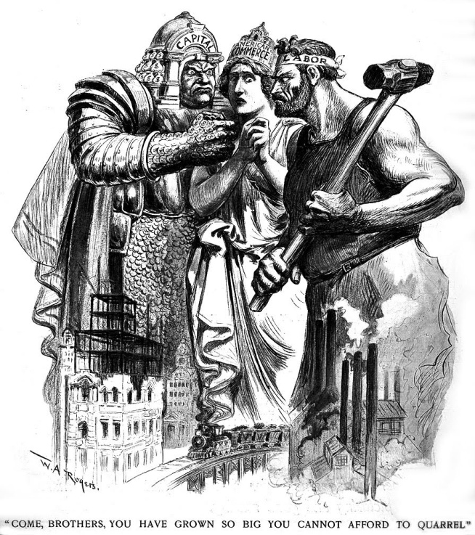
Reviewing the Populists and Analyzing Progressives
1865-1920

Reading Assignment: Chapters 19 and 21 in AMSCO; If you do not have the AMSCO text, use chapters 18 and 19 in Pearson. This review guide differs from others, because it includes reviewing portions of the previous unit as well as reading analysis for the current unit. Since unit 7 begins after the holiday break, it is important to go back and review some of the major themes and events that were the proverbial roots to the Progressive Era. Bonus points will be applied to both Populist Review quiz and the Progressive Era reading quiz.

Directions Print document and take notes in the spaces provided. Read through the guide before you begin reading. This step will help you focus on the most significant ideas and information as you read. This guide earns 10% bonus on BOTH the Populist review quiz and Progressive reading quiz.

(Political cartoon at left shows Capital, Commerce, and Labor with a caption saying, “Come brothers (Commerce speaking to Capital and Labor), you have grown so big you cannot afford to quarrel”).

PERIOD 6 1865-1898 Main Ideas
Key Concept 6.1: Technological advances, large-scale production methods, and the opening of new markets encouraged the rise of industrial capitalism in the United States.
Key Concept 6.2: The migrations that accompanied industrialization transformed both urban and rural areas of the United States and caused dramatic social and cultural change.
Key Concept 6.3: The Gilded Age produced new cultural and intellectual movements, public reform efforts, and political debates over economic and social policies.

Period 7 Main Ideas:
Key Concept 7.1: Growth expanded opportunity, while economic instability led to new efforts to reform U.S. society and its economic system.
Key Concept 7.2: Innovations in communications and technology contributed to the growth of mass culture, while significant changes occurred in internal and international migration patterns.
Key Concept 7.3: Participation in a series of global conflicts propelled the United States into a position of international power while renewing domestic debates over the nation’s proper role in the world.

Learning Goals:
Evaluate the changing role of government along with the contributions of progressive citizens illustrated by political, economic, and social reforms at the local, state, and federal levels.
Analyze the extent to which the Progressive Era was actually progressive.

NOTE: The first part of this guide includes a video and notes from The Regents of the University of California. This guide is the first one assigned after the holiday break; therefore, it includes review. For students moving straight from Period 6 to Period 7, the first few pages of this guide may be skipped.

- Watch this video:
http://nroc.mpls.k12.mn.us/US%20History%20II/course%20files/multimedia/lesson51/lessonp_nroc_nonap.html
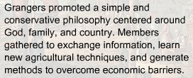
- Review the Grange and how it connects to the Populists by using the notes that accompany the video: http://nroc.mpls.k12.mn.us/US%20History%20II/course%20files/multimedia/lesson51/l51_t01.htm

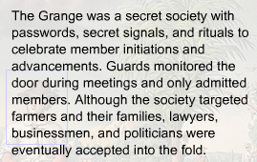
Review the main components of the Grange by analyzing the image.
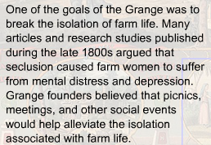
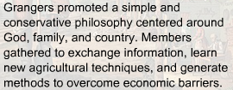
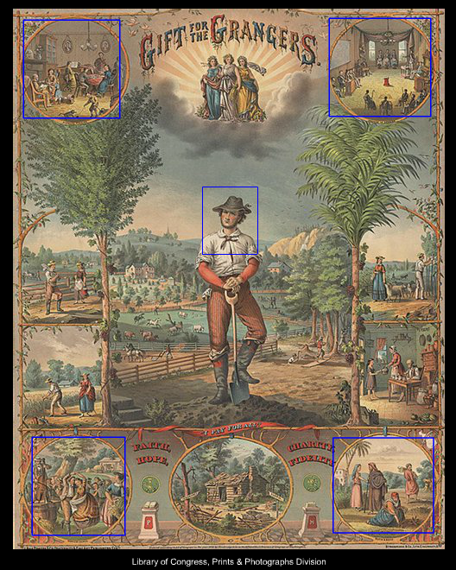
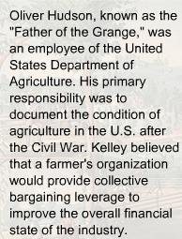
- Re-read chapter 19, pp 380-390, and then complete the review by answering the questions in the spaces provided. You may also have to reference chapters 16-18 for main ideas from Period 6.

- Identify and explain political, economic, and social consequences of closing the frontier.
Highlight cues and analyze the significance of the events by answering the questions in the spaces provided.

A striking manifestation of rural discontent came through the Farmers’ Alliance, founded in Texas in the late 1870s. Farmers came together in the alliance to socialize, but more importantly to break the strangling grip of the railroads and manufacturers through cooperative buying and selling. Unfortunately, the alliance weakened itself by ignoring the plight of landless tenant farmers, sharecroppers, and farm workers. Even more debilitating was the Alliance’s exclusion of blacks, who counted for more than half of the agricultural population of the South. | Was the Farmer’s Alliance successful? Why or why not?
Out of the Farmer’s Alliance a new political party emerged in the early 1890s – the People’s party. Better known as the Populists, these frustrated farmers attacked Wall Street and the “money trust.” They called for nationalizing railroads, telephones, and telegraphs; instituting a graduated income tax; and creating a new federal “sub treasury” – a scheme to provide farmers with loans for crops stored in government-owned warehouses, where they could be held until market prices rose. They also wanted the free and unlimited coinage of silver – yet another of the debtors’ demands for inflation that echoed continuously throughout the Gilded Age. | How “individualistic” were the Populists? Explain your reasoning.
Mary Elizabeth Lease was nicknamed “the Kansas Pythoness” and “Mary Yellin’.” She was an athletically built woman who made approximately 160 speeches in 1890 criticizing aristocracy, a government “of Wall Street, by Wall Street, and for Wall Street.” | What was the impact of this growing conflict between farmers and business on American society.

- How did the central government react to the changes of the Gilded Age?
Highlight cues and analyze the significance of the events by answering the questions in the spaces provided.

In the Pullman Strike (1894), The Pullman Palace Car Company was hit by the Depression and thus cut wages by about one third. The workers struck and paralyzed railway traffic from Chicago to the Pacific Coast. | How did the government react to the Pullman Strike?  How does this event characterize government?
Marcus Alonzo Hanna made his fortune in the iron business and later devoted his time and money into campaigning for future president William McKinley. Hanna believed that the core function of a government was to help business. | How is the role of government changing in the 1890s?
William Jennings Bryan, an orator from Nebraska, won the Democratic nomination for President in 1896 following his “Cross of Gold” speech. He was given the nickname “Boy Orator of the Platte” by a skeptic. He ran against William McKinley for the White House. It resulted in a McKinley win, starting an era of Republican rule for the next 16years. | Explain the message in the Cross of Gold speech. To what extent was this message a result of the plight of Westerners?  Why did Bryan lose?
Jacob Coxey led a march on Washington to demand unemployment aid from the government through inflation. (Coxey’s Army) | How did President Cleveland react to Coxey?  How does this event characterize government?
The Dingley Tariff proposed high new rates, but not rates high enough for some lobbyists who continued to nag the senate for increased rates. A ridiculous 850 amendments were added to the overburdened bill. The resulting average rate was 46.5%. | Compare the Dingley Tariff to the Wilson-Gorman Act of 1894.
- Analyze the impact panic and depression had on the nation, and assess the success of government response to the economic downturn.
- impact on farmers

- Impact on workers

- Impact on business

- Success of gov’t responses?
-repeal of Silver Purchase Act?

-borrowing from J.P. Morgan?

-military troops sent to end Pullman
Strike?

-government arresting Coxey’s army?

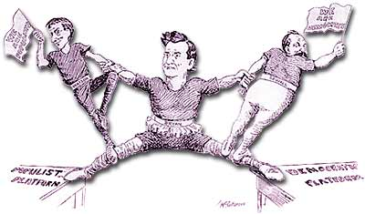
- Analyze the significance of he election of 1896.

Caption for cartoon from Chicago Tribune, 1896:
A great exhibition, but rather trying on the man in the middle." William Jennings Bryan is shown pulled in two directions as he campaigns on both the Democratic and the Populist Party platforms.

What did the Democratic Party and the candidate, William Jennings Bryan, seek?
Why did they lose?

IF YOU COMPLETED THE CHAPTER 19 READING GUIDE… THIS PAGE WAS INCLUDED IN THAT GUIDE!
- The Gold Standard Highlight cues as you read and review!
During the nineteenth century, U.S. currency was backed by both gold and silver—in other words, a dollar in silver, nickel, or copper coins or in paper money was guaranteed by the government to be convertible into a dollar's worth of either metal. As a result of this "bimetallic standard," the valuation of U.S. currency fluctuated wildly. Because the value of the two metals on the open market was constantly changing, speculators were able to turn a profit by selling their coins for more than their face value when the value of the metal exceeded its denomination. When the government flooded the market with silver coins, the price of silver dropped, citizens traded in their silver coins for gold, and federal gold reserves were exhausted. At the same time, prices of wholesale and retail goods saw a steady decline from the end of the Civil War through the 1890s, sending farmers and other providers of goods, whose fixed debts did not decline, into crisis. This chronic monetary instability was a large factor in the 1896 election of President William McKinley, who ran on a platform that included a change to a gold standard. In 1900 McKinley signed the Gold Standard Act, making gold reserves the basis of the monetary system. The gold standard remained in effect until 1933, when the economic pressures of the Great Depression—including gold-hoarding by a panicked citizenry—led the United States to abandon it, and legislation was passed that allowed the Federal Reserve to expand the supply of paper money irrespective of gold reserves.
Review the economic policies below by explaining each one’s purpose and impact on the American economy.

Legal Tender Act 1862 National Banking Act 1863
Purpose:

Impact on economy:

Purpose:

Impact on economy:

Coinage Act 1873 Specie Payment Resumption Act 1874
Purpose:

Impact on economy:

Purpose:

Impact on economy:

Bland Allison Act 1878 Gold Standard Act 1900
Purpose:

Impact on economy:

Purpose:

Impact on economy:

END OF REVEW PORTION OF GUIDE… NOW ON TO CHAPTER 21 AMSCO

- From Populists to Progressives… Connecting Units 5 & 6… (Periods 6 & 7)… Read pp 431-433

Key Concept --The continued growth and consolidation of large corporations transformed American society and the nation’s economy, promoting urbanization and economic growth, even as business cycle fluctuations became increasingly severe.

Answer the following questions by reviewing main events, defining terms, and analyzing significance in the spaces provided.
Highlight Cues.
Question: Identify the events that led to the Progressive Era, and explain who the Progressives actually were.
Answer/Main Events/Ideas | Definitions/Explanations – Your Notes | Analysis
The cause of the Progressive movement originated mainly in the radical changes in American society during the Gilded Age. As farmers and workers responded to these changes, states began reforming and eventually the federal government began addressing some issues. As cities grew, more individuals also tried to solve new problems.  - Granger Laws  - ICC  - Populist Party  - Jane Addams | Granger Laws…  ICC…  Populist Party…  Jane Addams… | To what extent did the Progressive Movement (Era) begin prior to Theodore Roosevelt becoming President in 1901? Defend your answer with one specific piece of evident.  Identify the event that ushered in the Progressive Era :  What event ushered it out?

Question: Explain the Progressive philosophy.

Answer/Main Events/Ideas | Definitions/Explanations | Analysis
Although waves of reform had swept the nation before, the 20th century Progressive Movement was unique in that is shifted away from prior philosophies.  - Adam Smith, The Wealth of Nations, 1776  - Transcendentalism, early 1800s  - Charles Darwin, Origin of Species, 1859  - William James & John Dewey, late 19th century  - Frederick W. Taylor, late 19th century | Philosophies before and during the Progressive Era:  Adam Smith, The Wealth of Nations, 1776…  Transcendentalism, early 1800s…  Charles Darwin, Origin of Species, 1859…  William James & John Dewey, late 19th century…  Frederick W. Taylor, late 19th century… | Compare and Contrast the Jackson era reform philosophies with the Progressive Era philosophies of reform. Identify one specific similarity and one specific difference.
- Read pp 434-443

Question: Identify and explain significant politicians within the Progressive reform movement and analyze the extent to which each successfully
accomplished their goals.

Answer/Main Events/Ideas | Definitions/Explanations | Analysis
The main goals of progressive reformers were to limit the power of big business, increase democracy among citizens, and increase social justice. There were many diverse groups and individuals that participated in this wave of reform, but not all were successful in achieving their aims.  - The Progressive Presidents:  Teddy, Taft, & Wilson  - William Jennings Bryan  - Robert La Follette  FYI-There were also many progressives that were not politicians. | Goals/Strategies  Teddy Roosevelt…  Taft…  Wilson…  William Jennings Bryan…  Robert La Follette… | Compare the goals of these progressives with the goals of Walter Rauschenbusch & the Social Gospel Movement.  To what extent was each politician successful in reforming the nation? Defend each answer with one specific example.  Teddy…  Taft…  Wilson…  Bryan…  Follette…  How did these progressives differ from Gilded Age leaders?
This page will be completed in class, but feel free to record notes as you read pages 436-439 and pages442-445.

Key Concept: Progressive reformers responded to economic instability, social inequality, and political corruption by calling for government intervention in the economy, expanded democracy, greater social justice, and conservation of natural resources.

Classify Progressive reforms during the Progressive era – during the terms of Teddy-Taft-Wilson (1901-1920) -- into municipal, state, and federal, and political, economic, social. As you fill in your chart, consider adding brief descriptions for future review.
Highlight the federal reforms during Wilson’s two terms.

 | Political | Economic | Social
Federal

State
Local

Key Concepts:
- In the late 1890s and the early years of the 20th century, journalists and Progressive reformers — largely urban and middle class, and often female — worked to reform existing social and political institutions at the local, state, and federal levels by creating new organizations aimed at addressing social problems associated with an industrial society.
- Progressives promoted federal legislation to regulate abuses of the economy and the environment, and many sought to expand democracy.

Analyze the historical significance and impact of the Muckrakers. Your answers should have specific examples of action taken. Be sure you have read the chapter before completing this section! Highlight your cues.

Muckraker Examples | Historical Significance and Impact on Era
Written in 1899 by Thorstein Veblen, Theory of the Leisure Class was a savage attack on “predatory wealth” and “conspicuous consumption.” In Veblen’s view the parasitic leisure class engaged in wasteful “business” rather than productive “industry.” The book thus criticized this aspect of consumerism, social order, and economic status. | The impact on Progressivism was…
In 1890, Jacob Riis shocked middle-class Americans with How the Other Half Lives. It was a damning indictment of the dirt, disease, vice, and misery or the rat-gnawed human rookeries known as New York slums. | The impact on Progressivism was…
Enterprising editors financed extensive research and encouraged pugnacious writing by their bright young reporters, whom President Roosevelt branded as “muckrakers” in 1906. Despite presidential scolding, these muckrakers boomed circulation and some of their most scandalous exposures were published as best-selling books | The impact on Progressivism was…
Theodore Dreiser’s novels, The Financier and The Titan portrayed the avarice and ruthlessness of an industrialist. | The impact on Progressivism was…
In 1902, a brilliant New York reporter, Lincoln Steffens, launched a series of articles titled “The Shame of the Cities”. He fearlessly unmasked the alliances between big business and municipal government. | The impact on Progressivism was…
Ida Tarbell earned a national reputation for publishing a scathing History of the Standard Oil Company. With this publication, she criticized Rockefeller over monopolizing the economy through his oil company. Two years later she teamed up with other muckrakers in purchasing the American magazine, which became a journalistic podium for honest government and an end to business abuses. | The impact on Progressivism was…
Along with his fellow muckrakers of the time, Ray Stannard Baker entered the industry of American publishers who sought to expose the country’s evils. In his book, Following the Color Line, published in 1908, Baker described the social evil of the subjugation of America’s 9 million blacks. One third of the black population was illiterate and 90% lived in the segregated south. | The impact on Progressivism was…
The Jungle (1906) was a sensational novel written by Upton Sinclair. He intended his revolting tract to focus attention on the plight of the workers in the big canning factories, but instead it appalled the public with his descriptions of disgustingly unsanitary foods. By publishing this novel, he informed the public on the horrible conditions of the factories. | The impact on Progressivism was…
Summarize the impact each of the following events had on Progressivism. Your answers should be complete thoughts with specific examples. Highlight your cues.

The Triangle Shirtwaist Company Fire involved a company that did not follow the fire code and locked its doors. As a result, 146 workers, mostly immigrant women, died in the fire or jumped from windows. It led to more restrictive, protective laws. | How did cities respond?
The Anthracite Coal Strike of 1902 occurred when a crippling strike broke out in the anthracite coalmines of Pennsylvania. Many of the immigrant miners, who had been exploited and accident-plagued, demanded an increase in pay and a reduction in work hours. Though the wealthy mine owners initially refused to meet these demands, they reluctantly complied after President Roosevelt threatened to operate the mines with federal troops. | What does this incident illustrate about the Progressive Era?

- Analyze the historical significance and impact of women during the Progressive Era. Highlight your cues.

Jane Addams and Frances Kelly not only created and spread the Settlement House movement which battled the social ills of inner cities, they also lobbied state legislatures for better schools, juvenile courts, safety regulations for tenements and factories as well as women’s rights. | In what ways did public education improve during the Progressive Era?
Florence Kelley (1899) became the state of Illinois’s first chief factory inspector and advocated imposing factory conditions. She took control of the National Consumers League, which mobilized female consumers to pressure for laws safeguarding women and children in the workplace. | Explain the shift in the role of government during the Progressive Era regarding consumers?
Ida B. Wells was an African-American journalist, newspaper editor and, early leader in the civil rights movement. She documented lynching in the United States, showing how it was often a way to control or punish blacks who competed with whites. She was active in the women's rights and the women's suffrage movement. | What progress was made during the Progressive Era regarding anti-lynching laws?
Founder Frances E. Willard built the militant organization, the WCTU (Woman’s Christian Temperance Union) to support antiliquor campaigns. Willard supposedly would fall to her knees in prayer on salon floors and mobilized almost 1 million women to “make the world more homelike.” Ultimately, the WCTU became the largest organization of women in the world. She also fought for women’s suffrage, insisting women to seek enfranchisement and they seek freedom from alcohol and the right to vote. | Why were so many suffragettes also fighting for temperance?
Carrie Chapman Catt took over the NAWSA, National American Woman Suffrage Association in 1900. She changed the strategy of the organization from seeking state laws permitting women’s suffrage to targeting the federal government for an amendment. She argued that women needed the vote in order to better care for their families in the new, industrial, complex society. | Following the 19th Amendment, how did Carrie Chapman Catt continue her fight for reform and gender equality?
…continued from previous page…

Analyze the historical significance and impact of women during the Progressive Era. Highlight your cues.

Alice Paul broke away from NAWSA and began a more militant campaign in the fight for women’s suffrage. She led picketing and parades in Washington D.C., was publicly harassed, arrested, and went to jail with some of her colleagues, including Lucy Burns (1917) for obstructing traffic. In jail she went on a hunger strike and was force fed. The violent way she and her peers were treated helped, finally, to get the attention of top government officials including President Wilson. | Following the 19th Amendment, how did Alice Paul continue her fight for reform and gender equality?

Question: Compare the strategies and accomplishments of Washington and Dubois during the Progressive Era. Highlight your cues.

When analyzing, keep the learning objectives for the reading assignment in mind:
-Evaluate the changing role of government along with the contributions of progressive citizens illustrated by political, economic, and social reforms at the local, state, and federal levels.
-Analyze the extent to which the Progressive Era was actually progressive.

Booker T. Washington | W.E.B. Dubois

Explain the need for and purpose of the National Urban League, formed in 1911.

Compare and contrast Roosevelt and Taft’s Progressivism. Your Venn should have specific examples as well as generalizations.
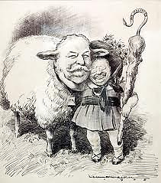

In the image on the previous page, Taft is portrayed as a sheep and Roosevelt as Mary. (Mary had a little lamb). Explain the message and significance of this political cartoon in relation to the similarities and differences between the two Presidents.

Was Taft a good “lamb?” Explain your answer.

- Identify the ruling and significance of the court rulings listed below. Some of these cases may not be in your text.

Pollock v. The Farmers’ Loan and Trust Co. (1895)

The Court Ruled…

Which was historically significant because…

U. S. v. E. C. Knight Co. (1895)

The Court Ruled…

Which was historically significant because…

In Re: Debs (1895)

The Court Ruled…

Which was historically significant because…

Plessy v Ferguson (1896)

The Court Ruled…

Which was historically significant because…

United States v. Wong Kim Ark (1898)

The Court Ruled…

Which was historically significant because…

…continued from previous page…

Identify the ruling and significance of the court rulings listed below. Some of these cases may not be in your text.

"Insular Cases" / Downes v. Bidwell (1901)

The Court Ruled…

Which was historically significant because…

Northern Securities decision (1904)

The Court Ruled…

Which was historically significant because…

Lochner v. New York (1905)

The Court Ruled…

Which was historically significant because…

Muller v. Oregon (1908)

The Court Ruled…

Which was historically significant because…

Hammer v. Dagenhart (1918)

The Court Ruled…

Which was historically significant because…

Schenck v. U. S. (1919)

The Court Ruled…

Which was historically significant because…

Of the cases you reviewed on the previous two pages, which court case had the greatest impact on the level of success reached by the Progressives?
Explain your answer.

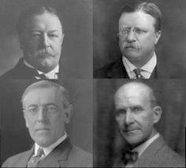

- Analyze the significance of the election of 1912.

Identify the four political parties and nominees in 1912.

Explain why Theodore Roosevelt challenged his hand-picked successor.

What was the outcome?

How did the goals of the Socialist Party differ from the other three?

What impact did the Socialists have on the Progressive Era?

What happened to the Progressive and Socialist parties after this election?

- To what extent were the progressive actions of Woodrow Wilson a significant turning point in U.S. history?

Extent? _____________________ For what reasons?________________________, ___________________________, ______________________

Evidence organized by theme/reason – two examples minimum per category
1.  2. | 1.  2. | 1.  2.

Read pages 446-447

- To what extent was the Progressive Era a reaction to the rapid industrialization of the late 19th century and early 20th century? Write a complete thesis/introduction including historical context, your argument, an opposing view, and three clear categories/reasons.1

Reading Guide written by Rebecca Richardson, Allen High School
Sources include but are not limited to: 2015 edition of AMSCO’s United States History Preparing for the Advanced Placement Examination, 2012 and 2015 Revised College Board Advanced Placement United States History Framework, public domain images, The Regents of the University of California , and other sources as cited in document and collected/adapted over 20 years of teaching and collaborating

