November
2017
TRUE LIES
The Stuart Rod & Reel Club Newsletter
The Stuart Rod and Reel Club is dedicated to improving local fishing through by increasing angler knowledge, encouraging conservation and maximizing the fun involved in light tackle fishing in the Stuart Florida area. We hold monthly meetings on the second Thursday of each month, year-round. Please join us or contact any board member for more information on how you can become a member of the Stuart Rod and Reel Club.
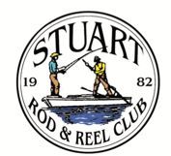

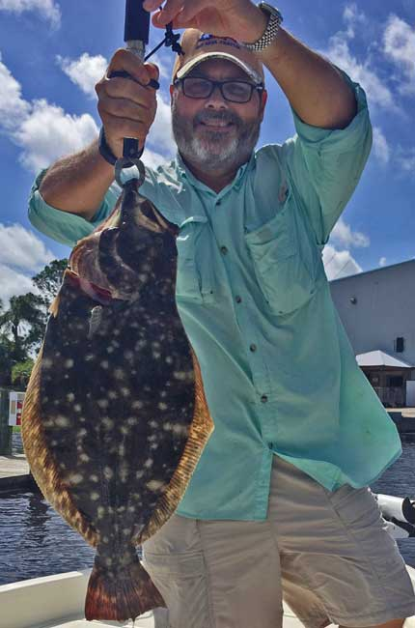
New member Dan Doherty caught this fine southern flounder while fishing with Membership Director Eric Rosenberg. A good start at the Stuart Rod and Reel Club!
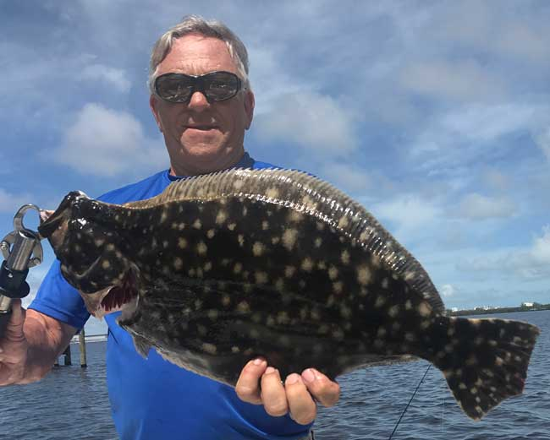
Not to be outdone, Jerry Hoge caught this monster southern flounder in the convenient doormat size. It was good eating at the Hoge household that evening.

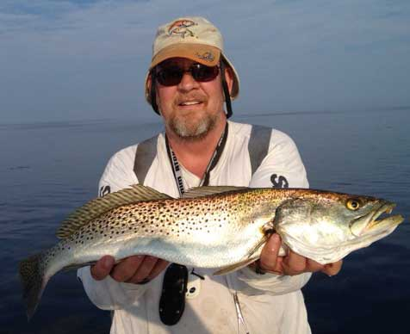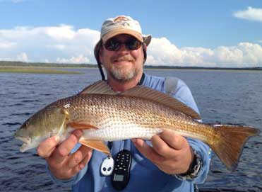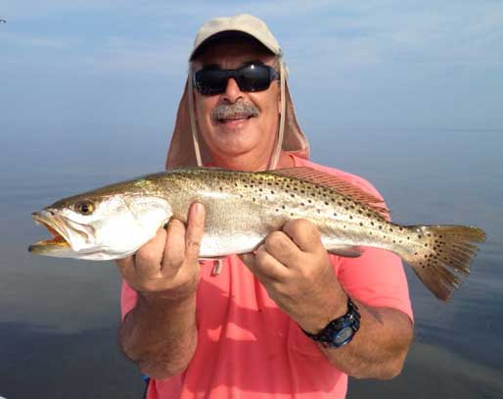
Chris Hope (above) and his longtime friend XXXXXX went up to Steinhatchee for some open water trout and redfish action. Just watch out for the car-sized boulders when fishing that area. The rocks there are propeller and skeg killers. This is a beautiful old Florida area that remains unspoiled although a few condos are going in now.
FRIENDS IN PINK-REEL ANGLERS WEAR PINK CHARITY EVENT OCTOBER 22, 2017
On October 22nd, The Stuart Rod and Reel Club and the Port St. Lucie Angler’s Club held a charity fishing event at the Port St. Lucie Botanical Gardens in PSL. A large number of members from both clubs participated. Jim Bohrer and Curtis Clark of PSL Angler’s Club put together a large number of lottery prizes and door prizes. The winner from each club (largest fish, regardless of species) won an offshore fishing trip. Shelly Bowdish was our winner with a nice 13 ½ inch largemouth bass caught on a six-inch Strike King plastic worm with 15-pound fluorocarbon leader.

Jim Bohrer was able to get charter trips from Capt Mark Nichols, Capt George Gozdz and Capt. Mark Dravo for the paid ticket lottery. Outboards Only donated a $650 gift certificate for a complete single engine service along with discount coupons. DOA donated lures and shirts in hot pink colors. T& A Jigs donated fabulous pink jig heads. Snook Nook generously donated rods, reels, a pink Yeti small cooler and other wonderful items.
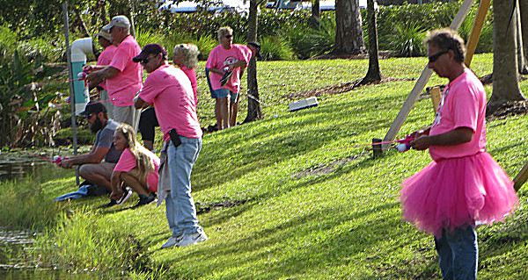
A group of anglers, fishing the bank. They threw everything from cut hot dogs to earthworms to plastic worms to Rapalas to weighted flies. Live bait ruled the day.
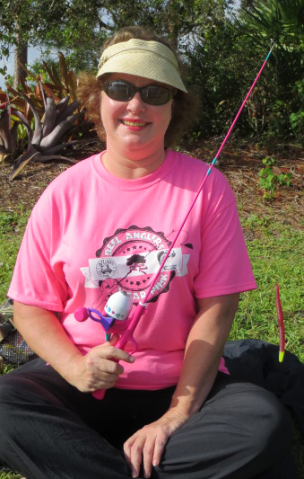
Shelly Bowdish with the 6-inch Strike King plastic worm that found the biggest bass of the day. She was a little discouraged at the half-way point with no strikes, but she kept working until a big bass showed interest. Shelly and three guests will share an offshore trip out of Port Salerno, donated by Manttanza Charters.
Shelly is an experienced bass fisher and knew how to keep using that lure. The worm was a copper penny color with a chartreuse tail, rigged weedless Texas style.

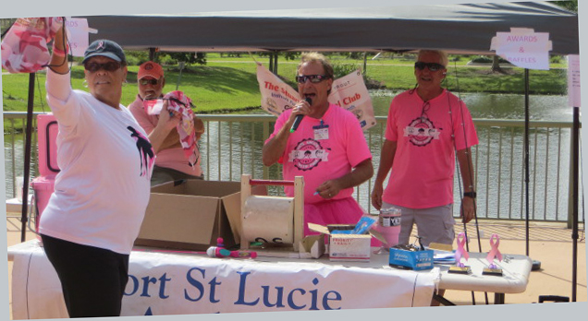
The auction tent featured a host of prizes. The theme was pink and many of the lures, shirts and coolers shared the color that signifies Breast Cancer Awareness

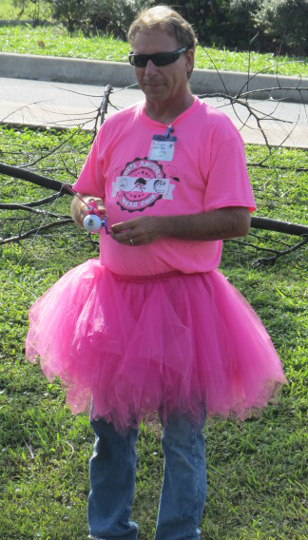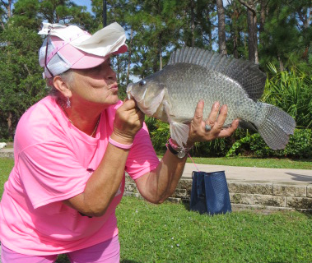
This colorful lady from the Port St. Lucie Angler’s Club won the overall award for a 16 ½” tilapia caught on an earthworm. This was the biggest fish of the day. She also won an offshore trip from Manttanza Charters.
Curtis Clark did a wonderful job putting together this first annual event. He worked tirelessly to get sponsors and the co-operation of a number of disparate groups. He organized the event, got the volunteers and even ran the auction. His fellow club members demanded that he wear this pink tutu and he did it with good humor and style. Curtis put in a stellar effort for a great cause. Jim Bohrer used his extensive knowledge of fishing captains and vendors to get additional items that made this event a great success.

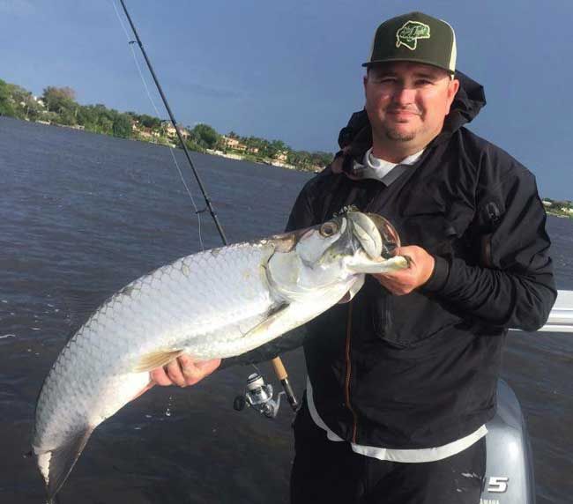

Capt. James Cronk wasted little time after return from guiding in Alaska this summer. In addition to these nice fish, his team won the recent Michael Shields fishing tournament. His team caught 3 tarpon, 3 redfish, 3 snook and 3 trout; the only team to do so. They also caught the biggest fish on a fly. Congratulations!
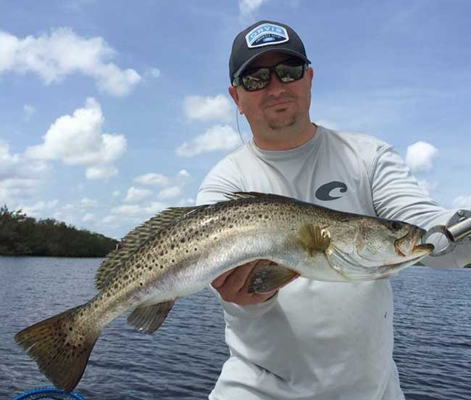

STUART ROD AND REEL CLUB OFFICIAL SLATE OF CANDIDATES FOR THE 2018 BOARD OF GOVERNORS:
This is the official of slate of governors/directors for the calendar year 2018: The election will be held at the November general membership meeting.
President | Jim Bohrer
Vice President | Jim Bowdish
Treasurer | Pete Noll
Secretary | Fred Bartlett
Director |  | Roy Buckley
Director |  | Jerry Hoge
Director |  | Frank Miller
Please attend the November meeting when the vote will be held.
REMEMBER TO RESERVE YOUR PLACE FOR THE STUART ROD AND REEL CHRISTMAS PARTY.
It will be held at the Dolphin Bar and Fish House in Jensen Beach on DECEMBER 9th at 6PM. A reservation form is attached as a separate document. Please get your form with payment in as soon as possible.

Date | Outing/Event | Details | Host/Food Service | Rules
November  10,11,12 | Local Redfish | Longest Overall Redfish | Sandsprit Park 1:00 PM, Nov 11th. | Longest total length
December 9 | Christmas Party | No Outing | Dolphin Bar & Fish House Jensen Beach | No Outing.

All Stuart Rod and Reel Club Outings are based purely on the Honor System. All scheduled Club Outings will be “Daylight Outings”. You can fish any of the dates listed above. Event will begin at the first safe light in the morning with lines out of the water by 1PM. Scores must be turned into the Angling Director or other board member by email, phone or verbally by 2 PM local time on the day after the event.  Natural Bait (alive or dead) is allowed except for March, May and July. Bait restriction is in effect for September.  Guests and spouses are invited to attend the food services on Saturday at Sandsprit Park. For food at restaurants, guest and spouses will be charged for their meal and beverage costs. | Family members under the age of 18 must be accompanied by a parent or legal guardian to participate in an outing. While guests are always welcome to join members during our outings, you must be a paid member of the Stuart Rod and Reel Club to be eligible to win an outing. Outing scores shall be published in the Club’s Newsletter following the Outing. Outings cancelled due to weather shall be rescheduled for the following weekend. Outing result disputes shall be settled by the Angling Director.  OUTING SCHEDULES AND RULES MAY CHANGE DURING THE YEAR.  FISHING BOUNDARIES  Boundaries will extend from the south shore of the Jupiter Inlet to the North Vero Beach Bridge.

2017 TOURNAMENT OUTING SCHEDULE
Support our Advertising Sponsors
We are very fortunate to have many local businesses that advertise on our web site and provide additional sponsorship support to the Club. These businesses provide a wide range of products and services for the entire community. Whether you are looking for lodging, restaurants, fishing supplies, boat repair and restoration, guide services, legal services, or roof repair our sponsors deserve your consideration. You can learn more about these businesses by visiting our website at www.stuartrodandreel.com. Click on the advertiser’s tab and you will find a brief description of our sponsors with contact information and links to their websites. Make our advertising sponsors your priority when shopping. Please let them know that you learned about them through the Stuart Rod and Reel Club and that you appreciate their support.

Bait & Tackle  - Crowder Rods  - D.O.A. Lures  - Fish Heads of Stuart  - Snook Nook  - Treasure Coast Rod and Reel  - White's Tackle  - T & A Jigs, Inc. | Area Lodging  - Marriott - Hutchison Island Resort
Area Dining  - Big Apple Pizza  - Crawdaddy’s  - Dixie Grill  - Manatee Island Bar & Grill  - Manero’s Restaurant  - Polka European Deli  - Rancho Chico  - Shrimper’s | Guide & Charter Services  - Cajun Fishing Adventures Louisiana  - Catch 22 Charters Florida  - The Fish Intimidator Louisiana
Marine Products & Services  - C&H Trailer  - Manatee Marina  - Marine Customs Unlimited  - Marine Parts Outlet  - Master Repair  - Metco Marine Electronics  - Outboards Only  - Sailfish Marina  - Stuart Propeller  - Treasure Coast Battery & Alternator | General Business  - Capps Roofing  - Inn of the Dog  - Plaza 95 Marathon, Dairy Queen and Highway Café  Professional  - Crary Buchanan Attorneys

MEMBER’S INFORMATION
MONTHLY MEMBERSHIP MEETINGS WITH SPEAKERS: The monthly membership meeting is the second Thursday of the month. Our home port is The Quality Inn/Flanigan’s Bar & Grill located at 950 SE Federal Hwy. (US 1) Stuart, FL. We have the privilege of listening to many fishing industry and conservation leaders in the Southeastern Florida region. These experts include tackle manufacturers, tournament winning Captains and guides, television and print journalists, and academic researchers. We have a guest speaker from this pool at each monthly meeting. Speakers will address topics of interests such as how to fish for the upcoming outing’s targeted species and our diverse estuary system. This is a great way to gain additional local knowledge of this fishery. Dinner begins at 6PM with Meeting at 7 PM.

MONTHLY OUTINGS: The Club sponsors a fishing outing each month. All outings are based on an Honor System. You don’t have to keep your catch or take a picture of it either. Outings are scheduled for the weekend following the general membership meeting. Outings are usually three day events where anglers select to fish Friday, Saturday or Sunday. Most outings are scheduled from first safe light till 1PM. The targeted fish and scoring change from month to month with interesting twists such as more points for one species than another. The intent is to have fun! The winner of each monthly outing receives a Club logo embroidered fishing shirt. As part of the outing we have several lunches at restaurants along with club and family cook-outs. Additionally, the Board is encouraging members to partake of the lunch regardless of the day fished. These are no-cost events. With two away outings and the remainder based at Sandsprit Park, there is opportunity to participate without travelling around the state. Frank Miller as the Angling Committee Chairman will also consider your ideas about other outings in other parts of the state. This year’s outing schedule was developed to increase participation, emphasizing the fun of fishing. You are able to view the schedule in every edition of True Lies.

NEWSLETTER: We publish a newsletter, True Lies, each month. It is circulated by e-mail. We are constantly looking for your fishing reports, pictures, recipes, and any other Club related information for inclusion. Submitting information is easy. You can send an e-mail to Jim Bohrer (halieutics@gmail.com).

WEB SITE: The Club’s web site (www.stuartrodandreel.com) is a wealth of information. You can find the latest weather and tides, fishing tips and information on our advertisers/sponsors.

RAFFLE: An activity at our membership meetings that generates a great amount of interest is the “Raffle”. Tickets are $1 each or 6 for $5. Raffle prizes vary monthly but usually include a fishing rod, reel or combination. Other prizes have been tackle bags, boxes, pliers, lures and boating accessories. Your purchase of raffle tickets gives you a good chance of winning and helps support the activities of your club.

MEMBER DISCOUNTS: Your Club membership can help you to save some money. White’s Tackle offers a 10% store discount on all purchases. Be sure to mention that you are a current member of the Stuart Rod and Reel Club and that you appreciate the support that they give the club.

to
2018 Annual Dues
Fully paid memberships begin the first day of January, and end on the thirty first day of December of each calendar year. An individual membership is one adult 18 years of age or older. Family memberships consist of the member, their spouse or significant other and their children under the age of 18.

Individual membership for a Full Year is $80.00

Family membership for a Full Year is $95.00

Send your checks payable to:
Stuart Rod and Reel Club, Inc.
c/o Pete Noll, Treasurer
1888 S. W. Mooring Dr.
Palm City, FL 34990
Membership entitles a single person (or family as applicable) to participate in all outings and to enjoy a meal at every local outing. Members also receive an included meal (with soft drinks) at Shrimper’s and Manatee Island Grill on the appropriate dates. We hold monthly meetings with interesting speakers and share information on where and when to fish in our area.

GUEST SPEAKER FOR NOVEMBER
Captain Carl Eby of Fintastic Charters will be our featured speaker for November. Captain Eby fishes out of the Snook Nook in Jensen Beach. He specializes in inshore tarpon, trout and redfish. He will speak about our area and his favorite D.O.A. lures and techniques.
Please join us at the November general membership meeting to learn from the experienced Captain Carl Eby.
2017 SRRC Fish
of the Month Contests
The Fish of the Month Contest will run from the day after the monthly membership meeting and end at 12 Noon the day of the following meeting. All fish need to be legal size except for Snook that must be 24-inch minimum. Natural bait (live or dead), artificial lures and flies are allowed. The member catching the most fish will be the monthly winner. The monthly winner will receive a monogrammed club hat.
Date | Species
Jan 13 thru  Feb 09 | Snapper, Bluefish
Feb. 10 thru Mar. 09 | Most Pompano
Mar. 10 thru April 13 | Most Snook
April 14 thru May 21 | Largest Trout
May 12 thru June 18 | Most Snook
June 19 thru July 13 | Most Redfish
July 14 thru Aug 10 | Most Trout
Aug. 11 thru Sept 14 | Most Tarpon Caught and Released
Sept. 15 thru Oct 12 | Largest Snapper
Oct. 13 thru Nov 9 | Largest Redfish
Nov 10 thru Dec 13 | Most Black Drum

The Winner of the Year Overall will be the person catching the most total species during the calendar year. The overall prize is a $50 gift certificate to White’s Tackle in Stuart.

