Sunday Club
at home
Hi Everyone!
Hope you are all well and safe.
We are at the beginning of the Journey towards Easter which is called Lent. During lent we are linking the Sunday Sheets with our Lent in a bag which you have either received or collected from Church. We will be exploring the stories that make up our understanding of lent.
So…. let’s Explore the first story.
Jesus in the Wilderness
https://www.youtube.com/watch?v=P-6a25Yo2wE&fbclid=IwAR3Y8w438jYATbgAX51zPYdHLdrh8Yeovi5_me0p1xBPovTXjYSHOJLUV-E
Story
The Story of Jesus in the lonely wildness
(for older Children)
Jesus had been baptised and after his baptism he went out into the Desert to be alone.
It was lonely in the desert, there was just Jesus, Sand, a few shrubs and the wind which would get very blowy at times.
Jesus was in the desert for 40 days and 40 nights.
He scratched around at the ground with his cracked dry fingers. He scratched at the dirt and the pebbles and the sand. He drew shapes in the sand and circles and lines, he was doodling. He was thinking. He was praying. He was Hungry! For forty days he had fasted, he had been told when he was growing up that fasting helped clear your mind and brings you closer to God. All these things were true and Jesus had felt them. But he had gone forty days without food. Forty days in the desert. Forty days alone. Forty days to think about and decide how he was going to do what God wanted him to do. Forty days to consider what it meant to be the saviour of the world! But fasting also makes you feel sick- sick with a Hunger aching belly, screaming feed me!! maybe that is why he felt all alone.

I Wonder …
- How you would feel sitting in the desert all alone for forty days and forty nights when the days were hot and dry and the nights were cold and windy.
Jesus stayed there just as God wanted, to try and make sense of what he had to do. Even at this stage Jesus knew he would die as this was part of Gods Plan.
I Wonder …
- What you would do or what you would feel, lonely, tired, upset at times, or even fed up. Nothing to see except sand and nothing to do except to think and pray.
- What you would do if you were hungry, there was no McDonalds or Subway just Sand, Sand and more sand!!
For younger Children.
Let’s Go!
After Jesus was Christened, he went straight out into the desert. That might seem like an odd place to go because, as you know, deserts are

very hot, and there isn’t any food or water or a place to stay. But Jesus needed to get away by himself and be somewhere quiet and lonely. He needed to be with his heavenly father to get ready for his new life.
In the desert, Jesus thought about the secret rescue plan he had made with God. Before the foundation of the world, they both knew what would have to happen. To rescue God’s Children, Jesus would have to die. here was no other way. It’s the reason he had come.
I Wonder...
- How you feel when you are hungry?
- When you are cold or tired?
l think Jesus must have felt all these things and lots more.
l wonder …what will happen?
Next week ……
We will find out!

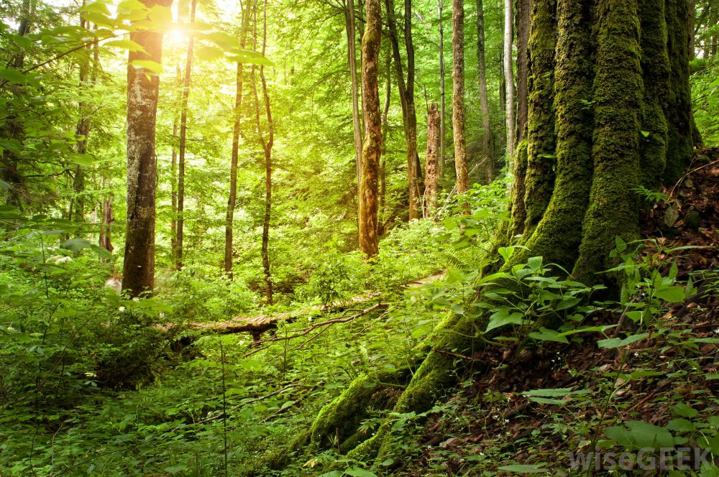
The Wilderness is very different in different countries.
You might have been somewhere like this in this country, maybe in the Lake District or in a wood.
When you go deep into the wood you feel alone and you can hear every little noise, and because you are alone those noises seems very loud and frightening.
I wonder …If you have ever been in a place like this and felt scared?
This is probably what the wilderness looked like to Jesus. It looks a bit like a very big beach. It looks like there is nothing there, but there will be

insects and other small animals that live in that sort of a place, it is very lonely.
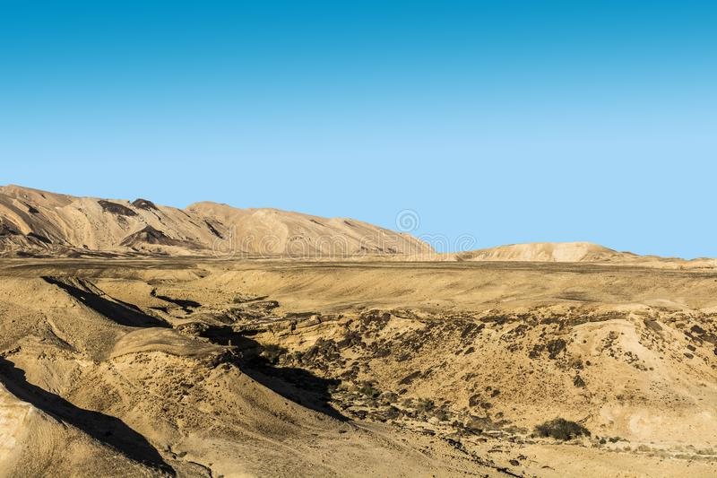
l wonder….
- If it is scary at night?
- Where you would stay?

- Songs
The whole world in his hands
https://www.bing.com/videos/search?q=videos+of+the+whole+world+in+his+hands&docid=608048867390197210&mid=F648C4C318BAD67600F9F648C4C318BAD67600F9&view=detail&FORM=VIRE
God Loves Me
https://www.bing.com/videos/search?q=gods+love+videos+&&view=detail&mid=45FDBF3AE34BB5F557A345FDBF3AE34BB5F557A3&&FORM=VRDGAR&ru=%2Fvideos%2Fsearch%3Fq%3Dgods%2Blove%2Bvideos%2B%26FORM%3DVDRESM
- Prayer time
Take the bottle of Sand out of your bag, get a plate or a lid and pour the sand onto it.
Then with your finger draw something in the sand, just as Jesus did in the story. Every time you draw something you can rub it out and draw something new.
Jesus does this when we get things wrong if we say we are sorry then he wipes it all clean just the way you can do with the sand.
Think about anything that you might have done wrong this week, now draw a picture to show what you have done, then say you’re sorry to God and wipe the picture away.
When you have finished put the sand back in the bottle and you can use it again.
Celebration Prayers
Now ...Let’s celebrate what has gone well this week, what have you enjoyed, and what are you thankful for? It’s time to say Thank you.
You will need: Bubbles
If you haven’t got any bubbles you can make some with washing up liquid and water.
- What to do
Blow a bubble and think about what you want to say thank you for. Then keep going until you have said thank you for everything.
Activities
- Sand play
If you have access to Sand you could make a desert yourself and put a Lego man or a wooden person in the sand, what would you have in your desert…. l wonder? You could make a very small desert using the bottle of sand.
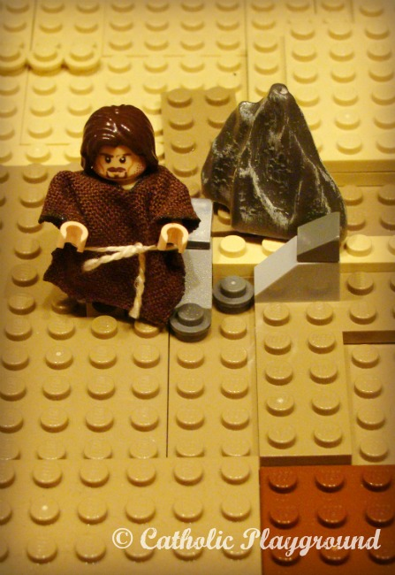
- Lego Desert
If you have some Lego you could make a Lego desert and put your Lego people in the desert. Then add what else you think should be in the desert.

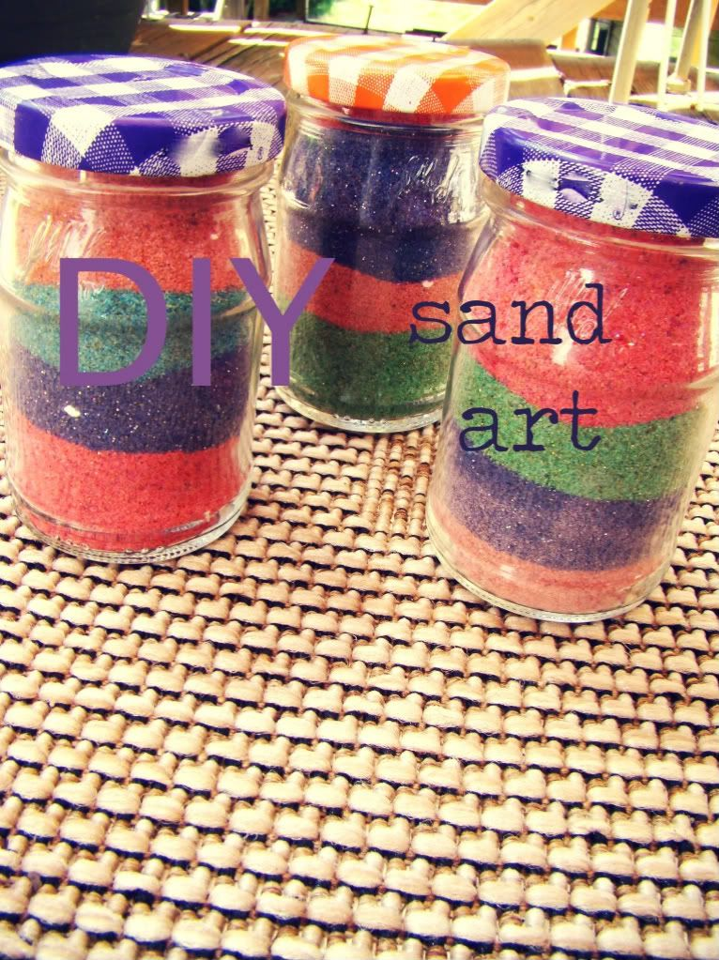
Make a sand Jar
You will need
- dry sand
- food colouring
- a Jar

What to do
Spread the dry sand on a tray and add the food colouring spread it out to dry (it will take a while)
Repeat with as many colours as you want.
If you haven’t got any sand use rice instead and use the same method to colour it.
You can put this on a shelf to help remind you of the story of Lent and Jesus in the desert.

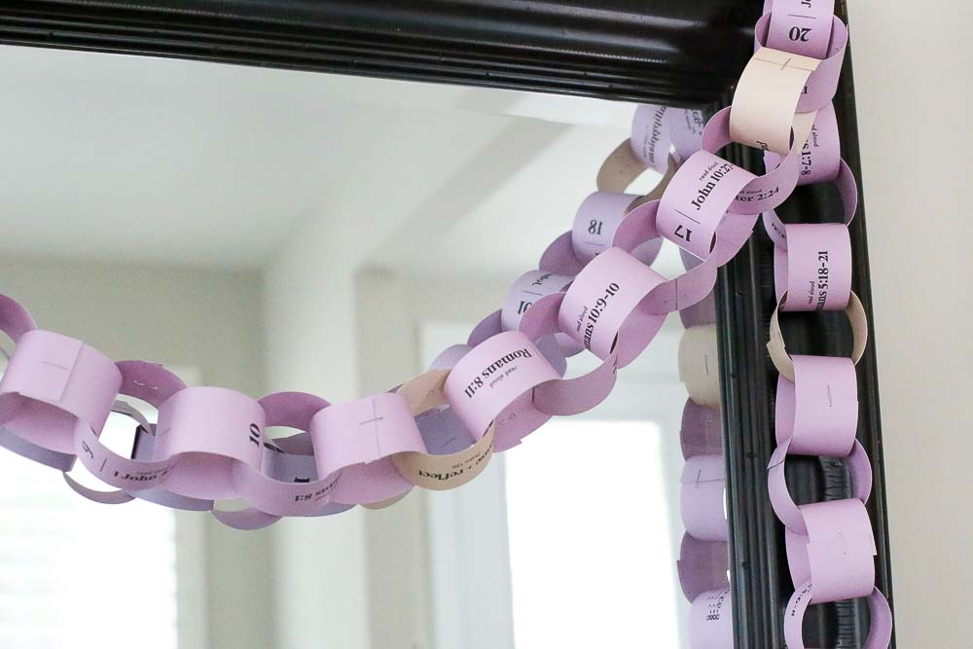
Make a paper Chain of Prayers
Things you want to remember during lent.
You will need
- Paper
- Glue
What to do
Take your paper and cut it into long strips.
Then write on the strips what you want to pray for or what you want to remember.
One every day in lent as you finish writing on one make it into a circle and glue for the first one then the next one needs to be looped through the first one and then glued.
You will end up with a paper chain that you can put up for Easter and decorate it as you go.

