RSAI Legislative Update
Jan. 19, 2023

In this RSAI Weekly Report from the 2023 Legislative Session, find information about:
- School Choice Committee Action in both Chambers
- State Budget Impact of HF 68/SF 94
- Governor’s Budget Recommendation: Highlight on Surpluses
- Subcommittee Action on Other Bills
- Bills Introduced and Subcommittees Assigned
- Advocacy Action Steps for This Week
- Links to Advocacy Resources
- Members of the House and Senate Education Committees and the House Education Reform Committee
Quick Committee Action in House and Senate on School Choice: Bills (new numbers) are being considered in the House HF 68 and Senate SF 94 on Education Savings Accounts. Action is expected next week in both House and Senate Chambers.
Having been considered and approved on party lines by the Senate Education Committee on Jan. 18 and the Senate Appropriations Committee on Jan. 19, SF 94 (formerly SSB 1022) moves to the Senate Calendar. The bill could be referred to the Senate Ways and Means Committee since the Education Savings Account payment is exempted from Iowa income tax in the bill.
In House Committee action, following Tuesday’s public hearing, the Education Reform Committee met on Wed., Jan 18 and approved HF 68 (formerly HSB 1) on party lines.
HR 3, also on the House Calendar, exempts bills from the Education Reform Committee from Appropriations and Ways & Means steps, meaning the House could debate early next week as well.
See the updated RSAI Call to Action from 1/19/2023, with updated key messages and links to legislator contacts. See the Jan. 13 RSAI Weekly Report for a bill description and some technical concerns. RSAI is registered opposed.

State Budget Impact of HF 68/SF 94: Note: the LSA’s Fiscal Note is not yet complete, so this analysis is our best estimate based on the Governor’s Budget Brief and Governor’s staff communications to the media.
The bill creates a standing unlimited appropriation, which means that for every Education Savings Account granted, the state will appropriate $7,598. The bill contains no caps on enrollment, so whatever number of eligible requests are granted, will be funded.
In the fiscal year following receipt of an ESA, the school district of residence will count the private school student in fall enrollment for purposes of categorical funding for TSS, PD, EICS and TLC. This is estimated to generate $1,205 on average per private school student with the ESA for school districts of residence.
School districts retain spending authority for the first year after the student enrolls in the private school with the ESA. The Oct. 2023 headcount will show the reduction in public school enrollment. The July 1, 2024 fiscal year will realize the funding reduction, estimated at $10,500 per public school pupil using the ESA to attend private school. After the $1,200 categorical funds retention, the net is a loss of $9,300 per pupil. State impacts, the estimated number of students participating and eligibility criteria are included in this table. FYI: for the 2022-23 school year, there are 33,075 K-12 student enrolled in accredited nonpublic schools.
Fiscal Year | Annual est. Approp (in millions) | Cumulative Total est. Approp | Annual Students with ESA | Cumulative Total Students | Eligibility
2023-24 | $106.9 | $106.9 | 14,068 | 14,068 | All kindergarten, All Public, Current Privates < 300% FPL
2024-25 | $156.2 | $263.1 | 5,995 | 20,063 | All kindergarten, All Public, Current Privates < 400% FPL
2025-26 | $313.9 | $577.0 | 19,989 | 40,052 | All K-12 Students
2026-27 | $341.0 | $918.0 | 2,948 | 43,000 | All K-12 Students

Governor’s Budget Recommendation Highlight on Surpluses:
(source LSA’s Preliminary Analysis of the Governor's Budget and Recommendations — FY 2024)
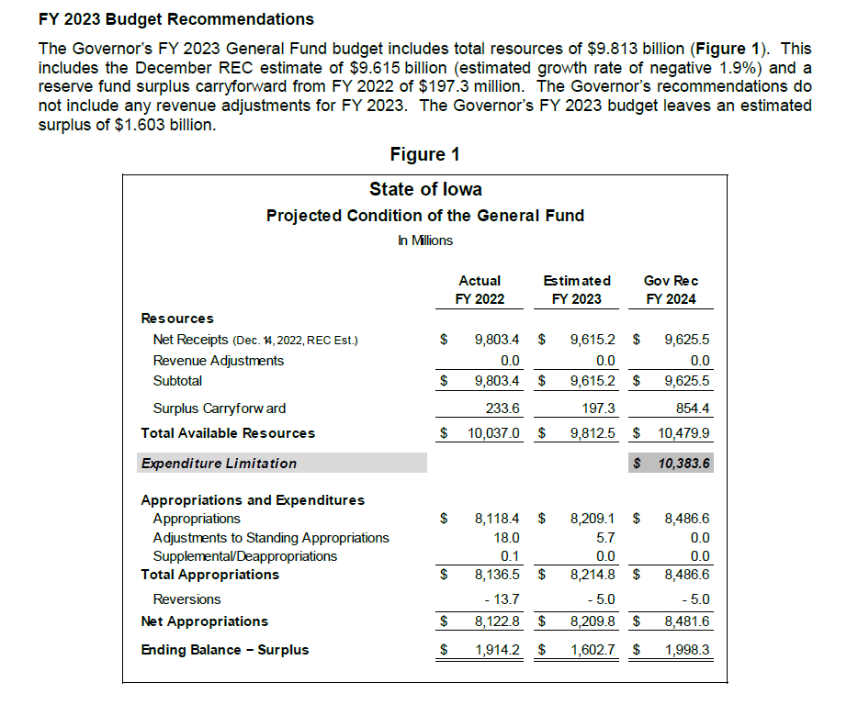
The Governor’s FY 24 Estimated Budget Recommendation leaves a surplus of $1.998 Billion, since the total appropriated general fund dollars are well below the expenditure limitation.
Figure 3 shows the combined state reserve funds approaching $1 Billion:
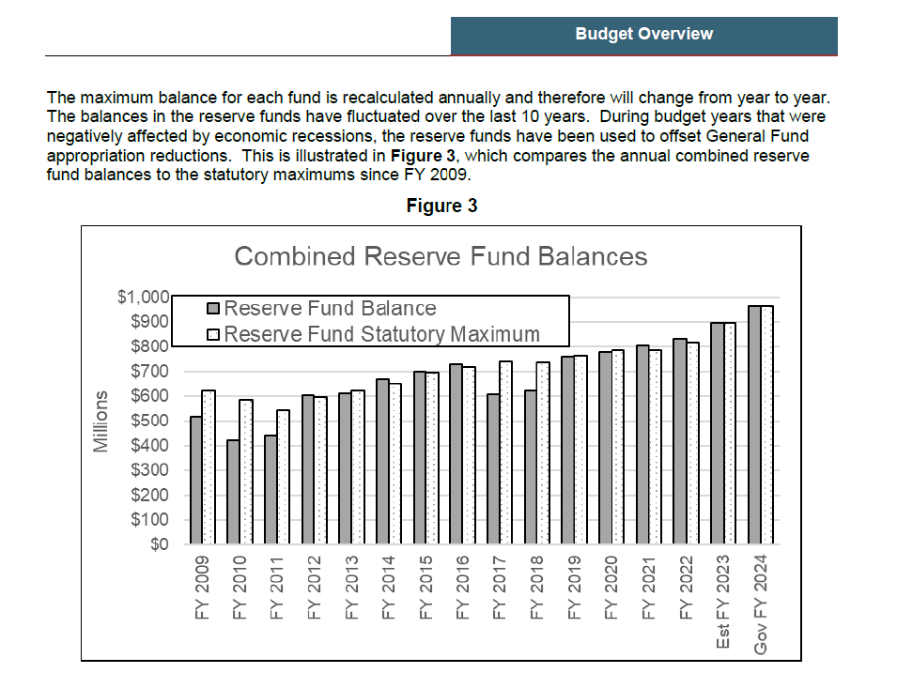

The Governor’s Recommendation Budget for FY 2024 anticipates ending balance of the Taxpayer Relief Fund:
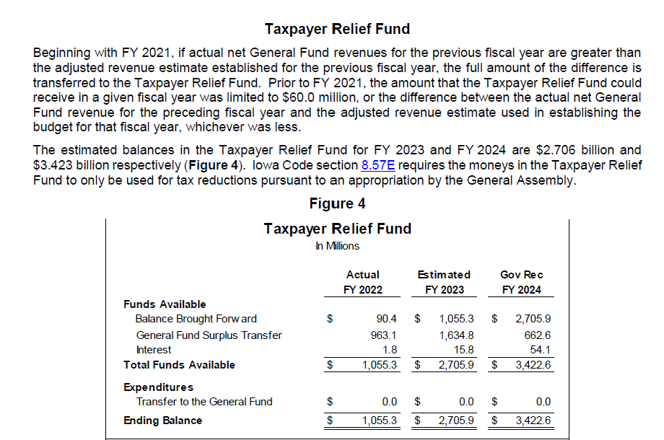

Subcommittee Action:
House Education Committee

HF 10 School Abuse: Requires mandatory reporters to report abuse of children over the age of 12. Requires the DE to develop for reporting on and investigating a school employee with an authorization, license or certification who may have committed certain felonies or acts. Establishes immunity for the school board or school authorities for discussing such incidents. Requires the BOEE to assess civil penalties against administrators for failures to follow the established process or for concealing an incident. Includes additional grounds for the BOEE to disqualify applicants or to revoke licenses. Requires the BOEE to notify schools about investigations and to investigate administrators. Requires schools to contact the BOEE about potential hires to determine if the person has been the subject of a complaint or investigation. Subcommittee of Reps. Boden, Gustoff, and Staed agreed to move the bill forward to the full committee with an amendment to the process of schools contacted BOEE to determine is a prospective employee has a pending investigation to instead, require school districts to verify investigation status on a spreadsheet which will include those cases where sufficient evidence is found to warrant staff recommendation to BOEE to consider licensure. RSAI is undecided.

HF 12 School Government Curriculum: Requires that comparative discussions of political ideologies that conflict with the ideas of freedom and democracy essential to the founding of the US be taught in HS government class. Subcommittee of Reps. Holt, Buck, and Hora met and moved the bill forward to the full House Education Committee. RSAI expressed to the subcommittee our preference that the DE convene a standards and curriculum review of social studies content during the normal standards review cycle instead of the legislature mandating content. RSAI is registered undecided.

Senate State Government Committee
SF 49 School Bond Elections: Limits school bond election to the Regular School Election, every other November in the odd year. Subcommittee of Salmon, Cournoyer, and Weiner met. After discussion, the bill did not move forward. RSAI is opposed.

Bills introduced:
HF 40 World Language Pilot Program: Requires the DE to establish a world language education pilot program in two elementary schools, with appropriations for each of two years. Subcommittee of Fry, Holt and Madison was assigned. RSAI is undecided.

Legislative Session Timeline: Posted on the Legislative website here: https://www.legis.iowa.gov/docs/publications/SESTT/current.pdf

Advocacy Actions This Week
- Always start with a thank you! See the RSAI 2022 Legislative Session Successes and find one you are grateful for them accomplishing.
- Shore up Education Savings Account Opposition: See the RSAI Call to Action for more information, but in short: Circle back with your legislators who’ve previously told you they opposed ESAs and reiterate key messages:
  - ESAs shift funds from public schools to private schools, limiting or eliminating programs and opportunities for students in public schools.
  - This program will cost between $300-$400 million, phased in at a time when historical tax cuts are estimated to lower state general fund revenues by 20%. If the legislature overextends (not just this proposal but also significant property tax relief), public schools will not be adequately funded.
  - Vouchers don’t offer parents real choice. Private schools pick and choose who they accept. Public schools accept ALL students.
  - Almost 75% of public schools are in rural areas with little to no access to private schools. Most families will be excluded from participating in a voucher program.
  - Vouchers increase costs by creating two competing school systems. This is likely to reduce resources for public schools, which educate 90% of students.Public schools are accountable and transparent to the parents, the community they serve, and the taxpayers who fund them. Private schools do not have the same state requirements for accountability and transparency or oversight by taxpayers.
  - The Governor’s 2024 Proposal is a costly and expansive voucher program.
  - Iowa already has many parent choice options.
Connecting with Legislators: To call and leave a message at the Statehouse during the legislative session, the House switchboard operator number is 515.281.3221 and the Senate switchboard operator number is 515.281.3371. You can ask if they are available or leave a message for them to call you back. You can also ask them what’s the best way to contact them during session. They may prefer email or text message or phone call based on their personal preferences.
Find biographical information about legislators gleaned from their election websites on the ISFIS site here: http://www.iowaschoolfinance.com/legislative_bios Learn about your new representatives and senators or find out something you don’t know about incumbents.
Find out who your legislators are through the interactive map or address search posted on the Legislative Website here: https://www.legis.iowa.gov/legislators/find
RSAI Advocacy Resources: Check out the RSAI Website at https://www.rsaia.org/2023-legislative-session.html to find Advocacy Resources such as Position Papers, RSAI Weekly Legislative Recap Reports and video updates, RSAI Calls to Action when immediate advocacy action is required, testimony presented to the State Board of Education, the DE or any legislative committee or public hearing, and links to fiscal information that may inform your work. Be sure to review the new 2023 RSAI Advocacy Handbook, which will be posted shortly.

Committee Members:

House Education Committee Members
- Skyler Wheeler (R, District 4), Chair
- Craig P. Johnson (R, District 67), Vice Chair
- Sharon Sue Steckman (D, District 59), Ranking Member
- Brooke Boden (R, District 21)
- Dr. Steven P. Bradley (R, District 66)
- Molly Buck (D, District 41)
- Sue Cahill (D, District 52)
- Taylor R. Collins (R, District 95)
- Tracy Ehlert (D, District 79)
- Joel Fry (R, District 24)
- Dan Gehlbach (R, District 46)
- Bill Gustoff (R, District 40)
- Steven Holt (R, District 12)
- Heather Hora (R, District 92)
- Chad Ingels (R, District 68)
- Monica Kurth (D, District 98)
- Mary L. Madison (D, District 31)
- Heather Matson (D, District 42)
- Thomas Jay Moore (R, District 18)
- Anne Osmundson (R, District 64)
- Ray Sorensen (R, District 23)
- Art Staed (D, District 80)
- Henry Stone (R, District 9)

House Education Reform Members
- Pat Grassley (R, District 57), Chair
- Matt W. Windschitl (R, District 15), Vice Chair
- Jennifer Konfrst (D, District 32), Ranking Member
- Sue Cahill (D, District 52)
- John H. Wills (R, District 10)

Senate Education Committee Members

- Ken Rozenboom (R, District 19), Chair
- Jeff Taylor (R, District 2), Vice Chair
- Herman C. Quirmbach (D, District 25), Ranking Member
- Claire Celsi (D, District 16)
- Chris Cournoyer (R, District 35)
- Molly Donahue (D, District 37)
- Lynn Evans (R, District 3)
- Julian B. Garrett (R, District 11)
- Eric Giddens (D, District 38)
- Kerry Gruenhagen (R, District 41)
- Tim Kraayenbrink (R, District 4)
- Sandy Salmon (R, District 29)
- Amy Sinclair (R, District 12)
- Sarah Trone Garriott (D, District 14)
- Cherielynn Westrich (R, District 13)
- Brad Zaun (R, District 22)

Contact us with any questions, feedback or suggestions to better prepare your advocacy work:
*Margaret Buckton, RSAI Professional Advocate, margaret@iowaschoolfinance.com , 515.201.3755 Cell
*Dave Daughton, RSAI Grassroots Advocate, dave.daughton@rsaia.org, 641-344-5205 Cell

Thanks to our RSAI Corporate Sponsors:
Special thank you to your RSAI Corporate Sponsors for their support of RSAI programs and services. Find information about how these organizations may help your district on the Corporate Sponsor page of the RSAI website at www.rsaia.org/corporate-sponsors.html.
 | www.apptegy.com
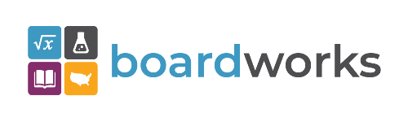 | www.boardworkseducation.com
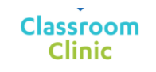 | www.classroomclinic.com
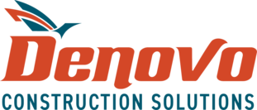 | www.teamdenovo.com
 | www.friedman-group.com
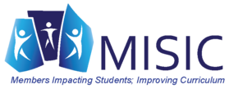 | www.misiciowa.org
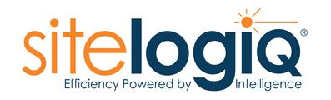 | www.sitelogiq.com
 | www.wgu.edu

