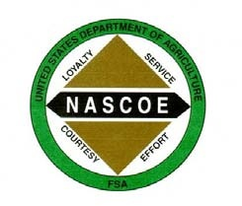

NEBRASKA ASSOCIATION OF COUNTY OFFICE EMPLOYEES
Membership Application

Date: _____/_____/_____ County Office: _____________________

Name: ______________________________________________________

Home Address: ______________________________________________

City/State/Zip: _______________________________________________

Cell Phone Number: ________________________________

Home Email Address: ________________________________________

Service Beginning Date: ______________________
**please write legibly**

Please check your membership type:

Annual Due Amount: Annual Salary rounded to whole dollar X .0028

_____ Full Voting Members: County Office employee serving under permanent appointment

Annual Due Amount: $25 for any of the following:

_____ Associate Members: GS employee at the county level under permanent appointment

_____ Associate Members: Temporary FSA employee

_____ Associate Members: State Office employee

_____ Associate Members: County Committee Member

Please send membership application and FSA-444 to:
Shanna Waterman, NEBRASCOE Sec/Treasurer – shanna.waterman@ne.usda.gov

If you have questions or comments, please email:
Joni Johnson, NEBRASCOE Membership Chair – joni.johnson@ne.usda.gov

