Tarps, Tents or Bivy Sacks?—
A Difference in Camping Philosophies
(Provided by: HighCountryExplorations.com)

Tarp-campers intimately know not only wind and bugs but also sights of moonlit clouds and shooting stars and dawn, scents of pine needles and flowers and grasses and prowling skunks, sounds of little feet scurrying everywhere in the darkness over sleeping bags. They experience more of everything except claustrophobia, and in retrospect their wilderness nights are as memorable as their days. These are the free spirits, a select band, smaller and more select by the year, who ask protection only against downward rain, heat loss and dew accumulation through radiation, and the hot sun. The creepy-crawlies they accept, perhaps becoming inordinately fond of beetles, and the buzzing wings they foil with a habitat of no-see-um netting. Mild breezes they welcome, and the gentle mists they may carry, bathing the brow. And as part of the bargain they accept the occasional Armageddon when forces of evil rage in the night, chewing up tarps and spitting them out, sending naked-to-the-sky refugees fleeing through the tempest, whimpering. Herein, then, is a treatise on [the practical aspects of buying and rigging] tarps—to preserve for the discriminating few, the alternative.
—Harvey Manning, Backpacking One Step At A Time, 4th ed., p. 311-312

Most lighter-weight commercial tents weigh four to five pounds. Yes, there are lighter shelters out there, like bivy sacks or flimsy little one-man tents, but they tend to be cramped and extremely restrictive of ventilation. My 16-ounce tarp weighs one-fourth to one-fifth the weight of even the lightest two-person tents currently available. Of course I enjoy the tarp’s lightness, but I also like its roominess. Scrunched inside a small tent, I have to keep most of my gear out in the vestibule, where it is much less accessible. Beneath the tarp I remain more a part of the landscape; I can still see and hear everything around me. This facilitates my connection with nature greatly — even while in bed. If using a stove, Jenny and I sometimes cook beneath the tarp, particularly in rainy weather. We tend to sleep much better under a tarp than inside a tent, and awaken more refreshed. The tarp allows for fresh air and wonderful ventilation, and it reduces the condensation in the quilt and clothing come morning . . . . I also believe that a properly pitched tarp is stronger than most tents, particularly lighter-weight tents . . . . I should point out that the majority of nights we hikers spend in the backcountry are mild. We are not automatically going to encounter the ultimate storm the minute we step out the back door with lightweight gear. But should it happen, a properly pitched tarp will handle it.
—Ray Jardine, Lightweight Hiking: Beyond Backpacking, pages 33-34]

Central Issues Addressed in This Article
What type of shelter best fits my values and philosophies of wilderness camping in the seasons and areas in which I backpack? Which of the claimed advantages for tent camping hold up under critical analysis? Which of the claimed advantages for tarp camping hold up under critical analysis? Am I philosophically a tent, tarp, bivy sack or hammock person? If I decide to own more than one type of shelter, which specific options will maximize my priorities and values?

Introduction
One of the most difficult and interesting choices for the dedicated backpacker is that of shelters. There are many options with more coming on line each year. Part of the decision is practical and part philosophical. For many, the decision is based upon past experiences in the wilderness (sometimes going back to childhood). For some, the decision is based on lack of experience or lack of critical analysis (or both) of the various options. For many, it is going along with the crowd and the subtle influences of advertising. For others, it is based upon the climate. For still others the decision is primarily economic: what is affordable? No matter what your past experiences, economics or biases, consider reading through this article with an open mind; the result might surprise you.

Starting Assumptions
To receive maximum benefit from this article, consider make the following assumptions:

- You will need some sort of shelter and a sleeping system that will keep you warm and comfortable enough to sleep well and be refreshed for the trail the next day.

- The choice of shelter is most critical in mountainous, alpine environments (the primary focus in this article).

- Even though winter-like conditions can occur anytime of the year in most mountainous regions, assume we are dealing only with three season environments; winter camping deserves separate treatment and is not dealt with in this article.

- There are many viable options and types of shelter available to the contemporary backpacker with many subtle variations of the main types. Instead of analyzing all of these options and variations, one at a time like most other backpacking manuals, it is most efficacious to narrow the focus to two popular and generalized options (tents vs. tarps) to illustrate the practical and philosophical differences between shelter choices. With this assumption in mind, the next sections are set up in the form of an in-depth analysis and debate (i.e., supporting argument and critique) of these two popular options. Put differently, the next sections are organized into a black/ white, either/or type of analysis fully realizing the issue is not this clear-cut.

- A simple working definition of a tarp is a sheet of fabric, without a floor or doors, suspended in such a way as to provide shelter. In direct contrast, a simple definition of a tent is a fabric shelter with walls, doors and a floor. A bivy is a lightweight, waterproof, minimalist fabric shelter designed to slip over a sleeping bag.

- Ignore the more emotional and non-rational attitudes about shelters. Following are some examples.
- “I just like this type of camping.”
- “I have always camped this way.”
- “Shelter X is what most of my friends are using."
- "I just love brand X's features and design.”

Tarp Camping: A Critical Analysis of Claimed Advantages
1. Lighter Weight, Less Volume and Low Cost: An 8 x 8 or 8 x 10 foot ultralight silnylon tarp sheltering one or two people can be purchased for about $60-80 and weigh as little as one pound (15-16 ounces), if using hiking poles, ice axes, available sticks and trees, rocks, etc. for support. The cost will be $20-30 if you make your own. A hardware store plastic or reinforced polyester tarp can be purchased for $10 or less. When packed, the bulk of a tarp is much less than that of a tent. With less bulk and weight one can gear down to a lighter pack. In essence, tarp camping can reduce your pack weight by pounds, not ounces. The on-trail comfort of less pack weight makes up for any lack of comfort in camp. The weight and volume saving is even more pronounced with larger groups. A 10 x 12 foot tarp will shelter up to five people. Lighter weight tents that handle this number will total at least 8-10 pounds. The larger the group, the greater the weight saving.

Critical Commentary: The weight, volume and cost advantage obviously goes to the tarp, but not by as much as is portrayed. The weight and bulk of ground cloths, bug netting, extra stakes and cord plus a heavier sleeping bag to stay warm in colder weather have to be factored in. Tarp campers often supplement their shelter with a bivy sack. Furthermore, ultralight, single-walled, two-person tents are available weighing two pounds or less. Chosen wisely, a tent will add only a modest amount of weight to your pack. In addition, it is often difficult to find enough flat ground for larger tarps to hold larger groups.

2. Room to Move Around: I sleep better under a tarp. I find tents to be claustrophobic and stuffy; I like the open air and open spaces of a tarp. Furthermore, I can get up in the middle of the night to relieve bladder pressure with minimal disturbance of my sleeping companions. Assuming one moves to lower elevations during periods of bad weather, tarps can provide a lot of room to move around, stand up, sort gear, cook, etc. while hunkered down.

Critical Commentary: Quality of sleep obviously varies a lot from person to person. Some tent campers have security issues and need a real sense of enclosure and protection from creatures big and small to get a good night’s sleep. Quality tents have more than adequate ventilation options to overcome stuffiness. They also are warmer in cold weather for better sleeping. Regarding claustrophobia, dome tents provide sufficient volume to offset most of these feelings. In bad weather with heavy rain and/or strong winds, one must generally pitch a tarp so low that there is little room to move around under it. In mildly inclement weather, a lightweight tarp can supplement a tent. Finally, tents can be purchased with doors at both ends so as to not disturb other sleepers for bladder calls. All of the issues raised in the above line of argument have good rebuttals.

3. Ventilation and Condensation: Tarps provide superior ventilation. Especially important is ventilation to reduce the humidity and condensation (for sleeping bags, for insulated clothing and for the shelter material). In cold weather, humidity and condensation can greatly reduce the insulation value of bags and clothes. Tarps can be pitched with a clothesline inside making it possible to dry damp clothes with this superior ventilation. Finally, in below freezing temperatures, frost will often form and rain down on those inside of a tent.

Critical Commentary: Quality tents have adequate ventilation in all but the worst weather. This coupled with the extra warmth of a tent will also help dry damp clothes. This warmth can be supplemented with a heat source (e.g., candle). As mentioned earlier, when the weather turns really bad, tarps will be pitched so their sides and one end come close to the ground. In this configuration, there will be a lot less ventilation and more condensation.

4. Better Choice of Campsites: If good campsites are limited, tarp campers can often make better use of marginal sites. Tarp campers have been known to pitch their tarp over bushes, rocks and downed trees. The often lighter packs of tarp campers allow them to arrive at the best campsites before the traditional backpackers toting their heavy loads.
Critical Commentary: Shelter type and weight are only two variables in hiking speed and finding good campsites. Total pack weight, physical conditioning, number of rest stops, and knowledge of the area are more important variables. Groups with larger tarps also have the problem of finding sites that are big enough.

5. Midday Relief from the Elements: It is often important to stop midday to rest, eat lunch and get out of the elements. Tarps provide good midday relief from the sun and rain. Tarps are much more convenient for this temporary setup than tents. This function of tarps is especially important in hot climates and mountainous areas with afternoon thunderstorms.
Critical Commentary: This function of tarps is valuable only in a limited number of situations; it is not needed most of the time. In the mountains, it is seldom necessary to stop during the day to get out of the sun; a good sun hat and sun shirt will do wonders most of the time. When needed, a lightweight group tarp to supplement the tent will usually fill the bill.

6. Communal Living with Larger Groups: Instead of two or more small tents, a larger tarp or two will accommodate several people. In good and bad weather, a tarp provides for an increased sense of community.
Critical Commentary: If with a larger group, this again sounds like a good argument for carrying both small tents and a large ultra-lightweight tarp as part of group gear. Besides, plenty of opportunity exists during the day to develop a desired sense of community.

7. Communing with Nature: The two quotes at the beginning of this article (Manning and Jardine), taken together, provide a good statement of this line of argument in favor of tarp camping. In addition, if pinned down by bad weather, a tarp will allow continued communing with nature during the day.
Critical Commentary: If this communing is that important, purchase a tent with an extensive vestibule so that the door of the tent can be kept open most nights. This argument revolves around how much communing is desirable. Unless pinned down by bad weather, tent campers will spend 2/3 of every day out in the open air communing with nature. At night, most tent time is spent sleeping and communing with a dream world. Upon critical reflection, this argument turns out to be more emotional than logical, even if communing with nature is high on the agenda.

8. Simple, Low-tech Lifestyle: With a tarp, “there are no poles, no zippers, no rainfly, no windows or doors, and no gadgetry to make it complicated” (Ryel Kestenbaum, The Ultralight Backpacker, page 30). With a little practice one can learn to pitch a tarp quickly to deal with most weather situations. Housekeeping is a breeze using a tarp. Many quality tents are high-tech marvels. I go into the wilderness partly to get away from a high tech lifestyle.
Critical Commentary: This is more a philosophical than a practical issue. Philosophically, if a low-tech lifestyle is this important, then it is relatively easy to choose this lifestyle year-round when out of the mountains. From a practical standpoint, one can easily purchase a tent that is relatively simple in both design and erection.
_____________________________________

There are other arguments in favor of tarp camping (e.g., more pet friendly; more in tune with changes in weather; able to strike camp and move more quickly to get a way from oncoming weather; easier to cook under cover in bad weather; less to repair; easier to clean), but the eight claimed advantages analyzed above cover the most important.

Tent Camping: A Critical Analysis of Claimed Advantages
1. Spectacular Camps in High Alpine Basins: Use of a quality tent will allow camping at higher elevations. Some of the most spectacular camps are above the tree line. In contrast, tarp camping usually dictates camping well below the tree line to stay out of the wind and weather.
Critical Commentary: In periods of extended good weather, many choose to sleep out under the stars at all elevations. The following quote expresses this position well:

Another advantage of tarps was that in mild weather we were not so inclined to use them. They were not like tents where the tendency is to pitch them rain or shine, and the perceived security draws a person in and compels him or her to shut out the world. With the starry canopy overhead and the earth’s gentle embrace beneath, we found that our simple, low-tech style allowed us a more profound interaction with the natural world. The night is as full of wonders as the day, so why barricade ourselves off from them and spend the quiet, starry hours in oblivion? We can do that at home, inside our houses.
—Ray Jardine, Lightweight Hiking: Beyond Backpacking, pages 65 and 83

In addition, some spectacular camps can be found in the lee of a ridge or at the tree line where a small grove of trees will shelter much of the wind. More importantly, if the weather is marginal or about to change for the worse, most tent campers will be conservative and follow the tarp campers to lower elevations. Not only is wind chill a factor out in the open, but also it is difficult to sleep well in a tent buffeted by strong winds.

2. Ride Out Serious Storms: A quality tent will not only allow camping above the tree line, but will ride out most severe storms. In stormy conditions, wind driven dust, snow, rain and mist will be a serious problem for tarps, no matter how well-pitched or constructed.
Critical Commentary: This common belief of tent campers has numerous problems. First, this claim is obviously true only if using a four season, mountaineering tent. Most backpackers choose lighter, less expensive tents that are subject to some of the same storm problems as tarps. Severe storms will chew up tarps and lightweight tents alike. Second, most serious storms are predictable compared with quick passing thunderstorms or rain showers. Why try to ride them out? Move to lower elevations in protected areas to be more comfortable. Third, when caught in bad weather with a tarp, erect it with rocks or stakes so that bottom edges and back wall are mostly flush with the ground. This set up will mostly eliminate wind driven rain and splatter. Having a shaped, catenary cut tarp is even more storm proof. In the same vein, several gurus of ultralight tarp camping (e.g., Ray Jardine and Ryan Jordan) claim that tarps, when properly pitched, are stronger than most three-season tents. Fourth, tarp campers often supplement their shelter and light weight sleeping arrangements with a water resistant or waterproof bivy sack to cut the wind, snow flurries, dust and rain splatter. Fifth, let’s assume (for purposes of argument) that tarp campers get hit by a severe storm once every 5-10-15 years of wilderness travel. If necessary, one can mostly collapse the tarp or simply wrap up in it ("tarp burrito") to ride it out. Have we gotten so soft and comfort obsessed that we can’t deal with a miserable night on occasion? Why should this rare occurrence dictate our choice of shelters?

3. Protection from Bugs: Quality tents provide both bug protection and ventilation in all but the hottest weather. The experience of just one trip where eaten alive by biting insects under a tarp will be enough to convert all but the most fanatical. Furthermore, some are affected (both psychologically and physically) a lot more than others by insects and insect bites. Even though bug repellent, bug resistant clothing and bug netting provide some relief, bad infestations will prevent having a positive camping experience. In the seasons when bugs are not a serious problem, it is often too cold for tarps.
Critical Commentary: This common praise of tents over tarps prompts several replies. First, in many decades of wilderness travel, I have experienced only a few days of getting eaten alive. When the bugs are bad, it is seldom for more than a day or two. Insects can be bad in one area, but moderate considerably when moving on to other areas. Bugs can be bad at lower elevations, but not a problem at higher elevations, especially if camped on a ridge with more breezes. Bugs settle down and mostly disappear by bedtime in the higher elevations. Second, and most importantly, lightweight hikers in good condition don’t usually spend a lot of time sitting in camp trying to fight off the bugs. They are on the move during most of the daylight hours. When it is time for sleep, a little repellent and/or a headnet will usually allow one to drop off to sleep. Third, for those who attract hordes of biting insects or who have a difficult time coping with swarming bugs (physically or emotionally), a loop can be sewn into a tarp to attach very light bug netting (“net tent”) to handle this problem. Finally, when camping in known areas of high bug infestations (e.g., wet and boggy areas of Canada or Alaska), one would admittedly sing a different tune. Then a quality tent with good bug netting would be called for. However, this fact does not in any way negate tarps for most trips under normal conditions.

4. Protection from Rodents: Critters large and small will generally be kept at bay by the integrated tent floor and zippered tent doors.
Critical Commentary: Avoiding heavily used campsites can mostly avoid this problem. Most important, it is not a serious problem if all food has been stored away from the sleeping area and it is cool enough to be mostly enclosed in a sleeping bag. The rare instances when rodents are a problem should not dictate the choice of a shelter. An extreme solution used by some tarp campers is to spread mothballs around the periphery.

5. Protection from Groundwater: If it rains heavily and the ground is not very absorbent, a tent with a waterproof “bathtub” floor will be much dryer than a tarp.
Critical Commentary: The more skilled the camper, the higher probability there is of selecting a campsite that will stay dry in a downpour. This will more likely be the case if heavily used and compacted campsites are avoided. In addition, skilled campers will rig the tarp and ground sheet in a way to keep all water out. In the worst-case scenario, placing small branches under the edges of the ground sheet so the water runs underneath or digging trenches in critical places will usually be sufficient.

6. Secure Night Enclosure: Besides better sleep when insects, rodents and weather are kept outside the tent, there is another more subtle and intangible factor involved with tent camping in the wilds: the sense of security once you are zippered in for the night. Part of this symbolic act is zippering the tent; the other part is zippering into the sleeping bag (assuming it has a zipper). For many, the idea of leaving the security of a tent for a tarp is sacrilegious. Even though the quantity of sleep might be the same, the quality of a tent-based sleep is superior. This fact may also be evolutionary in nature. The following quote captures this element:
Maybe a tent appeals to some latent nomadic tendency or neo-Neanderthal thrill of hiding in a snug little cave. Encircling fabric walls bring out a sense of confidence and security, of shelter reduced to its very essence . . . you always sleep more soundly if there’s a tight tent to dive into when the weather turns foul.
— Dave Getchell, “Safe Havens,” Backpacker, April 1992

Another quote on this subject:

There is something almost magical about unrolling the wad of nylon and string from its sack and in a few minutes having it become your own little fabric fort.
—Rick Dreher, “Shelters,” Lightweight Backpacking and Camping, page 187

Critical Commentary: The most obvious problem with this argument is that the thin walls of backpacking tents provide no real security and often a false sense of it. A tarp is much better suited to real security: watching, listening and reacting when necessary. A more subtle critique emphasizes the highly individualistic response to the need for security. On one extreme is the person who has grown up conditioned to believe that the society in which they live and the wildernesses in which they travel are to be feared—places where one needs to always be on guard. This attitude is especially prevalent in those who spend most of their time in secure enclosures (i.e., houses, office buildings, cars) and in larger cities. On the other extreme is the person conditioned to believe that the society in which they chose to live and wilderness in which they chose to hike are mostly safe and benign. These people often spend more time outside. Our safety and security oriented culture often pushes the former attitude. Manufacturers of outdoor equipment often capitalize on and emphasize the former. Those with lots of wilderness travel under their belts, who have developed the skills and knowledge to go with it, tend to manifest the latter attitude. With more and more experience, this fearful attitude and its need for nighttime security can be outgrown.

7. Tent Warmth: It is obvious that tents are warmer than tarps when temperatures drop. They especially reduce the wind chill element. Double-walled tents are warmer than single-walled. The warmer the tent, the lighter need be the sleeping bag and insulated clothing carried.
Critical Commentary: There are at least three different considerations here. First, properly pitched tarps can minimize wind chill. To further reduce wind chill, tarp campers often carry lightweight bivy sacks. Second, tents are generally warmer if the temperatures are moderate and the weather is good. However, if the humidity is high (e.g., rainy conditions) or the temperatures are well below freezing then tent warmth will be gradually compromised. Under these conditions, condensation will gradually build up in the insulation of sleeping bags and clothes, thereby robbing them of their warmth. This is especially true when temperatures are well below freezing. The greater the number of heavy breathing bodies in the tent (some estimate as much a liter or two of moisture lost per person per night), the greater the problem. The longer the trip and the fewer the opportunities to dry out the bags in the sun, the greater will be the problem. Sometimes tent campers are forced to leave a lantern burning overnight (not a good practice) to generate enough heat to enhance warmth and ventilation. The best way to keep condensation at bay is to have good ventilation or be a fair weather camper. Tarps offer better ventilation than tents. Either option (a well ventilated tent or tarp) counteracts tent warmth, the main point of this argument. The final consideration is stuffiness and smelly bodies. This can be a major issue in hot weather and when the tent is buttoned up for warmth and the group has been out several days. Tarps are superior in both regards.

8. Physical Security of Gear: One feature of a tent is that it can be completely closed up during the day (or multiple days) when away from base camp on a day hike or climb. Tents provide ample security from both four-legged and two-legged creatures.

Critical Commentary: This is a definite advantage, if you are into base camping. One option for tarp campers is to hang most of the gear left behind along with the extra food. Another option is to take down the tarp, roll extra gear securely inside and hide it or hang it someplace. Granted, both of these options involve extra hassle.

9. Hassle of Tarp Setups: Most tarps require many tie-out points to be secure in the wind and driving rain. Time must be spent analyzing the site to decide the best tarp configuration. Often tarp setups require temporary ties for the initial setup and then going around the perimeter to make more permanent ties. In wet weather, the tarp will sag and need further adjustment. If going ultralight without stakes and poles, replacement objects need to be found. Setup sometimes requires stringing a line between two trees or adding length to guy lines that are too short. If a storm comes up, the whole thing has to be repitched closer to the ground. You get the picture: one big hassle (especially if you get to camp late, the weather has turned bad, and you are doing it all yourself). A quality tent, while heavier, usually requires only a few minutes for setup, especially if it is freestanding. Freestanding tents can also be easily moved.
Critical Commentary: The best answer to this "hassle" is obtaining a shaped, catenary cut tarp, using adjustable trekking poles, using stakes for most of the tie outs and adding easy-adjust line tensioners. The catenary cut makes it easier to get the tension right the first time. Another answer to the problem is to practice set up at home in several different configurations. Having two or three experienced tarp campers on hand also makes for short work. If a hassle free setup is a priority, consider replacing the flat tarp with a single-walled tarp-tent. Many tarp-tents using trekking poles can be set up in less than two minutes with as few as four stakes.

___________________________________________________

There are other arguments in favor of tent camping (e.g., more privacy, my partner demands a tent, storage pockets for small items, fanaticism of ultralight backpackers, mucho bucks already spent on a high-tech tent) but the nine claimed advantages analyzed in this section cover the most important.

[Special Note: The fact that there is an almost equal number of advantages listed for both tent and tarp camping is not by design and should not be used in making the decision. In fact, one specific advantage or disadvantage could be a deal maker (or deal breaker), no matter the total number on each side.]

End of Section on Competing Claims and Critical Analysis
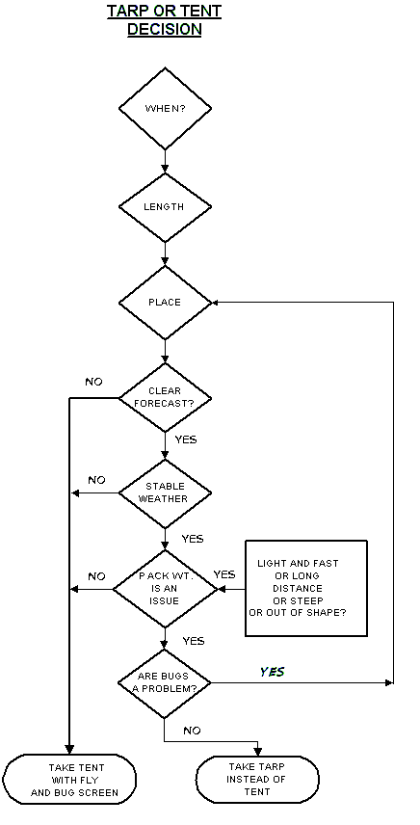

Reader Participation: Personal Shelter Values and Priorities
There are many elements to consider in selecting a good shelter. What are your priorities for your primary shelter option (assuming you do not own multiple shelters satisfying multiple sets of priorities)? Following is a comprehensive list of shelter priorities and values. First, add any priorities I have missed. Second, circle at least five but no more than fifteen top priorities. Third, rate your current primary “go-to” shelter option from 1-10 in how well it meets your circled priorities.

Minimum weight
Minimum packed size
Withstands most winds
Maximum protection from rain and snow
Minimum of inside condensation
Adequate ventilation
Warm in cold weather
Cool in hot weather
Maximum floor space
Maximum vestibule space
Ease of access
Good interior volume
High enough to stand or kneel
Good bug and rodent protection
Physical security of gear when away
Privacy
Communal Living
Setup and adjustment from inside
Free-standing
Functionality and reliability (i.e., well designed)
Simplicity; few things to go wrong
Convertible (change configuration depending upon needs)
Ease of setup
Good visibility to outside
Esthetically pleasing style and color
Best value (price for quality)
Trail shelter or lean-to accommodations
Hut-to-hut, cabin-to-cabin or hotel-to-hotel level accommodation

Reader Participation: Tent, Tarp or Other Shelter?
You will need some sort of shelter, and a sleeping system that will keep you warm and comfortable enough for you to be able to sleep well and be fresh for the trail the next day. Everyone has a different emotional/psychological reaction to being outside and not behind a locked door at night. Some people are charmed by the naturalness of being out there and find it very easy to sleep peacefully. Others jump at every rustle and tiny noise. You'll soon find out which category you fit into, and you'll soon realize that most creatures out there are much more frightened of you than you are of them, although they may be interested in your food.
—Don Ladigan, author of Lighten Up

Review your responses to this article so far. Then circle one camping philosophy or set of values, from the six basic options listed below, that best describes you at the present time. Focus on your philosophy of alpine shelters, not past behavior, realizing that you could be in transition.
Tent Person
Tarp Person
Tarp-tent Person
Bivy Person
Hammock Person
Flexible Situationalist (utilizing a full range of options)

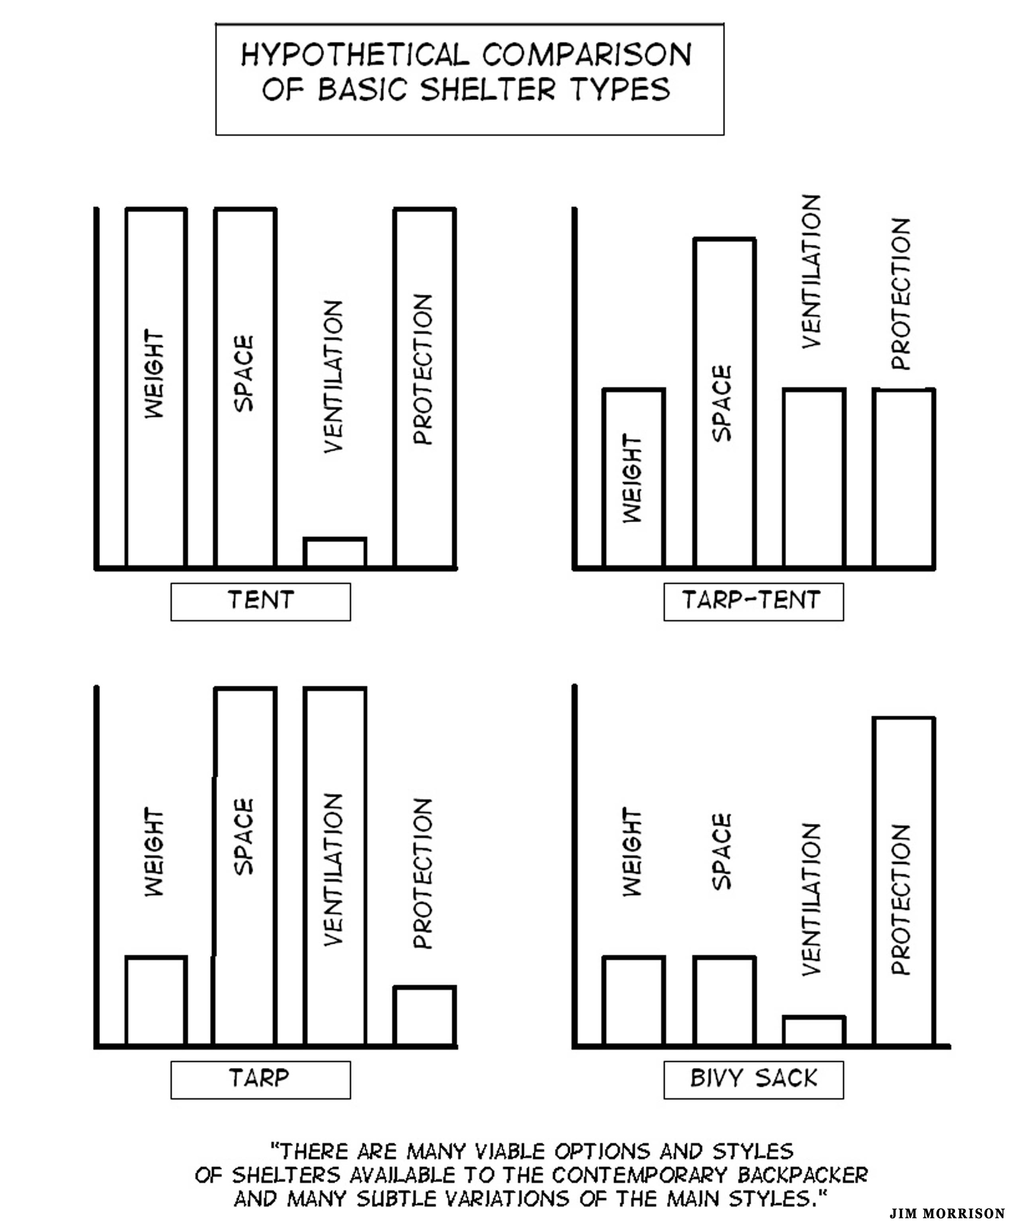

Emergence of Hybrid and Convertible Designs
A number of shelter options are now referred to as “hybrids” and “convertibles.” First, a brief look at the hybrids. One common hybrid is the poncho-tarp. Regarding the number of walls, a few tents are now available combine both single and double-walled sections. Some double-walled tents combining both dome and tunnel designs. Regarding the choice between tents and tarps, a number of newer options combine the advantages of each. They are usually referred to as “tarp-tents.” The tarp-tent style (not identical with Henry Shire’s “Tarptents” branding) are available using one hoop and one pole to make setting up easier and to provide more stability in the wind. Most tarp-tents come with the option of being staked to the ground, providing an almost total 360-degree enclosure for bad weather. Many tarp-tents come with removable floors and substantial bug netting (side skirts and doors). Also available in the hybrid category are enhanced bivy sacks with a tent-like hoop, bug netting and small vestibule. A resurgence of interest in hammock camping has resulted in hybrid shelters tailored uniquely to this type of shelter.
What about the “convertibles”? Tents that allow packing just the poles and fly (“minimum tent” or “fast pack” option) are common. Most double-walled tents allow pitching only the inner tent. Some convertibles attempt to provide the option of two, three and four season camping by adding or subtracting poles, hoops, struts and tie out points.
Many of these hybrids and convertibles options (more will likely emerge in the future) have been inspired by the recent interest in lightweight backpacking. Most attempt to overcome the either/or choice between tents or tarps. Hybrids and convertibles considerably increase the number of options (and frustrations?) in the decision-making process.

Author’s Experiences and Conclusions About Wilderness Shelters
I have experienced a wide range of fabric shelters in the backcountry (i.e., excluding cabins and wood shelters). I have owned six single walled tents (including a two-person Army surplus coated nylon mountain tent and a four-person REI “Mt. McKinley” pyramid tent). I have owned four double walled tents of different configurations and three hybrid tarp-tents without floors. I have done a fair amount of camping in the high country with tarps and bivy sacks of various kinds. Finally, I have bivouacked during the summer season without any real shelter four or five times.
From this experience and my analysis in this article, I have come to several conclusions. The first is that no single shelter type is ideal for all conditions. Selecting a shelter is a series of compromises based on individual priorities and the conditions expected in the field. The logical end-point of this position is to own or have access to a number of different types and sizes of shelters. Ideally, the shelters would range from ultralight nylon tarps on one end of the spectrum to a three season, double-walled tent for base camping on the other end. In the middle somewhere would be a hybrid tarp-tent or two. Finally, for sleeping under the stars, add a sleeping bag with a waterproof and breathable outside cover to complete the repertoire of options.
Roomy, bomb-proof, four season expedition tents are overkill for most people. They take too much time to setup, take up too much space, weigh too much and are too expensive.
After being forced to hunker down for a few days of bad weather, strongly resist the temptation to carry a free-standing, roomy, heavyweight double-walled tent. Part of this conclusion is based upon the fact that weather forecasters, while not perfect, are getting better at predicting big weather systems. Fast-moving storms can strike in the mountains at any time, but they are usually of short duration. Having said this, I acknowledge that freestanding, double-walled tents are often the shelter of choice in wet mountain climates like the Pacific Northwest. If roominess in bad weather is a priority, then size up by one person. For example, take a two-person tent for one, a three-person tent for two and a four-person tent for three people.
As I get older and have become more of a fair weather hiker, total shelter weight and simplicity of setup are rising to the top of my priorities. This reprioritizing translates into a natural bias towards tarps and hybrid tarp-tents. Nothing beats a quality catenary cut and ultralight tarp when the priority is to travel fast and light. Tarp add-ons (beaks, lifter tabs, bug netting tabs) are a plus. In many cases, tarp camping is best supplemented with a waterproof and breathable bivy sack or sleeping bag. With this addition, windblown rain and unseasonal snowstorms can be tolerated.
If weight and simplicity are not the biggest consideration, carrying three types of shelters is ideal for trips lasting more than a couple of days: (1) a lightweight tent for bugs, rodents, warmth, bad weather and security of gear; (2) a tarp for midday stops out of the sun and rain as well as for cooking and eating and relaxing in camp; (3) a waterproof and breathable bivy sack or sleeping bag for sleeping out in the open in good weather. Sleeping only in a bivy sack is an ideal hot weather option (crawling into the sleeping bag when temperatures cool off towards morning). A lightweight bivy also functions as an emergency shelter on day trips out and away from base camp, and to supplement a lightweight sleeping bag in cold weather. Depending upon the design and size, all three of these shelter elements (tent, tarp, bivy) could be quite reasonable regarding total weight per person.
If I were forced to own only one shelter to cover the widest range of conditions and trips, the best compromise would be a two-person, single-walled hybrid tarp-tent. The tarp-tent would be a hybrid A-frame and tunnel design. It would have high-low ventilation options (the “stovepipe effect”) to combat condensation and a goodly amount of bug netting. The tent would use trekking poles in the setup. Such a shelter is quick to set up and will handle moderate level winds. The shelter could easily be collapsed in high winds. It would be lightweight, weighing 20-30 ounces for two persons (excluding the poles).
When there are at least three in the party on longer trips with marginal weather predicted, have access to a single walled, pyramid tent made of silnylon or comparable material (e.g., Mountain Laurel Design’s “Supermid”, Black Diamond’s “Megalite,” Oware’s “Alphamid,” Golite’s “Shangri-La”). This option will keep the total shelter weight between 0.5-1.0 pounds per person. The steep walls provide good rain and snow protection. The ability to stand up provides more comfort when pinned down by the weather. The height of the tent can be easily raised or lowered as the weather dictates.
Comprehensive, up-to-date, and detailed discourse on wilderness shelters can be found in at least two places: (1) Chris Townsend, The Backpacker’s Handbook, 3rd Edition (Ragged Mountain Press, 2005); (2) Colin Fletcher and Chip Rawlins, The Complete Walker IV, 4th Edition, 600 pages (Alfred Knopf, 2002). There are likely others.

Additional Issues for Reflection
- Importance of Topic: How important is my choice of a three season shelter in the environments in which I choose to camp? Will I be spending a lot of time in base camp or usually camping just long enough for a good night’s sleep? How high is camp comfort on my list of needs?

- Choice of Several Shelters? Should I plan on several different types of shelters to meet my needs (e.g., three season double-walled tent, shaped catenary cut tarp and weather proof bivy sack) or attempt to find one or two shelters that will work well most of the time?

- Choice of Accessories: What type of groundsheet, guy lines, stakes, bug netting, etc., are best for my shelter choices?

- Best Tent or Tarp Material: What is the best material for either tarps, single-walled tarp tents or the tent fly of a double-walled tent? Silicone impregnated nylon? Polyurethane coated nylon or polyester? Reinforced polyester (“blue tarp”)? High tech cuben fiber? What about single-walled shelters made with a waterproof, breathable fabric (e.g., Gore-tex or eVent)?

- Color of Shelter Material: What about color of material? Bright color to be seen from the air? Let the light in on dark days? Camouflage or forest color to blend in? Is silver reflectorized material worth the extra cost?

- Tent Configuration: If I opt for a tent as my primary “go-to” shelter, what configuration will best suit my priorities? Freestanding? Single or double walled? Dome, wedge or tunnel shaped? Hybrid? One or two doors? Internal or external poles? Convertibles for different seasons?

- Tent Square Footage Needs: What about the amount of floor space needed for my tent? Size of vestibules? Peak height? What about square footage that is more than ample for one and adequate for two large persons?

- Tarp-tents: What about the currently popular hybrid “tarp-tents” (single-walled shelters without doors and floors, but with beaks and vestibules and bug netting)? Is this option the best of all worlds for backpacking or a bad compromise?

- Best Tie Down Options: What is the best combination of tie downs for alpine shelters? How many stakes should generally be carried and how many improvised?

- Tarp Size: What is the optimal size for a one-person tarp? Two-person? Three to four person? Is a 5’ x 8’ (60” x 96”) rectangular tarp adequate for one person? Is a square tarp (say 10’ x 10’ or 9’ x 9’) adequate for two?

- Tarp Options: Is a flat rectangular or square tarp best for maximizing setup options or some other configuration (e.g., shaped catenary cut, wide at front and narrower at rear)? What about poncho tarps? Is it best to buy it pre-made or make it myself?

- Tarp Setup Configurations: How much should I practice setting up my tarp in different configurations for different campsite layouts? Of the numerous setups possible, which will I likely use in bad weather? Is a modified A-frame configuration that is higher at one end and very low at the other the best all around choice?

- Tarp-Bivy Combinations: When should I supplement the tarp with a bivy sack? If supplemented, what are the best materials for tarp-bivy combinations? Can I get by without a separate ground sheet if I use a bivy?

- No Shelter Options: Under what conditions might I seriously consider not taking a shelter on multiday trips? Under what conditions would a waterproof and breathable storm suit plus a plastic garbage bag or two be a reasonable choice?

- Emergency Shelter: For day trips, what is the best emergency shelter? Space blanket? Mylar bivy sack? Poncho tarp? Plastic garbage bags? Other?

- Large Group Tarp Camping: What is the best tarp shape, size and material for large group camping (say 8-12 campers)? What about pyramid designs with a single center pole for this purpose?

- Hanging Shelters in Storage: How important is it to have the room to hang stored shelters (i.e., not store rolled up)?

