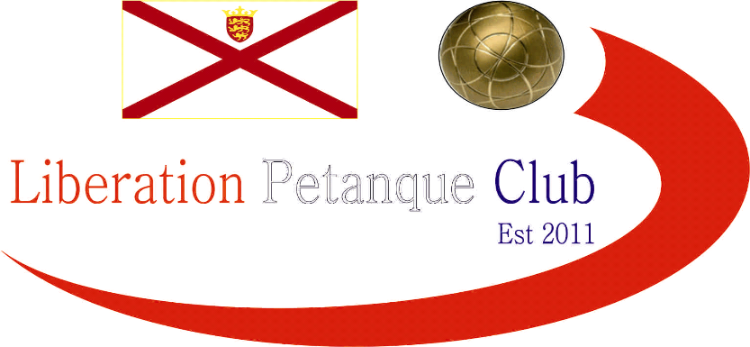

2019

Liberation Petanque Club

Doubles Open

16 Teams took part this year with the Cup’s holders absent, meaning new winner/s this year.

Round 1 saw 2017 winner Mark Nicol playing with Paul Bell. The pair nearly came unstuck in round one just getting over the finishing line 12 – 10 as new Liberation members Tom Le Sueur and Ivo Raitchev.

Other new members Tim Jackson & Branden De La Haye almost beat experience pair Alan Lahiffe & Matt Scholefield.

The were some bigs wins though as Gary Cowburn & Wendy Ritzema handed Jake Romeril & Dawn Buckley a 13 – 0 defeat, Derek & Joy Hart lost 13 – 3 to Brian Harris & Paul Le Moine and Neil Selby & Ross Payne beat Mo De Gruchy & Stephen Stoneman 13 – 3.

Round 2 saw Andrew Bellamy-Burt & Callum Stewart beat Toby Northern & Matt Buesnel 13 – 6 although the game was much closer than the scoreline suggests.

Paul & Brian made it two from two by beating Neil & Ross 13 – 10. Laurent Pellaton & Geoffroy Bueffetrille also made it two wins beating Alan & Matt 13 – 8.

Gary & Wendy saw a complete reversal of their score from round 1 as they lost 13 – 0 to Mark & Paul. Wins also for Dawn & Jake and Alex & Jean and Tom & Ivo.

Round 3 saw some very close matches as Callum fired out the coche on the last end as himself and Andrew beat Brian & Paul 12 – 11. Paul Bell & Mark just beat Laurent & Geoffroy 13 – 11 and Alan & Matt beat Gary & Wendy but this was due to poor shot choices on the losing team when holding shot fired three boules knocking their own out with their last one when having a couple of feet spare to place in.

Toby & Matt Buesnel beat Alex & Jean Stewart 13 – 2 and Derek & Joy matched the score against Mo & Stephen as both teams moved back into contention.

Round 4 saw Mark & Paul move top being the only team with 4 wins after a 13 – 7 win over Andrew & Callum. Toby & Matt moved into contention with a good win over Neil & Ross.

Paul & Brian’s good start fell apart as they lost again this time to Alan & Matt Scholefield, abeit 13 – 10.

In a thrilling match with a big crowd Alex & Jean v Gary & Wendy went into overtime and was then tied so another extra end was played with some excellent shots by both teams but Gary and Wendy just took the win 10 – 9.

Round 5 saw Paul & Mark finish on 5 from 5 with a win over Toby & Matt with Paul placing exceptionally well.

Brendan & Cassie’s win over Gary & Wendy saw them qualify for the quarter finals finishing 5th place.

The comeback of the tournament was by Neil & Ross who were 11 – 2 down against Derek & Joy in a match that would decide which team made the knockout stages. The end result an 13 – 11 win for Neil & Ross, what a comeback to finish 8th.

Laurent & Geoffroy beat Brian & Paul, a team that won their first two matches but lost their last three, this mean’t that Laurent & Geoffroy finished 2nd. Third went o Andrew & Callum who thrashed Alan & Matt 13 – 2, but despite this Alan & Matt finished 6th place.

7th place went to Tom Le Sueur & Ivo Raitchev who ended with three wins following a 13 – 9 win over Tim & Branden

FINAL SWISS RANKINGS

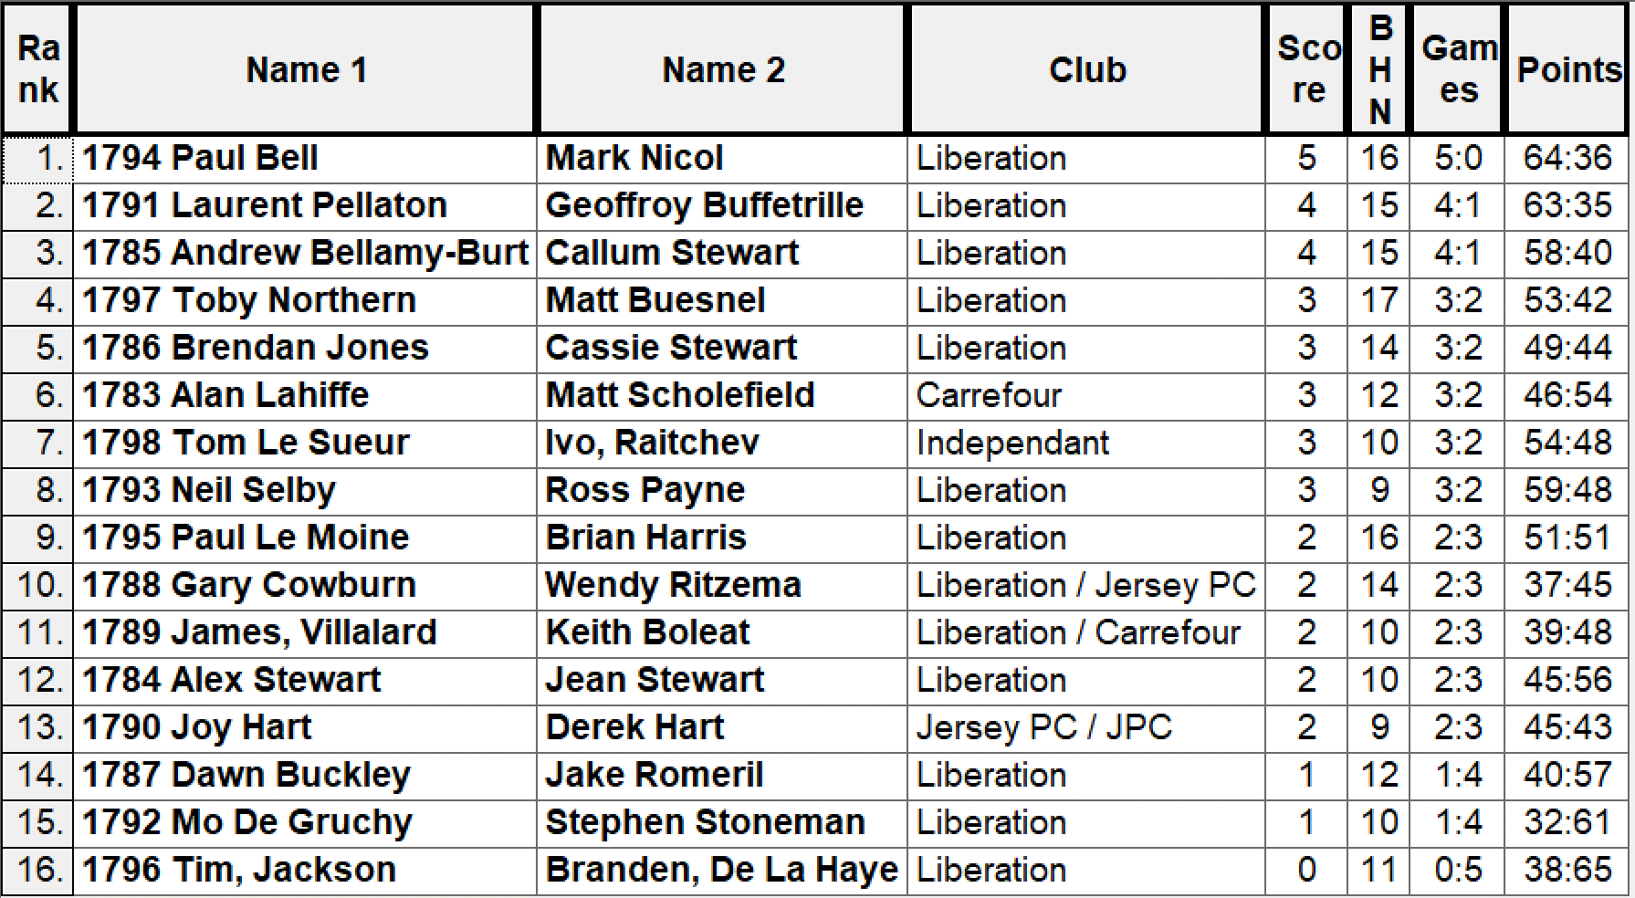

Quarter Finals

Paul Bell & Mark Nicol v Neil Selby & Ross Payne

Laurent Pellaton & Geoffroy Buffetrille v Tom Le Sueur & Ivo Raitchev

Andrew Bellamy-Burt & Callum Stewart v Alan Lahiffe & Matt Scholefield

Toby Northern & Matt Buesnel v Brendan Jones & Cassie Stewart

Paul & Mark fought out a close match against Ross & Neil who 9 – 4 down started to come back again but this time could not do so as they lost 13 – 9. Experience showed in the match against Laurent & Geoffroy who overcame newcomers Tom & Ivo 13 – 7.

For the second time Matt & Toby played Cassie & Brendan having beaten them 13 – 6 in round 1, beat them again 13 – 7 to make the Semi-Finals.

Andrew & Callum had to play Alan & Matt again also, having won comfortably 13 – 2 in round 5 had to play them again straight away in the Quarter-Finals. This was a big turnaround as Alan & Matt got revenge winning 13 – 6 to knock Callum & Andrew out of the competition.

Semi Finals

Paul Bell & Mark Nicol v Toby Northern & Matt Buesnel

Laurent Pellaton & Geoffroy Buffetrille v Alan Lahiffe & Matt Scholefield

In Semi-Final one Paul & Mark play Toby & Matt again having beat them 13 – 8 in round 5, this time is was slightly closer, but with Mark missing a host of shooting opportunities it could easily have gone the other way but Paul’s placing was spot on every time as Paul made the final two years running having done so in 2018 with James Rondel.

The second Semi-Final was timed out but saw Laurent & Geoffroy triumph 11 – 6 over Alan & Matt.

The third place playoff swung back and forth as Alan & Matt lead Toby & Matt 7 – 0 before the latter took a 12 – 7 lead. But end by end Alan got his last boule in with Toby & Matt missing their chances resulting in a 13 – 12 win for Alan & Matt.

The Final saw Paul Bell take the title at the second time of asking, this time with Mark Nicol who won this tournament in 2017 with Seb Renaud. The overcame Laurent & Geoffroy 13 – 6 in an untimed match.

Winners pictured below – Paul Bell & Mark Nicol

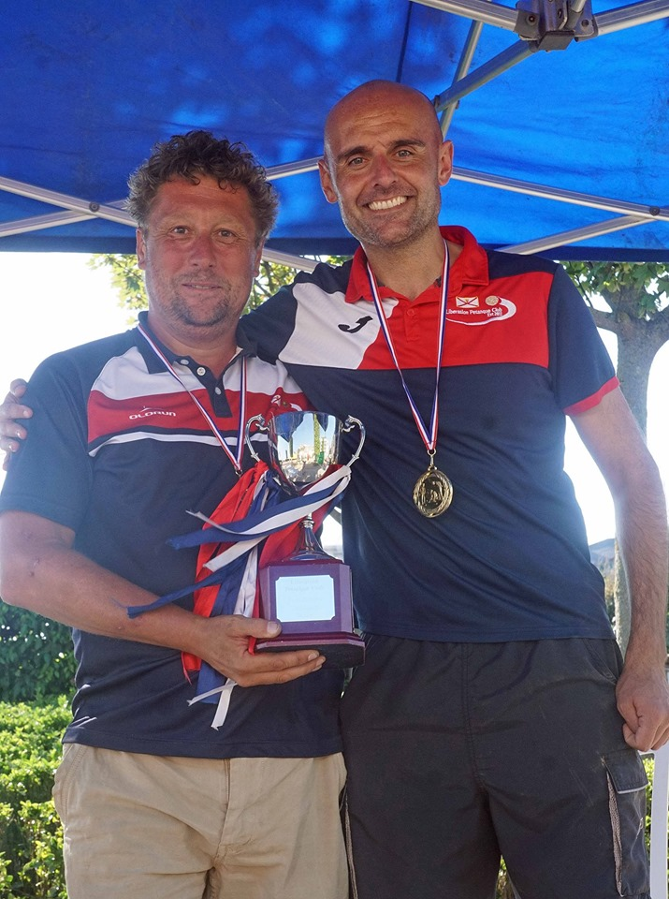

Congratulations to everyone who took part in another successful competition.

Thank you to everyone who helped prepare for this competition and the running of it on the day, which takes a great deal of time and effort.

Kind Regards

Toby Northern

Chairman

Liberation Petanque Club

www.liberationpetanque.co.uk

liberationpc@gmail.com

