BRIMPSFIELD PARISH COUNCIL
Draft minutes of ANNUAL MEETING OF THE COUNCIL
HELD AT 7PM ON 17TH MAY 2022
IN THE VILLAGE HALL
Welcome and introductions –
Election of Chairman took place
Following a Nomination/seconded – Cllr Overbury was duly elected signing of acceptance of office papers
Election of Vice-Chairman took place – Following a Nomination/seconded – Cllr Parsons was duly elected signing of acceptance of office papers signing of acceptance of office papers
Attendance recorded as Parish Councillors Tom Overbury, Roger Lock, Michael McWilliam, Jane Parsons, Heather Eaton, Claire Jardine, District Councillor Judd & 1 member of the public
Apologies recorded Parish Councillor Archie Larthe
County Councillor Joe Harris did not attend
Declaration of Interest for matters on the agenda were invited- none
Public Participation was invited – none at this point
No Report received from County Councillor Harris
Report received from District Councillor Judd (this was deferred to the Parish Assembly which immediately follows this meeting)
Minutes of the previous Parish Council Meeting held on 14th April 2022 approved following minor amendments – Chair to sign updated copy
Council reviewed structure of committees/working groups and any delegation of authority to those committees
Common Land working group -no delegated authority– members Tom, Roger, Jane, Archie & Heather
Road Safety working group – no delegated authority – members Claire and Michael

Council agreed delegation to Clerk of authority to make submission of comments on planning matters where no meeting of the Council is able to be held
Council deferred changes possibly required to standing orders or financial regulations pending new publications
Council considered if any changes are required to the asset register – none
Council reviewed representation on outside bodies -none
Council considered if any changes are required to insurance policy for the coming year - none
Council considered if any changes are required to banking mandate - still in process for electronic banking – Clerk to chase
Council deferred any changes possibly required to its Complaints, Freedom of Information or Data protection policies procedure -pending new publication
Council confirmed it wishes to continue with its standard contracts for grass cutting and payroll,
Council confirmed it wishes to renew its subscription to GAPTC
Council approved the financial reports and payment list as attached
Council approved its AGAR completion and delegated to the Chair of Council to sign the appropriate forms
Council agreed that its meeting schedule shall remain as 3rd Tuesday of May, July, September, November, January, March commencing at 7.30pm
Any other business for information
Planning items since received and Council asked for an additional meeting on Monday 6th June at 7.30pm

Meeting closed at 19.38

Approved Minutes of Extra Brimpsfield Parish Council meeting
held on 14th April 2022 at 7.30pm
In the Village Hall
Welcome and introductions
Attendance recorded as Parish Councillors Tom Overbury, Roger Lock, Michael McWilliam, Jane Parsons, Heather Eaton, Claire Jardine & 1 member of the public
Apologies for absence received – Parish Councillor Archie Larthe & District Councillor Judd
County Councillor Joe Harris did not attend
Declaration of interests on matters on the agenda were invited -none
Public session – no comments at this stage as member of the public wished to speak on item 8
Minutes of the previous meeting approved and minor amendments were approved by Council
An opportunity was given for District and County Councillors to speak to the meeting regarding the proposed Boundary Review and its possible implications – not in attendance
Council considered and approved its response to Boundary review consultation – details distributed via email and as attached - Discussion points
Following 2 roadshows /information sharing by CDC, Council considered the boundary relating to Brimpsfield Parish area

There are some dwellings which are close geographically to Birdlip
It was noted that Birdlip & Cowley Parish Council is intended to split

Public consultation and the lack of communication by CDC and the member of public noted that he was not informed on the matter until he received the agenda of this meeting. He asked for his disappointment in the lack of consultation and publicity for this review

The member of public felt that the original map lines were not correctly drawn on CDC documents

Member (Chair) of the Parish Council had contacted the “affected” homeowners on the evening of the roadshow to make sure that they were aware. Other members contacted the public subsequently
CDC officer discussion point was raised by Parish Councillor as one of the quoted feed -back was disputed
Deadline date for feedback was discussed as the CDC meeting in May 2022 is due to make a decision.

Effect on electoral roll and individual contributions to annual precept was noted
Effect on postcode /house valuations was discussed

The Council specifically looked at Blue dotted line and accepted that this dwelling to move to Birdlip

Other properties discussed as listed on post-it note
Gowanlea/Blacklaines Farm House – had expressed a wish to be in Birdlip Parish
Haregrove /Leveretes
Church View Bungalow, Blacklaines House, Cranmore
Blacklaines Cottages 1, 2- had expressed an interest in Brimpsfield
Blacklaines Farm

Boundary within NDP’s (future) was noted

Council agreed this map as preferred boundary (as per SD email 13/4/22) 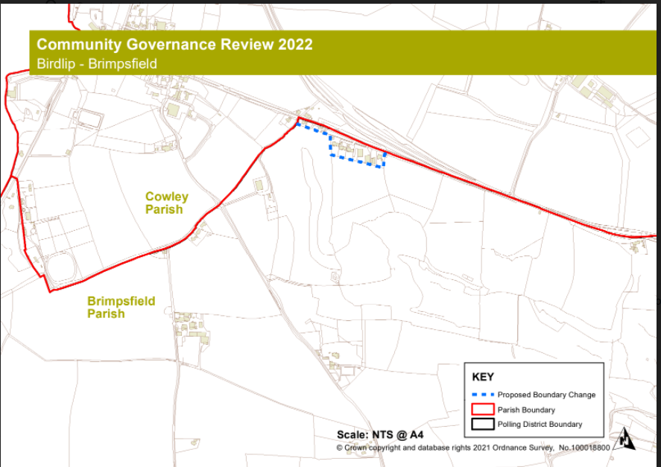

Council approved letter to property owners/contractors at Woodfield, Caudle Green to repair tracks across Brimpsfield PC owned common land -Cllr Claire Jardin
Any other business for the purpose of information sharing as no decisions can be made at this point
21/03856/FUL The Mill House additional information available -noted
Date of next meeting noted as 17th May 2022 at 7.00pm- AGM and 8pm for Parish Assembly
Village website to be asked to publicise. Agenda for Parish Assembly to be distributed 14 days before hand. Village Hall Committee Chair to be invited to present a report,
Close of meeting 20.17

Year- end financial reports to 31/3/22
Cash book
Date | Detail | Chq no | Payment/receipts | balance
01.04.21 | opening credit bal (TREASURERS C/A) |  |  | 4029.17
22/04/2021 | precept |  | 4743.00 | 8772.17
26/04/2021 | b j holder salary | so | 194.18 | 8577.99
17/05/2021 | b holder expenses | 580 | 59.61 | 8518.38
17/06/2021 | hmrc | 584 | 149.40 | 8368.98
19/07/2021 | b holder expenses | 585 | 68.81 | 8300.17
01/09/2021 | came & co | 586 | 374.50 | 7925.67
25/05/2021 | b j holder salary | so | 194.18 | 7731.49
25/06/2021 | b j holder salary | so | 194.18 | 7537.31
25/07/2021 | b j holder salary | so | 194.18 | 7343.13
25/08/2021 | b j holder salary | so | 194.18 | 7148.95
25/09/2021 | b j holder salary | so | 194.18 | 6954.77
23/09/2021 | precept |  | 1581.00 | 8535.77
14/10/2021 | hmrc j,a,s | 587 | 149.60 | 8386.17
14/10/2021 | pata | 588 | 23.85 | 8362.32
14/10/2021 | dicon roberts | 589 | 385.00 | 7977.32
16/10/2021 | b holder expenses | 590 | 67.99 | 7909.33
16/10/2021 | I selkirk | 591 | 105.00 | 7804.33
19/10/2021 | hmrc o,n.d | 592 | 149.60 | 7654.73
01/12/2021 | I partridge | 593 | 1290.00 | 6364.73
25*10/21 | b holder salary | so | 225.48 | 6139.25
25/11/2021 | b holder salary | so | 225.48 | 5913.77
25/12/2021 | b holder salary | so | 225.48 | 5688.29
17/01/2022 | pata | 594 | 23.85 | 5664.44
28/01/2022 | b holder salary | so | 225.48 | 5438.96
28/02/2022 | b holder salary |  | 225.48 | 5213.48
18/01/2022 | b holder expenses | 595 | 13.74 | 5199.74
20/01/2022 | wayleave | receipt | 28.98 | 5228.72
28/03/2022 | b holder salary | so | 225.48 | 5003.24
09/03/2022 | pata | 596 | 94.20 | 4909.04
08/03/2022 | b holder expenses | 597 | 13.54 | 4895.50
10/03/2022 | t overbury website fees | 598 | 195.60 | 4699.90
22/03/2022 | b holder backpay | 599 | 41.64 | 4658.26
31/03/2022 | hmrc jfm | 600 | 160.00 | 4498.26

Payment list for approval at May meeting
Expenses/clerk £16.81
HMRC £50.60 x3
GAPTC subscription £74.04
PATA Payroll annual fee £95.40
Roger Lock paint £59.99
Insurance £446.53.

Bank reconciliations

BANK SUMMARY
 | o/bal 1/4/21 |  | 4029.17
 | payments TO 28/12/21 |  | 5883.89
 | receipts TO 28/12/21 |  | 6352.98
 | Closing balance28/3/22/22 |  |  | 4498.26
BANK RECONCILIATION
treasurers | bank statement 28/3/22 |  |  | 4658.26
 | unpresented cheque | 600 | 160.00
 |  |  |  | 4498.26
 | current account |  |  | 4498.26
 | deposit account |  |  | 3146.86
 | BANK BALANCE |  |  | 7645.12
 | reconciled balance |  |  | 7645.12

Reserves at year end
 |  | 2021 | 2022
 | reserves brought forward | 6479 | 7176
 | general reserves | -1273 | 520 | Council budgeted for £900 overspend but achieved £1377 underspend
 | earmarked DEFIB grant | 625 | 625
 | earmarked equipment | 1500 | 1500
 | contingency fund | 6324 | 5000 | Ideally = 1 yr precept
 | at year end bank balance | 7176 | 7645

Council approved distribution of reserves at year end.
Council to consider charges for contested elections to be imposed by District Council and considered if some of the contingency fund should be vired to new “election” earmarked reserve

Budget against actual at year end
 | BUDGET | income/ expenditure 31/3/22 | BALANCE
INCOME
Precept | 6324 | 6324 | 0
Interest | 1 | 0 | 1
VAT refund | 0 | 0 | 0
Wayleave | 30 | 29 | 1
other | 0 | 0 | 0
TOTAL INCOME | 6355 | 6353 | 2
EXPENDITURE
Clerks Salary | 2910 | 3044 | -134
Admin / Expenses | 360 | 348 | 12
Payroll Management | 100 | 142 | -42
Insurance | 365 | 375 | -10
Audit | 120 | 105 | 15
Grass cutting Brimpsfield | 500 | 500 | 0
Grass cutting Caudle Green | 1000 | 790 | 210
Meeting Room hire | 200 | 0 | 200
Subscription | 80 | 0 | 80
Training | 0 | 0 | 0
legal/specialist Advice | 150 | 0 | 150
Maintenance & repairs | 800 | 385 | 415
Grants / Donations | 200 | 0 | 200
FROM RESERVES |  | 0 | 0
Equip & Assets | 0 | 0 | 0
Web- site | 176 | 196 | -20
Sect 137 | 0 | 0 | 0
Village hall Grant | 300 | 0 | 300
EXPENDITURE TOTALS | 7261 | 5884 | 1376
Anticipated from reserves | 906 | 471 | Actual underspend
 | 6355 | 6355

AGAR forms approved and signed

Annual financial statement

