JSB Capital Management, LLC
Pro-active Wealth Management

March 24, 2020

Without question, the weeks since the U.S. stock market hit its all-time high on February 19th have produced an unprecedented movement and volatility in asset prices. Not only did the market reach a 30% decline in record time (fewest number of trading days), but it also saw the highest percent gain in history in one day (up 11.4%) today. In fact, over the last five weeks the stock market has experienced the largest percentage loss per day six times and the largest percentage gain per day five times, in history!
This would test even the most experienced investor’s patience and intestinal fortitude, and it has. Each time the market decline appeared to have reached a nadir, it would continue lower as more bad news poured in. We appear to have seen a temporary low for the very short-term with today’s surge higher, but there’s likely another challenge to be made over the next week or two at the low point we saw yesterday.
What is going on here and what investment implications does it have?

Let’s start with what’s on everyone’s mind:
The U.S. has closed down vast portions of our economy as have just about every other major nation on the planet. Overnight, PM Modi of India, with over a billion citizens, has totally locked down the entire country (despite currently having 536 incidents and 10 deaths) creating near riots from panic buying. Globally, in most countries, coronavirus caseloads continue to increase rapidly and much of the public is remaining indoors
Many international investment banks have attempted to extrapolate where this situation might lead. For example, JP Morgan forecasted that Italy was likely to pass its virus peak soon. This forecast was made on March 17th:
LONDON (Reuters) - JPMorgan said on Tuesday (3/17) it expected ‘active’ coronavirus cases in Italy to peak in the next seven days based on its internal models.
It said those models have been in line with the daily reported cases.
JPMorgan defined net change in ‘active’ cases as new infections less the change in recovered patients less the change in deaths.
The U.S. bank said for the European Union’s biggest countries — Germany, France, Italy, Spain and the UK — it expects active virus cases to peak by the end of March at close to 80,000 infections.
Source: Reuters
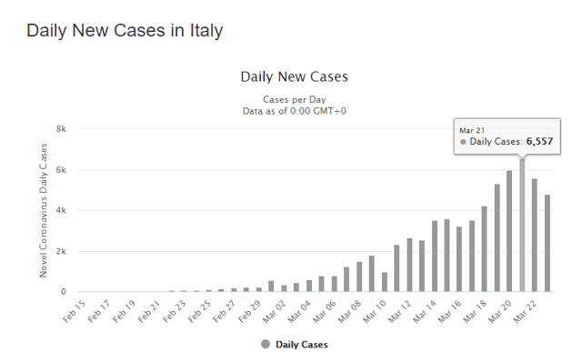
Source: Worldometer
It should be noted that Italy went into full lockdown on March 11. If the peak in daily new cases in Italy holds, Italy will be following the same timeline as S. Korea of approximately 43 days from initial outbreak to the peak.
While the fight against the virus can be won, the biggest question on investors' minds is how long this war will last. Currently China offers some clues in that regard as its Wuhan Lockdown, where the first case of coronavirus was detected, is about to be lifted. Authorities in Hubei, the province where the COVID-19 outbreak started, announced they are lifting tight travel restrictions beginning Wednesday provided people have a clean bill of health. Whatever that means. It will be critical to see if the infection rate resumes higher once the people roam free.
Monday marked the first time in weeks that people had been seen returning to China's streets after being locked up for two months in their houses to curb the spread of the infection.
The Trump bump:
President Trump not too subtly hinted on Monday that the economic shutdown designed to halt the spread of the virus across the country could be coming to an end “by Easter.”
“Our country wasn’t built to be shut down,” he said. “America will again, and soon, be open for business,” the president declared. Today, the market responded to that prospect and it probably also had something to do with the bullish comments first thing this morning by Larry Kudlow who trumpeted (pun intended) the massive “soon-to-be-passed” Congressional stimulus plan. He appeared all over the TV thumping his chest.
These two events followed the action on Monday by The Federal Reserve as it released its full “nuclear monetary arsenal” declaring that they would buy unlimited amounts of corporate bonds, agency bonds and even Exchange Traded Funds (ETFs). For the first time in its history the Federal Reserve is set to purchase ETFs as part of its aggressive quantitative easing measures in a bid to calm spooked stock and bond markets.
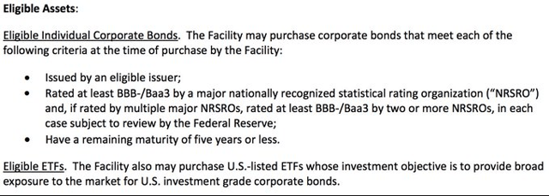
Source: Federal Reserve
How will the market react to these events?
With an unlimited money printing press at its disposal the Federal Reserve will look to “plug holes” in the fixed income markets as it discovers them. The estimated $2.5 trillion Congressional stimulus plan, if/when passed, will calm some workers nerves as well as provide short-term traders with the spark they need to lunge back into the equity markets.
There appears to be at least two distinct possibilities for what the stock market will do in the short-term:
- Using history as our guide, previous “bear” markets have exhibited a “head fake” when the first sign of a bottom in prices appeared. This is characterized by a brief (two to three weeks) breath-taking recovery sometimes amounting to 30-40% up, followed by what is known as a re-testing of the lows to, in effect, verify the earlier bottom. This bottoming process is commonly confirmed by the market demonstrating strength on a day or days when bad news would normally see a precipitous drop (like what we have experienced at least six times in the last five weeks).
- The other possibility is that this bear market is as unique in its recovery as it was in its historical decline. The “black swan” which appeared suddenly as the global pandemic could be followed by an “instantaneous” cure or at least an effective treatment, and the result could be a very rare “V-shaped” bottom that would never test the previous lows.
The next several days should provide some clues as to which scenario plays out, but right now it appears that we’re in a very short-term melt up that will end with some bad news overwhelming the bulls. The bad news will likely begin with economic data such as the predictably horrible unemployment numbers that will come out on Thursday morning before the market opens. The new claims for unemployment insurance will be in the millions and it will be unprecedented. Think about how overwhelmed the system will likely be, there will be unfulfilled claims still, and the new claims could continue in the weeks ahead to set new records.
Also, with the U.S. conducting tens of thousands of virus tests each day now (we have officially passed South Korea, thought to be the template for testing, when we reached over 300,000 tests as of today), the number of “new cases” is rapidly increasing which means we haven’t experienced the “peak case” situation that is described above as in Italy’s (or South Korea’s) case.

Conclusion
While recovery days like today slightly dampen the pain of a nearly 40% loss in five weeks, the 11-year bull market is over. Markets reset and settle in over time and then the inevitable recovery begins. We could see a very rapid rise in stock prices over the coming months and we are prepared to take advantage of that. We have spent the last several weeks pouring over fundamental and technical data for hundreds of stocks looking for the top players in the most attractive industries. We have developed strategies which will take advantage of the world we will live in after this is all over. It is an exciting and vibrant environment and there will be big winners. There are a few opportunities right now in blue-chip names that we didn’t think we would have a chance to own at these discounted prices. There will be other great buys once the bottom is established (or as close to it as humanly possible). If the market “chooses” to form a “V,” it will simply mean a slightly reduced discount then.
Please contact us with any questions you have. We will publish another letter soon to follow up on this one.

