***Pleasant Township Board of Trustees Meeting Highlights***

**Date _November 26, 2024______________ Next Resolution No._ 79—11-26-2024_ _**

* **Call to Order -- The meeting tonight will also be on WebEx. (Paula off sick)**
* **Please stand for a moment of silence. --Pledge of Allegiance--Roll Call**
* **Visitors –**
* ***Hanna Poling*** with the Southwest Messenger via WebEx.
* Grove City IT gave an overview of what they provide for Pleasant Twp. and a presentation about some upcoming changes we should be thinking about and planning for. Most importantly, a multi-factor authentication implementation for added security at an annual cost of $2,500. The network infrastructure we currently have is 7 years old and past it’s lifetime. To replace it will be a one time cost of $8,000. Also discussed additional security cameras, new office software, update to Windows11 by 10/25 when it expires and restriction to Go-Daddy access.
* Leeoria Willis, OSU Extension, Montgomery County, Educator, Agriculture and Natural Resources, [willis.615@osu.edu](mailto:willis.615@osu.edu), Office: Montgomery County, Phone: 937-637-6536 Leeoria came to present a resolution from the Montgomery County Commissioners for two Pleasant Twp. Firefighters attending the grain bin rescue class.
* **Minutes to approve**- No minutes
* **Financial Reports** – Paula absent but gave checks and report to Ed. Payroll 11/19/24, gross $49,482.34, IRS payroll tax of $9,043.63, State, School & Local tax for October was $5,424.75, Deferred Comp. $580.00, CME-HAS deposits $285.00 and 22 total checks for expenditures of $15,588.97 Motion to pay expenditures.
* ***Department Reports***
* **Franklin County Sheriff’s Dept-Community Liaison, Deputy Adkins, 1120- Cell: 614-809-5843**
  + 11/12/2024 through 11/26/2024
  + Total Calls for Service/Self-Initiated Runs: 114
  + Total Reports Taken: 13
  + Total Arrests/Citations: 5
  + Burglaries: 0
  + Traffic Crashes: 12
  + Medic Runs: 16
  + Thefts: 2 (3300 block of Georgesville-Wrightsville; 7100 block of Johnson)
  + Missing Persons: 0
  + Stolen Vehicles: 1 - 9100 block of Alkire
  + Suspicious Persons/Vehicles: 5
  + Vandalism:0
  + Traffic Offenses: 11
  + Motorcycle/ATV/Bike Complaints: 0
  + On November 11th, Deputies responded to the 9100 block of Alkire Road on the report of a stole ATV. Upon investigation it was determined that an unknown person(s) had taken the ATV from a detached garage. This investigation is ongoing.
* **Road Department****- Rick Haag in for Robert Bausch, Superintendent**
* Equipment repair
* Headstone footers
* Transitioning to winter operations
* *Any updates on Gay Rd. about repairs due to heavy rains washing the roadway and gravel away. (meeting on 8-8-23 we said we’d keep it on the agenda till resolved in some way.)*
* **Fire Dept. – Chief Whiting**
* Apparatus
* M-231 at Brawn – will get back in January
* Personnel
* Equipment
* The generator on the agricultural trailer was repaired.
* Updated rope rescue equipment in service. – Some ropes we had were over 10 years old.
* Looking at AEDs for two vehicles (utilizing grant money)
* Received a Thermal imaging camera from the Shriner’s- Chief applied for a donation grant from the Shriner’s and they selected Chief Whiting’s application. This camera is worth approximately $4.500.
* Training
* Multi-agency training evolution in the park on lost and injured hunters.
* Players-Prairie Fire/Metro Parks/Grove City Dispatch
* Station
* Well pump went out/without water for 24 hours/had to replace well pump-temporary pump in place Resolution 79 to pay Blair Well Drilling & Plumbing $3,500 for repairs.
* The plumber replaced it with a new pump & repaired the well casing today (in the works now).
* Miscellaneous painting and drywall repair.
* Changing who we utilize for our HVAC work-local contractor
* Chief and Robert met with an electrician about security lighting on the township property. The estimate is $6.260, not sure how long this estimate is good for.
* Community Risk Reduction
* One foster home inspection
* Numerous building inspections

Billing

* Currently working on reporting that is required by the Feds. The required date was pushed back to May 31, 2025.

**New Business –**

* Resolution 80 to reimburse Trustee Sheets for his notary renewal in the amount of $95.
* 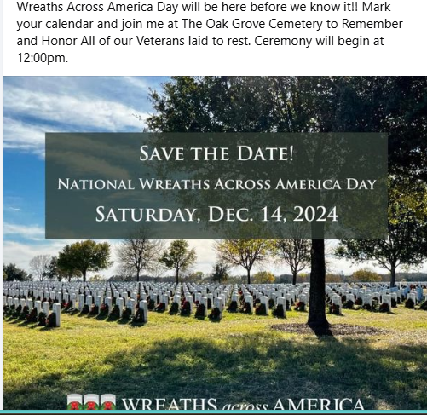**Announcements -**---------------------------
* **Clerk Updates- Paula -absent**



* **Speaker Sheets-** (come to the podium to be heard on WebEx)
  + Alicia Geiger

* **Adjourn** at 7:50 p.m.