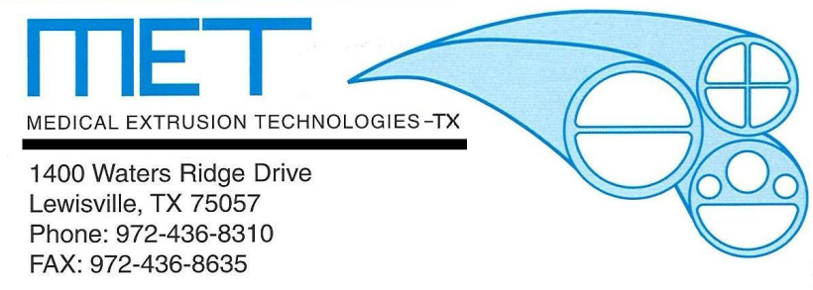

05 May 97 -Medical Extrusion Technologies, Inc. establishes a corporate presence on world wide web
Murietta, CA. Medical Extrusion Technologies, Inc. (M.E.T.), a manufacturer of custom tubing extrusions from thermoplastic resins, announced today that it has launched its New home on the World Wide Web. The company Web-Site can be found at:
http://www.MedicalExtrusion.com

Brian Frechette
General Manager
Medical Extrusion Technologies, Inc.-TX
Brian@MedicalExtrusion.com

