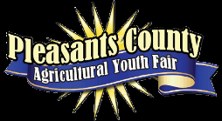
½ Processed Hog Raffle 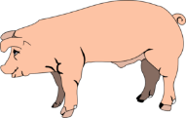
Winner will receive half of a hog, fully processed at their request. Processing fees paid by PCAYF BOARD.
(Smoked or cured meat available, at an
additional cost to the winner.) ~$10.00 per ticket~
Drawing on
Sept. 17, 2023 @ 2:00p.m.
Purchase tickets at Phillips Pharmacy or the Pleasants Co. Extension Office.
Call 304.684.2448 for info.
Proceeds benefit the Pleasants Co. Agricultural Youth Fair, Inc.
You have 2 chances to win!

