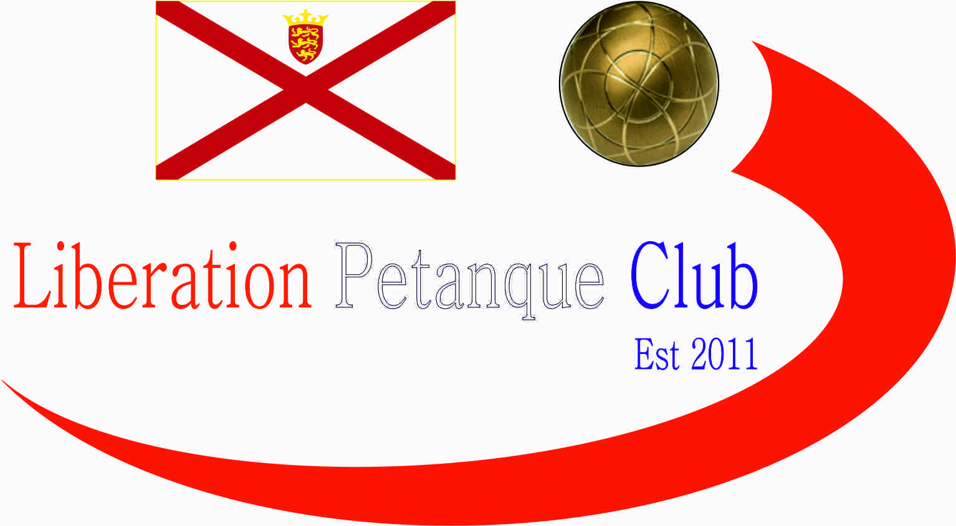  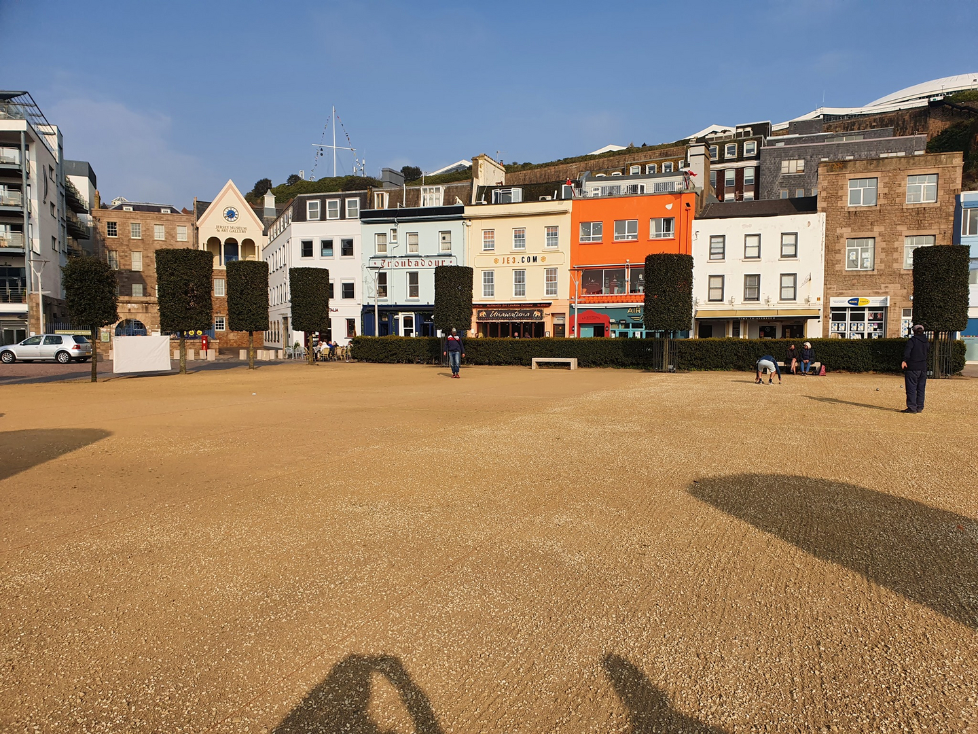  - 2023  open competitions  We are pleased to announce we will again be holding our International Open over Friday 14th to Sunday 16th July. The Singles and Doubles Opens will be incorporated into the International Open competitions. See contact details for Entry forms for International Open with details of Entry fee’s.  Entry Fee’s are £8.00pp for Members and £10.00pp for None Members.  Ladies Singles Open _______________________________  Mixed Doubles Open Player 1 _______________________  Mixed Doubles Open Player 2 _______________________  Charity Triples Open Player 1 _______________________  Charity Triples Open Player 2 _______________________  Charity Triples Open Player 2 _______________________  Contact No. _____________ Email ____________________ | Competition Dates  ____  International Open Singles – Fri 14th July Doubles-Sat 15th July Triples-Sun 16th July  ____  Ladies Singles – 27th May  ____  Mixed Doubles – 26th August  ____  Charity Triples Open 21st October  Liberation peranque club  www.liberationpetanque.co.uk  Club Email - liberationpc@gmail.com  Bacs Payments to: Sort Code – 40-25-34 Account No. 92557738
Liberation Petanque Club

