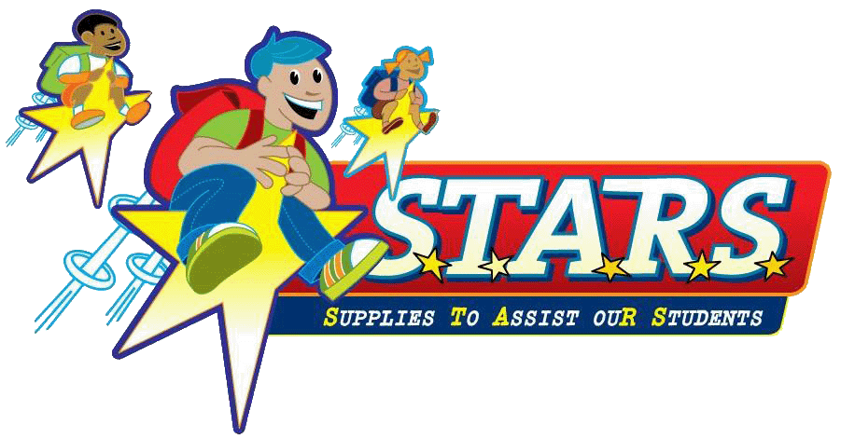

The Joe & Chesta Hembrooke
“Reach for the STARS”
Scholarship
2019 Application

All applications, with supporting documents, must be submitted to
STARSfofWO@gmail.com by 9:00 p.m. on Friday, April 12, 2019

.
“Reach for the STARS” Scholarship Requirements

- Student must be graduating from an OCPS high school student at the end of the 2018-2019 school year and must live in one of the following (West Orange County) zip codes: 32703, 32704, 32712, 32805, 32808, 32811, 32818, 32835, 32836, 32835, 34734, 34740, 34760, 34761, 34777, 34778, 34786, or 34787.
- The completed application, transcript, essay, letters of recommendation, test scores and acceptance letter/proof of application must be emailed by 9:00pm on April 12, 2019 to STARSofWO@gmail.com. A confirmation email will be sent within 3 business days of your application being received.
The Scholarship Review Committee will determine the scholarship winner(s)
based on funding and the quality of applications submitted.
Scholarships will range from $250 - $1000.
Scholarship winners must send proof of acceptance into
a post-secondary institution before scholarship money is released.

PERSONAL INFORMATION
Please type or print

Applicant: ___________________________________________________ Current Age: ________
Last Name First Name Middle Initial

Parent/Guardian Name (that student lives with):___________________________________________

Home Address: _____________________________________________________________________
Street City Zip

Telephone: (_______) __________________ Email: ____________________________________

High School you will graduate from: ____________________________________________________

Names of References (please print/type):

Academic Reference: ______________________________________________________________

Position: ____________________________________ Location: ________________________

Personal Reference: _________________________________________________________________

Relationship (Non-Family): _______________________________________________________

My signature below indicates that all information contained in the full application is complete and factually correct.

Student Signature_________________________________________________Date______________

Parent/Guardian Signature ________________________________________Date_______________

**Please Note ** Failure to provide any of the below could disqualify applicant.

- Official Transcript
An official transcript of school work through the first semester of the current school year must be submitted, to include UNWEIGHTED cumulative grade point average and class standing for grades 9th- first semester 12th. ONLY an official transcript will be accepted. This document cannot be an academic involvement or subject/grade printout.
- Recent Test Scores– PSAT, SAT, ACT, TABE, or PERT scores accepted.
- Application Packet
The application packet should include:
- An essay, of no more than 800 words, responding to either question:
  - How have you made an impact in your community?
  - How will continuing education benefit yourself and your community?
- An acceptance letter from your desired institution. If you do not have a letter of acceptance yet, please submit your application and then send in the acceptance letter ASAP.
- A list of your outside activities, such as church or community involvement, offices held and/or paying jobs you have had outside of school hours.
- A list of your membership in any school clubs and organizations.
- A list of any academic and service honors received.
- Reference Letters
One letter of academic recommendation and one letter of personal reference
(non-relative) are required.

All applications must be submitted no later than Friday, April 12th at 9:00pm to STARSofWO@gmail.com.
It is suggested that all information be submitted simultaneously however,
letters of reference and transcripts may be emailed separately.

All participants will be invited to attend the STARS 16th Anniversary of Giving and Volunteer Recognition Event to be held on April 27, 2019. Participants will be recognized and winners will be announced at 1pm.
Scholarship money will be distributed, upon confirmation of proper documentation, beginning June 1, 2019.

