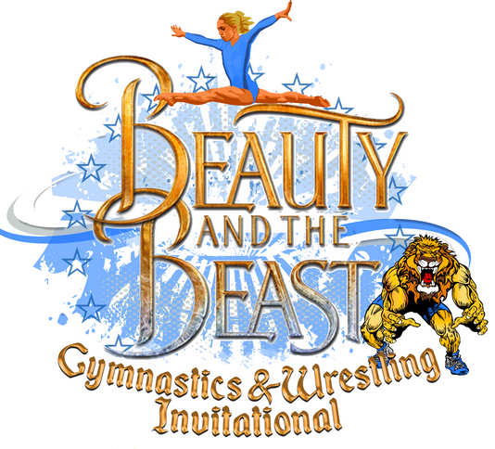

January 19-21, 2018
Rhode Island Convention Center
1 Sabin St.
Providence, RI 02903
Hosted by:
Dream Big Gymnastics
41 Comstock Pkwy.
Cranston, RI 02921
(401)228-8946

Dear Business Owner,

The Beauty and the Beast Gymnastics and Wrestling Invitational is the first of its kind in youth sports. To create a world class athletic competition that celebrates the best sports on the planet, side by side. At the 2019 Beauty
and the Beast Invitational we are expecting over 1,500 competitors; 1,200 gymnasts and 600 wrestlers, and over 3,000 spectators. These spectators are active families living throughout New England. We are looking for businesses that would like to get noticed by being a sponsor for this exciting event. By becoming a sponsor you will be helping your business expand into this active market. This is a perfect opportunity to work together as a business community and expand local commerce.
Let’s Dream Big together.

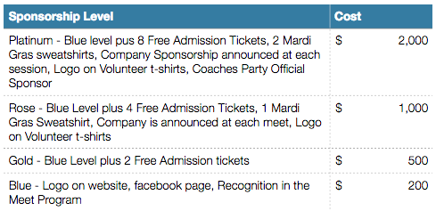
Please fill out this form in order to be added as a sponsor
at this year’s Invitational. Please email logo in .pdf or .jpg format to

victoria@dreambiggym.com

Please submit check with form made out to Dream Big Inc. by December 21, 2018.

Name of Company:__________________________________

Business Address:___________________________________
___________________________________________________

Contact person:_____________________________________

Phone:_____________________________________________

email:______________________________________________

Business website:___________________________________

Sponsorship level:___________________________________

Sweatshirt size(s):___________________________________

Dream Big athlete you are associated
with:_______________________________________________

Thank you for your support. We hope to see you at out big Invitational!!

We will be sure to get your business
noticed!

Form and payment must be submitted by December 21, 2018.

