CONSTITUTIONS - We trust that our elected officials will take their oaths of office to heart and will act accordingly during their terms.
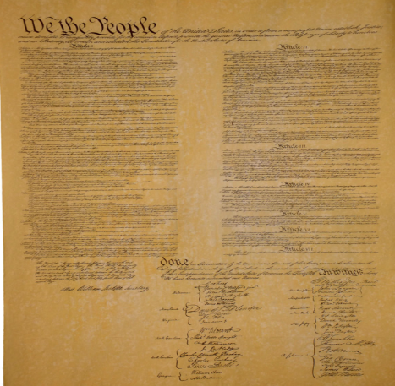 | Presidential Oath of Office - "I do solemnly swear (or affirm) that I will faithfully execute the office of President of the United States, and will to the best of my ability, preserve, protect, and defend the Constitution of the United States."  The Congressional Oath of Office - "I do solemnly swear (or affirm) that I will support and defend the Constitution of the United States against all enemies, foreign and domestic; that I will bear true faith and allegiance to the same; that I take this obligation freely, without any mental reservation of purpose of evasion; and that I will well and faithfully discharge the duties of the office on which I am to enter. So help me God."  New York State & Local Officials Oath - "I do solemnly swear (or affirm) that I will support the constitution of the United States, and the constitution of the State of New York, and that I will faithfully discharge the duties of the office of _____ according to the best of my ability."
QUESTION OF THE MONTH - The oath of office is a contract with the citizens of the jurisdiction to which an official has been elected or appointed. The oaths don't provide leeway for personal or political preferences, competence, abilities, race, creed or gender. Yet many officials who have broken their contracts are tolerated, defended, protected and even promoted. Is the oath of office binding or merely an archaic ritual?

