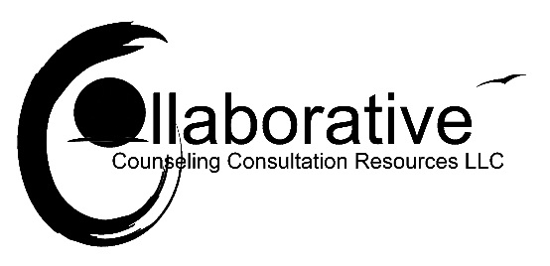
Testimonial Release Form
I hereby grant The Collaborative. Counseling-Consultation-Resources LLC. to use my testimonial in any and all of its publications, including website entries, without payment or any other consideration.
I understand and agree that these materials will become property of The CollaborativeCCR LLC. and will not be returned.
I hereby authorize The CollaborativeCCR LLC. to exhibit, publish or distribute this testimonial for purposes of publicizing The CollaborativeCCR LLC. or for any other lawful purpose.
I am at least 18 years of age and am competent to contract in my own name. I have read this release before signing below and I fully understand the contents, meaning, and impact of this release.
Your Name: ______________________________ Your phone number: _________________________
Your Address: _____________________________________________________________________________________
Your email address: _____________________________________________
Your Testimonial: ________________________________________________________________________________________________________________________________________________________________________________________________________________________________________________________________________________________________________________________________________________________________________________________________________________________________________________________________________________________________________________________________________________________________________________________________________________________________________________________________________________________________________

