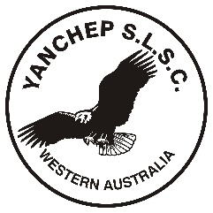
Yanchep Surf Lifesaving Club

NIPPERS
IMPORTANT DATES 2018/2019 SEASON

13th October 2018 Proficiency Swim 10:30am-12:30pm
4th November 2018 Nippers Commences
16th December 2018 Christmas Break, Last Day for 2018.
3rd February 2019 Nippers Resumes for 2019
3rd March 2019 No Nippers (Long Weekend)
31st March 2019 Last Day of Nippers and Presentation

