|  |  |
| --- | --- |
| *Puckety Presbyterian Church*  *1009 Puckety Church Road Lower Burrell, PA 15068*  *(Return Service Requested)* |  |
| Last Day For:  **Post Scripts Information:**  Third Friday of the month.  **Bulletin Information:**  The Tuesday before the Sunday the article is to be announced  **REMINDER:**  Worship: 10:00 a.m.  Zoom/video at pucketychurch.org | [This Photo](http://frommidnight.blogspot.com/2011/09/hey-midnight-warriorsdo-yall-hear.html) by Unknown Author is licensed under [CC BY-NC-ND](https://creativecommons.org/licenses/by-nc-nd/3.0/) |
| *Puckety Church*    Our vision is to be the heart, voice and hands of God, making a lasting difference in your life, in our community and the world. | |



 ***Puckety Presbyterian Church***

**At Puckety we personally and collectively Honor God, Grow in Faith,**

**and Improve our Community and World.**

**October 2020**

*Pastor’s Corner*

Please first read **Matthew 19:16-30**

In our Sunday messages over the last 3 months, we’ve been taking a *thorough* look into the second half of the Gospel of Matthew *(chapters 13 through 19 to date)*. In the current series, we’re going to skip chapter 19, so I wanted to offer a devotional on it for you here.

First, I want to point out the *striking contrast* Matthew wants us to see. Right before Jesus’ encounter with the rich young man (*literally 2 verses*), he reprimands the disciples for scolding parents for bringing their children to him; Christ says, “the Kingdom of Heaven belongs to those who are like these children.” Now, *keep that in mind* (how Christ is saying that *the humble* have it right). Now look at the rich young ruler (who is a great representative for *most churchgoers and leaders* by the way). He appears so confident, so well organized, so determined. I mean he has worked *hard* to “be good.” But he looks into the face of the one *he* calls “good” and turns away sad. He had hoped to impress Jesus with his piety and devotion. [Don’t we do the *same*, sometimes?]. Unlike the “sinners” of whom we’ve heard about in previous chapters, he had an impeccable moral record – “I’ve kept all these [commandments] since I was a boy. What else must I do?” To which most church boards say, “*Quick*, call the nominating committee!”

But Jesus knew that this young man was trying to do all these “good” things *here* (on earth) to get what he wanted *there* (heaven – the heaven he had in mind – Jews usually thought of it as a new place, fresh and free of corruption, decay and death). His idea of heaven wasn’t necessarily wrong, but his focus was.

See, Jesus was bringing this kind of realm into the present – a realm where God and his children live with each other, where God rules with his saving power. Where Jesus was, and where people (like children) with humble and penitent trust accepted that God’s kingdom was active in him, there the life of the new age began to be seen. That’s why the rich young man became sad. ***In order to inherit the life of the new age, he had to abandon the values of the old and trust himself totally to the new***, like a diver throwing himself forwards into the water. This is what we’re called to do as well, and it’s not as easy as we think. Have you ever stood on top of the “high dive” platform at a competition pool? I have, and TRUST me, it seems WAY higher up there then it did on the ground!

In this passage, we’re called to relate to the young man and ask ourselves, “Am I wedded to my ***possessions***?” … “Do I find security in my ***performance***– my own righteousness?” If the answer to either is “Yes,” then we may never be able to accept God’s kingdom like a child, with the humble trust that allows God to be God. The true wealth is to be found in the heavenly realm BUT ‘treasure in heaven’ doesn’t simply mean the sort of treasure you possess after you die, but treasure that’s kept safe in God’s storehouse until the time when heaven and earth are brought into their intended unity. Even now, this new age breaks into our sad old world, within the life of Christian fellowship – new families, new attitudes, new opportunities that open up for those who leave behind the old ways and the “old Adam.” The church is called in every age to be that sort of community: a living example of the age to come. So, *instead of turning away sad*, I invite you (and ask you to invite me) to say “Yes” to that sort of selfless and trusting common life, so the world around can glimpse what God’s new world is like! Amen. ~ Pastor Brian

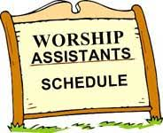

### 04 Chari Burtner

### 11 Michelle Gordon

### 18 Mick Dober

### 25 Beth Dober

### Your Deacons:

**Your Session:**

Deb Artman – Clerk

Chari Burtner Jack Barnett

Rebecca Fisher Michelle Gordon

Charlene McKay Jennifer McKay Matt Wehrle Chuck West

Mira Whalen

Sandy Ankney Mick Dober

Pat Fish

Margie Hazlett Traci Kirchartz

John McAllister

Cecil McCutcheon

Brandy Roland Maria Schafer

Kim Soulcheck Peg Uhing

Jean Welte

**Corporate Officers:**

**President:** Matt Wehrle

**Vice-Pres.:** Jennifer McKay

**Secretary:** Debra Artman

**Treasurer:** Donna Bracken

**"The Memorial Service for Bill Lundie will be on Saturday, October 3rd at 1:00 PM at Puckety. Nita would like to invite the Puckety Church family to the event in honor of Bill and to the glory of God."**

# 

**Attention Puckety Offering counters:**





Please warmly welcome all, provide masks if needed and direct to designated seating.

### Pastor:

Reverend Brian Kilbert

### Administrative Secretary:

Kelly Kapelewski

### Treasurer:

Donna Bracken

### Choir Director:

Lorraine Menk

### Organist/Pianist:

Sue Close

### Housekeeper:

Irene Nelson

### Financial Secretary:

Judy WestChuck West will handle

counting with Donna

Bracken until further notice.

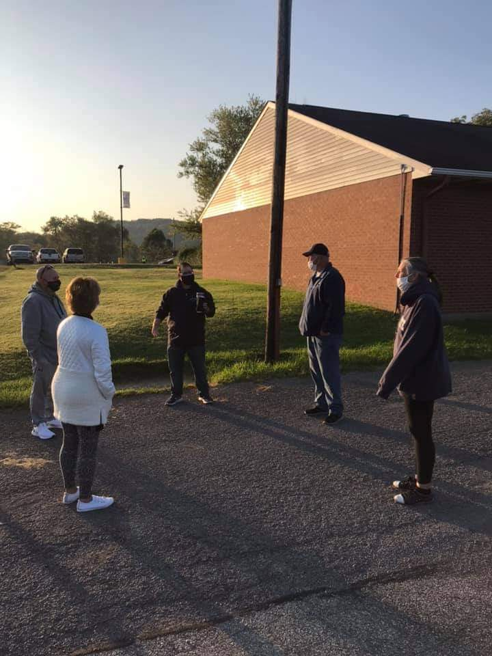

Seven of our members

gathered behind

Faith Hall to pray for the

students, faculty, teachers and

other staff of the Burrell School

District.



1 Evan Girard

4 Ryan Bargerstock

Beth Hilbeck

9 Nita Lundie

10 Rachel Aungst

Sandy Schafer

12 Joel McCullough

Kwade Kirchartz

14 Denise Johnston

Elaine Bargerstock

16 Doug Marshall

Chris Hilbeck

17 Bridget Brown

18 Jessica Mele

20 Melissa Brown

24 Doris Prinkey

30 Lillian Blandford





*The Bible readings are from*

*“Book of Common Worship”*

***For the week of: October 4:***

*Exodus 20:1-4; 7-9, 12-20*

*Psalm 19*

*Phil 3:4b-14*

*Matthew 21:33-46*

***October 11:***

*Exodus 31:1-14*

*Psalm 106:1-6;19-23*

*Phil 4:1-9*

*Matthew 22:1-14*

***October 18:***

*Exodus 33:12-23*

*Psalm 99*

*1 Thes 1:1-10*

*Matthew 22:15-22*

***October 25:***

*Deut 34:1-12*

*Psalm 90:1-6, 13-17*

*1 Thes 2:1-8*

*Matthew 22:34-46*



**If you know of a college student that could benefit from receiving the OUR DAILY BREAD, please give their name and address to Margie Hazlett 724-337-6629, and she will mail a copy to their dorm or apartment or even to home if they are in virtual school at this time!**



*(October 4th) is **World Communion Sunday** – please prepare your hearts for the Sacrament – whether you celebrate remotely at home or in-person.



The *Crafting Circle* meets the first Saturday (October 3) of the month from 8:30 AM to 10:00 AM in Faith Hall.  ALL crafts that can travel are welcome, not just yarn crafts.  Please feel free to join us!   If your craft can be a bit messy please bring something to protect the table surface.  Please wear a mask until we all get settled at a good social distance.

We still need people to step forward to offer special music for our Sunday worship.  Please contact Lorraine Menk, choir director, at 724-339-9531 or kirbie1@comcast.net if you would like to learn more.



***Remember to check Puckety's website and social media for information on upcoming events and encouragement!***

Website: [www.pucketychurch.org](http://www.pucketychurch.org)

Like and Follow on Facebook: Puckety Presbyterian Church

Follow us on Instagram: Puckety Church

Follow us on Twitter: @churchpuckety  

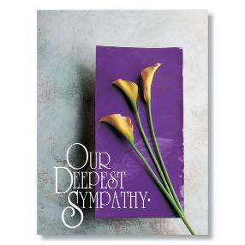

Our sympathy to the family and friends of Norma Thompson who passed away on September 23, 2020.



***October 25, 2020***

Weird Wonderings from Wiebke

Dear new friends and family in Christ,

Many of you have asked if we are settled in and I can say that the beautiful house feels very much like home now.   We are all settled in and the day to day rhythms and schedules are getting established as best as they can in these times.   We have found the essentials: food, Walmart,  pet store, vet and doggie day care.  Now we need some help with some of the weirder things to help us with our transition.   Please feel free to call me at 724-799-3323 or e-mail at [veesb@yahoo.com](mailto:veesb@yahoo.com) if you have any suggestions to the below:

Where can a girl get a straw bale for her Halloween display?

When the time comes where can I get fresh cut greens for the Christmas display?

What local mechanic will not try to tell me that my manual transmission needs a flush?

Best local dentist?

Any recommendations for a trusted cat sitter that will be ok doing oral medications?

Best local bakery that isn't Giant Eagle for breads and sweets?

Best local sushi?

Are there any really good Mediterranean restaurants in our area?

Best local place for a pedicure?

Which Kohls is better, Gibsonia or Monroeville?

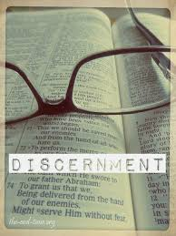Discernment? What is that? By Wiebke Kilbert

I am so looking forward to meeting all of you at the Spiritual Gifts Events.

I understand that there may be still be questions that are on your heart about the event that you aren’t sure how to express, the biggest may be why and what will be asked of me then?

I thought it might be good to share with you how learning about my spiritual gifts impacted me. Just like here at Puckety my home church was trying to find new ways to grow and serve the community. The leadership there decided it might be time for the members to find out a bit more about themselves and the gifts God has given them. So, there we sat at our tables in our groups and were given “The Inventory”. When we were done, we were walked through the totaling process and then the snorts of laughter, giggles, confirmation from our neighbors and deeper exploration started as we shared our results.

Some of the gifts that came out on top were immediately cheered as obvious to anyone who met the person. My mom, for example, had *giving* as her top gift, (she has been known to buy something for someone because in passing they mentioned they were looking for such and such). Some were a bit more perplexing. I sat there with my results and scratched my head. “What is discernment?” I asked my table. They all looked at me and asked if I had a secondary gift. “Teaching.” A friend at the table laughed and said, “Well, that combination makes sense to me. You teach our 7th and 8th graders. Discernment is how you know when they are trying to pull one over you, catch them in it, and then use that as a teachable moment.” “So, discernment is knowing truth versus stretched truth?”

We left the event having been challenged with taking our new knowledge about what gift God specifically gave us and seeing if we were using it or leaving it on a shelf to collect dust. I took a deeper look into my relationship with God. Was I using these gifts to further His kingdom? Was I putting my energy into the things He had equipped me for? Was there room for improvement, for responding to these gifts in a deeper more meaningful manner? The answer for me at that time was surprisingly no. God made that clear when the Wednesday morning women’s Bible Study announced they were going to study a book I had always wanted to study as a group. There was no way that I could make a workday morning group. In my heart I heard God say, “And now what are you going to do?” So, I prayed and used that gift of discernment that if I wasn’t able to go to a workday morning Bible Study there were probably others. My action step was to ask around and suddenly I had 10 ladies who wanted to join me in the evening studying the same book. The scary part for me, 5 of them had been my Sunday School teachers! I loved every minute of it. We all learned so much from each other. The best part? By using my gifts, I found a hole that God had specifically equipped me to fill. It never felt like a chore or just something I *should* do.

Years later, knowing what my gifts are helps me be bold when God lays something on my heart. It helps me know that I am not called to do EVERYTHING in the church, no one is. I’ve also learned there is no age limit to serving God and the church. Proof of that is the 80+ year old lady who was the biggest champion of our youth group. She would be the first one at all events cheering them on, even when she could no longer walk, she would have her son roll her into all the events in her wheelchair. She was using her gift of encouragement to reach the next generation and the kids all loved her and knew her and learned from her. Having the right people in the right places using their gifts moves the body of Christ forward to win the race. Only together as one body can we win this race. Come join us and see what new adventure God has equipped you for!

## PRAYER REQUESTS!

If you are not on our prayer chain, please consider signing up for it. It only takes a minute to lift someone who may need your prayers! Call or email the office. We have an email prayer chain as well as a phone call prayer chain.

|  |  |  |  |  |  |  |  |  |  |  |  |  |  |  |  |  |  |  |  |  |  |  |  |  |  |  |  |  |  |  |  |  |  |  |  |  |  |  |  |  |  |  |
| --- | --- | --- | --- | --- | --- | --- | --- | --- | --- | --- | --- | --- | --- | --- | --- | --- | --- | --- | --- | --- | --- | --- | --- | --- | --- | --- | --- | --- | --- | --- | --- | --- | --- | --- | --- | --- | --- | --- | --- | --- | --- | --- |
| Halloween Pumpkin Pail With Candy - Sweet Clip ArtOctober 2020  | **Sunday** | **Monday** | **Tuesday** | **Wednesday** | **Thursday** | **Friday** | **Saturday** | | --- | --- | --- | --- | --- | --- | --- | | **27**  10:00 AM **In Person - Hybrid Worship**  12:00 PM Strategic Planning Meeting | **28**  Meals on Wheels | **29**  8:00 PM N.A. meeting | **30**  Meals on Wheels | **1** | **2**  Meals on Wheels  OFFICE CLOSED | **3**  8:30 AM Crafting Circle  1:00 PM Bill Lundie Memorial Service | | **4**  10:00 AM **Worship** | **5**  Meals on Wheels  10:30 AM Card Ministry  6:30 PM Upkeep Meeting | **6**  4:00 PM Worship Team Meeting  6:00 PM Girl Scout Troop 20130  8:00 PM N.A. meeting | **7**  Meals on Wheels  6:00 PM Girl Scout Troop 26605  6:30 PM Deacons Meeting | **8**  5:30 PM Girl Scouts 26234 | **9**  Meals on Wheels  OFFICE CLOSED  6:00 PM Motosicky/Orren Wedding Rehearsal | **10**  2:00 PM Motosicky/Orren Wedding | | **11**  10:00 AM **Worship** | **12**  Meals on Wheels  6:30 PM Seneca Service Unit Leader Meeting | **13**  1:00 PM Bracken Bible Study  6:30 PM Session Meeting  8:00 PM N.A. meeting | **14**  Meals on Wheels  7:00 PM Women's Bible Study | **15**  5:30 PM Girl Scouts 26234 | **16**  Meals on Wheels  OFFICE CLOSED | **17** | | **18**  Maloney Birthday Party ???  10:00 AM **Worship** | **19**  Meals on Wheels  6:30 PM Discipleship Team Meeting | **20**  6:00 PM Girl Scout Troop 20130  7:00 PM Sewing Guild  8:00 PM N.A. meeting | **21**  Meals on Wheels  6:00 PM Girl Scout Troop 26605 | **22**  5:30 PM Girl Scouts 26234 | **23**  Meals on Wheels  OFFICE CLOSED | **24** | | **25**    10:00 AM **Worship** | **26**  Meals on Wheels | **27**  1:00 PM Bracken Bible Study  8:00 PM N.A. meeting | **28**  Meals on Wheels | **29** | **30**  Meals on Wheels  OFFICE CLOSED | **31**  9:00 AM Spiritual Gifts Event |   **Spiritual Gifts Discovery Event**  ***October 31, 2020 9 AM - 11 AM***  *or*  ***November 1, 2020 11 AM – 1 PM***  By now, you’ve likely received a call from one of our Elders or Deacons about the *Spiritual Gift Discovery* event coming. This is the first major goal coming out of the Strategic Planning meetings the church leaders have been devoting many hours of thought and prayer into - planning on how *we all as a church* can better fulfill the **mission** the Lord has given us. Over the last 6 months, it has become evident that the first step is to identify what *our individual spiritual gifts* are and *what we can do with them for God and the church*. To that end, this will likely be the most important thing we do this year. Scripture clearly teaches that every believer in Christ is bestowed by the Spirit with a *particular* and *supernatural* gift (1 Cor. 12, Romans 12, 1 Peter 4) to be used together with the local body of believers. So, we have planned two *Spiritual Gifts Discovery Events* so that we can get *as many members as possible* (and larger church family as well) to participate! Each member discovering their spiritual gifts is essential to fulfilling their individual purpose as a disciple of Christ and finding how they can be part of Puckety becoming a comeback church.  Whichever event works best for your schedule will be about two hours and include refreshments. We will be taking the Spiritual inventory together and then discussing how the gifts we just uncovered can be used by God to not only help the church grow but fulfill his purposes for each of us.  This is NOT merely an informational event – it is a transitional event: designed to position all of us, individually and collectively, to better honor God, grow in faith, and improve our community and world. If you have not done so already, would you please contact the church office and RSVP for one of the two event dates – 724-339-1323.  **Saturday, October 31st** from 9-11 AM with a light breakfast provided … OR:  **Sunday, November 1st** after worship – at 11:00 AM - 1:00 PM, lunch provided.  If you have any other questions, do not hesitate to call Pastor Brian (724-678-6976). Thank you and God bless you. |
|  |