Start typing your newsletter here. There is room in this section for 175-225 words.

Image caption.

## Lead Story Headline

## Secondary Story Headline

Type here. This section can hold 75-125 words.



#### Special points of interest:

• Briefly highlight your point of interest here.

• Briefly highlight your point of interest here.

• Briefly highlight your point of interest here.

• Briefly highlight your point of interest here.

Story Title

1

Story Title

1

Story Title

1

Story Title

1

**Inside this Issue:**

Event

Date

**Coming Events**

Event

Date

Event

Date

Event

Date

Newsletter Template

© 2011 Integreat! Thematic Units

www.thematicteacher.com



**Artful Classroom**

The

**School Name Room #**

May 15, 2013

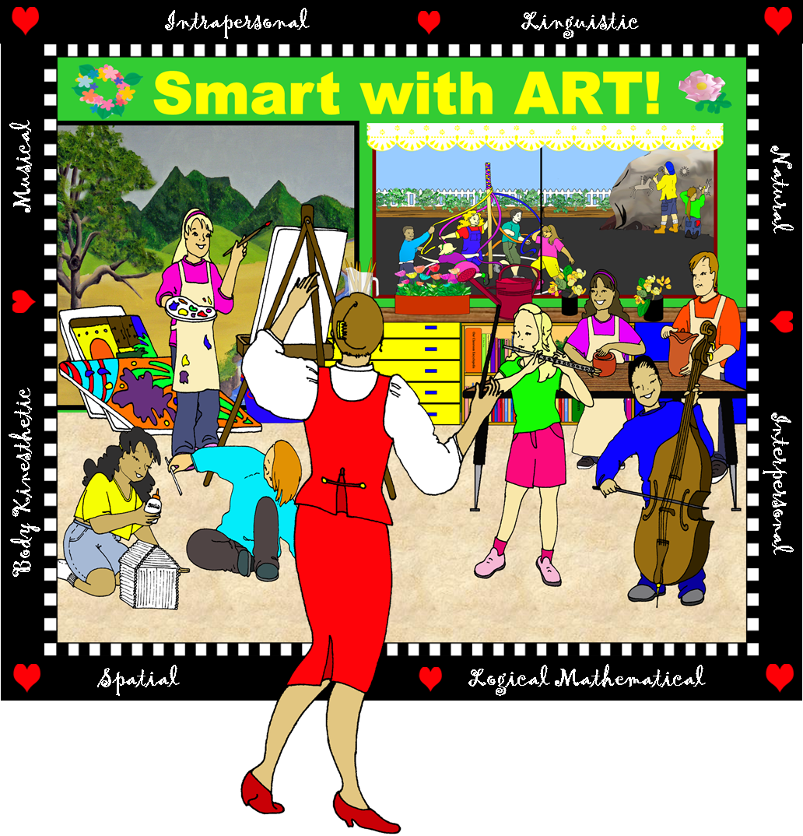

To insert an image, click on this text box. Go to Insert-Picture and choose your new image. Adjust the size by dragging the corners. Don’t forget to remove these directions!

To insert an image, see directions on page 1.

Type your story here. This section can hold 150-200 words.

Start typing here. This section can hold 50-75 words.

## Inside Story Headline

## Inside Story Headline

## Inside Story Headline

Caption describing picture or graphic.

Start typing here. This section can hold 100-150 words.

Place a quotation from the article or important information here.



**Artful Classroom**

The

May 15, 2013