Aloha Steak on a Stick - yields 16 appetizer portions

recipe developed by Chef Roc®

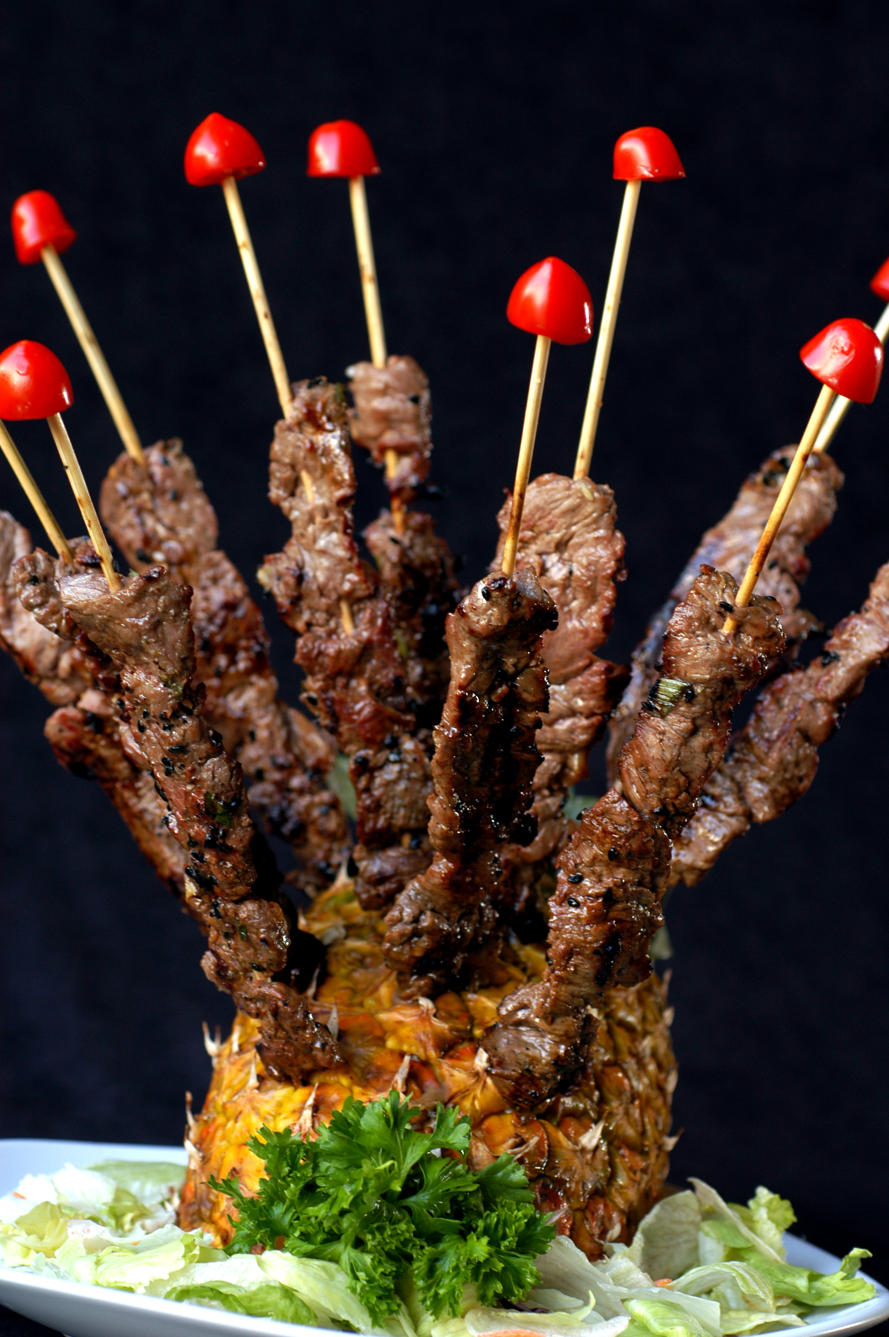
2 pounds skirt steak
16 wooden skewers, soaked in water for 30 minutes

Marinade

1/4 cup Aloha® rice wine vinegar
1/4 cup Aloha® apple cider vinegar
2 tablespoon sweet Chinese chili sauce
1 teaspoon sesame seed oil
1 tablespoon Hot Sauce
1/4 teaspoon dried lemon grass
2 teaspoon grated ginger
6 cloves minced garlic
1/4 cup green onions - sliced thin

1 tablespoon black sesame seeds
1/4 teaspoon salt
1/8 teaspoon black pepper

1. Trim the fat and membrane from both sides of the skirt steak. With a sharp knife, slice the skirt steak against the grain into thin slices.

- Feed the beef slices onto each skewer. Spread out the beef on the skewer to make as thin as possible. Place all 16 skewers into a large plastic container, making sure they can all lay flat.

- In a bowl, combine the marinade ingredients. Pour marinade over skewers, lifting the skewers to make sure they all are covered with the marinade. Cover container and refrigerate a minimum of 3 hours (overnight is better).

- Preheat the Grill to medium-high heat. Place the skewers on the grill and cook for 1 minute on each side. Remove from the grill and enjoy Aloha Steak on a Stick with your favorite beverage.


For more great Aloha Shoyu recipes go to www.chefroc.com

For the best meat, poultry or fish on Oahu please visit VJ’S Butcher Block in Haleiwa. Check them out on Facebook
https://www.facebook.com/VJsButcherBlock/

