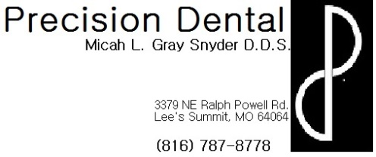
Care and expectations after Scaling and Root Planning
- If anesthetic was used during your procedure today:
  - Not only is the tooth numb, but the surrounding soft tissue structures are as well, including lip, tongue, gums, cheeks, etc. Be very careful not to bite or suck on these soft tissues while profoundly numb. Since you are so numb you will not be able to feel how hard you are biting or sucking which can result in serious soft tissue damage.
  - Your numbness can last for several hours following your procedure, on average about 3-4, however everyone reacts to local anesthetic differently. If you wake up tomorrow morning and still feel numb please contact the office for further evaluation.
  - As the numbness wears away, your soft tissues may begin to itch or tingle. This is a normal reaction and does not indicate an allergic reaction. It is very important to be careful not to scratch or itch the area because the tissues are still numb and it is possible to do soft tissue damage by scratching or itching too hard without realizing it.
  - You may want to take a pain reliever (ex: Ibuprofen, Acetaminophen, etc.) prior to the numbness wearing away because the site of the injection may be sore like a bruise. The injection site may actually bruise and some swelling is also a normal occurrence. If you are concerned about any bruising or swelling please contact the office for further evaluation.
- It is normal for your gums to be sore for several days following your procedure. It is alright to take pain relievers (ex: Ibuprofen, Acetaminophen, etc.) according to their dosing instructions on the back of the bottle to help with this discomfort.
- Brush and floss gently starting this evening. Your homecare is very important to maintain to help ensure proper healing of your gums
- Your teeth may be sensitive to hot and/or cold following your procedure- try using sensitivity toothpaste. This sensitivity is due to the fact that portions of your teeth have now been exposed to your oral environment after being covered with tartar/calculus build up. If sensitivity persists beyond a couple of days, please call the office.
- You may notice increased mobility or “new gaps” between your teeth. This is due to the removal of the tartar/calculus build up from your teeth. If mobility is a problem eat soft, cold foods and maintain meticulous home care and hopefully teeth will begin to “tighten up” and become less mobile with healing.
- To reduce discomfort and reduce any swelling, rinse your mouth out 3 times a day with warm salt water.
  - 1 teaspoon of salt per 8oz glass of warm water
- Remember: it is very important to complete proposed treatment.

