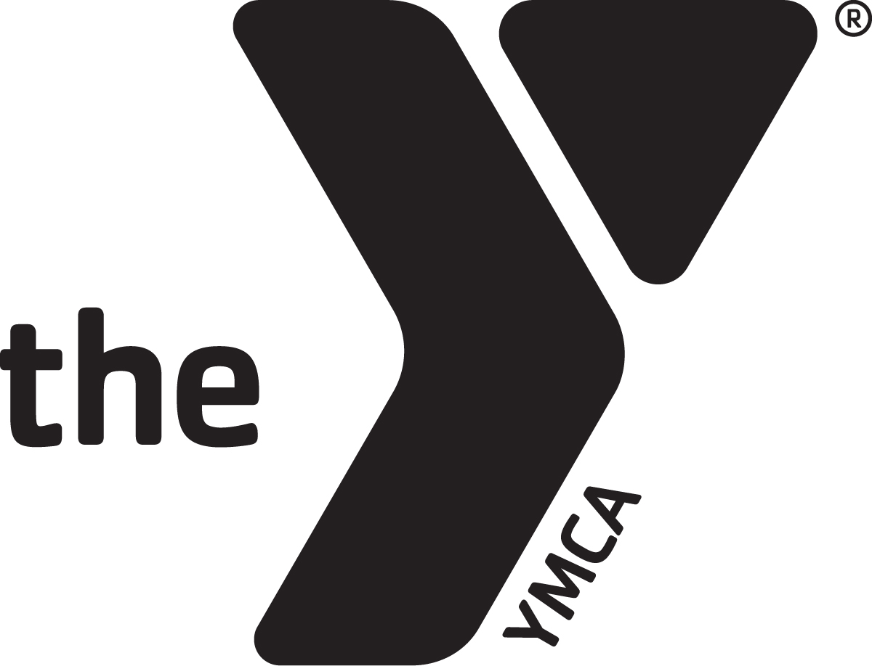
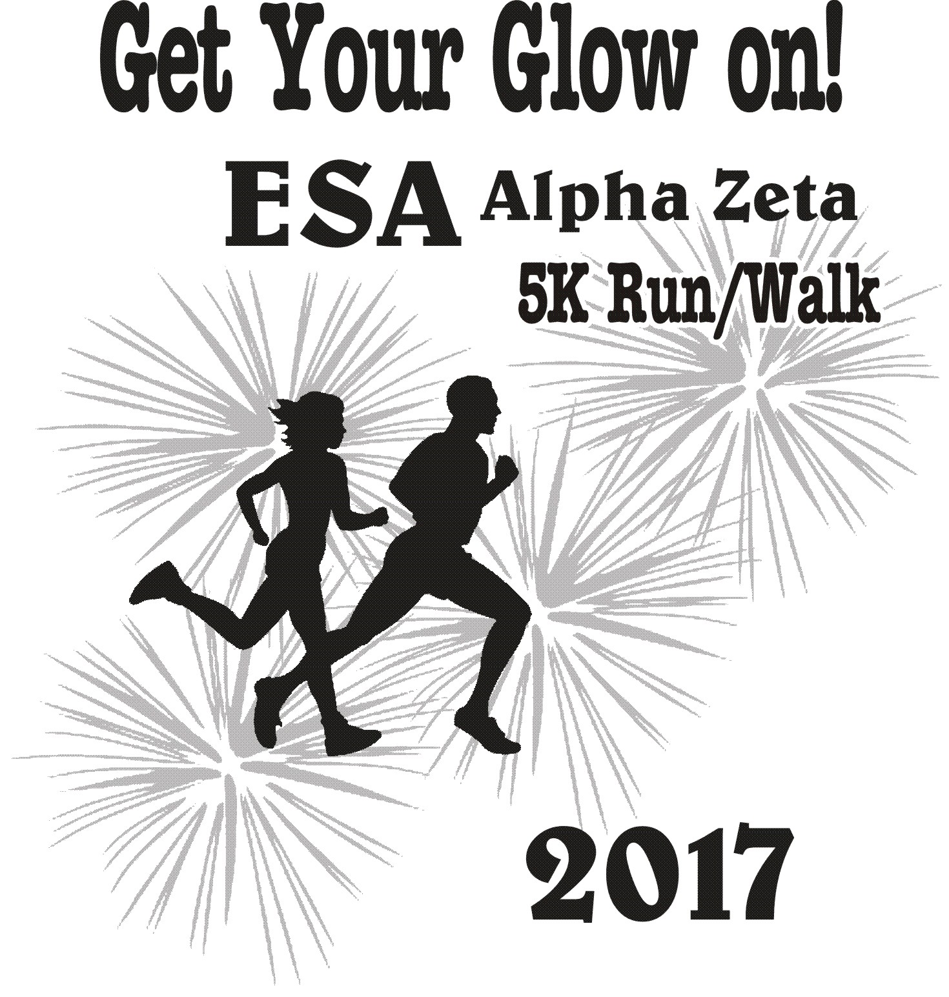

Race will begin at the Clarion Inn east parking lot in Garden City, KS at 8:00 p.m. and will finish at the same location. Glow items will be provided prior to the race during registration and packet pick up. All participants will be entered into a drawing for prizes which will be announced after the race. Samy’s will provide hors d’oeuvres and a cash bar (must show I.D.)

Proceeds to Benefit: Family Crisis Services, Inc. of Garden City and
St. Jude Children’s Research Hospital
Fee: $25.00 - Fee includes t-shirt. (Register by April 17th to guarantee a shirt for race day.) Please make checks payable to YMCA.
$35.00 – Day of event (Shirt not guaranteed on day of event)
Online registration available at www.ymcaswkansas.org

When: Saturday April 22, 2017

Time: 7:00 p.m. check-in/registration 8:00 p.m. race begins

Pre-registration and packet pick-up - April 21st, 5:00 – 7:00p.m. Clarion Inn lobby, 1911 E. Kansas Ave.
For more information contact Anita Gottsponer, Alpha Zeta at 620-521-0848 or alphazeta5404@gmail.com.
Please return the registration form below with payment to:
Garden City Family YMCA, 1224 Center, Garden City, KS 67846

-----------------------------------------------------------------------------------------------------------------------------------------

ESA Alpha Zeta “Get Your Glow On” 5K Walk/Run Registration Form
Name: __ Mailing Address: ______________ _________________ Contact Phone Number: _____________ City, State, Zip: _________________________________
E-Mail _____ Age: ______________
Men’s shirt size: ________ Women’s shirt size: ________ Youth shirt size: ________
** There are inherent risks in participating in any activity and I will not hold the ESA Alpha Zeta Organization responsible for any accident or injury that may occur during this race.
Signature of participant/parent: ___________________________________________________________

