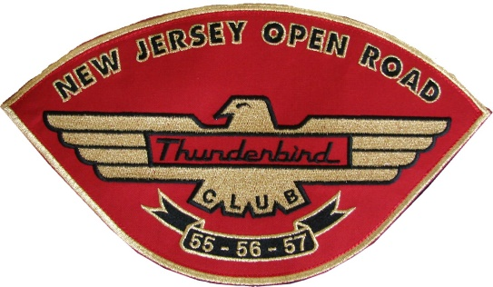
NEW JERSEY OPEN ROAD THUNDERBIRD CLUB
Chapter 41- Classic Thunderbird Club International
ALL NEW WEBSITE
P.O. Box 615; Hewitt, NJ 07421
http://www.njortc.org

Application for Membership
You must bring your completed application to a club meeting or event.
*See Event Calendar on website for Activities & Meeting Info.

For more information, and a schedule of upcoming meetings, contact our club President:
Pat Le Strange 201-920-7226 rolodexp@aol.com

Name of Applicant: _____________________________________________________________________
Spouse or Partner: _____________________________________________________________________
Address: ______________________________________________________________________
City: ____________________________ ST: ________________ Zip: ________________
Home Phone: ________________________________ Cell : _____________________________________
Spouse / Partner Cell: _______________________________ Fax: _______________________________
Member Email __________________________________________________________________________
Spouse / Partner Email___________________________________________________________________

Birthdays/ Anniversary (month and day only… we don’t need to know the year! )

Applicant: _________________ Spouse: _______________ Anniversary: _________________

I own the following Little Thunderbird(s) and / or classic cars:

_____ 1955 color ___________ Other Car: ______________ Year: ____ color: ___________
_____ 1956 color ___________ Other Car: _______________ Year: _____ color: __________
_____ 1957 color ___________ Other Car: _______________ Year: _____ color: _________
No car/s at this time: ________

Although not a requirement for chapter membership, we urge each member to be a member of CTCI.
I am ______ / am not _______ a member of CTCI. My CTCI number is ______________.

Membership requirements:
- Prompt payment of dues. January 20th each year.
- Hosting a club meeting on a rotational basis. Approximately once every 3-4 years. The cost of refreshments is the member’s responsibility, we urge you to keep it simple.

Chapter dues are $50.00 per year. Please make checks payable to NJORTC.
Dues will be prorated on a quarterly basis for new members.

Signature: ____________________________________________ Date: ________________________
JS 3/2016

