SPECIAL MEETING
JANUARY 3, 2024

A Special Meeting (Organizational Meeting of 2024) of the Town Board of the Town of Hampton, County of Washington and the State of New York was held at the Town Hall, 2629 State Route 22A, Hampton, New York the 3rd day of January 2024.

PRESENT: David K. O’Brien------------Supervisor
Donald Sady------------------Councilman
Tamme Taran----------------Councilwoman
Michael Pietryka------------ Councilman
Andrea Kugler---------------Councilwoman - absent
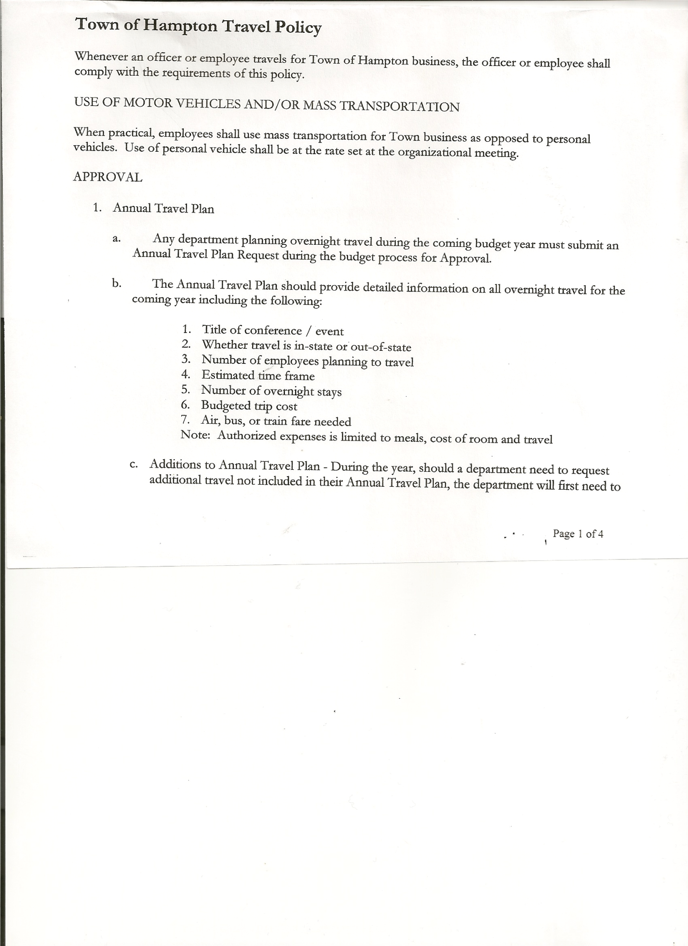
Rebecca Jones---------------Town Clerk
Camilla Shaw----------------Deputy Town Clerk
Tyler McClure---------------Highway Superintendent

Planning Board Members: Bonnie Hawley, Chair; and Matthew Pratt

The Special Meeting was called to order by Supervisor O’Brien at 7:02pm, followed by the Pledge of Allegiance. Location of Fire Exits were given. Quorum of board members present.

RESOLUTION NO. 1-2024
APPOINTMENT OF TOWN OFFICIALS
On a motion of Councilman Sady, seconded by Councilwoman Taran, the following resolution was ADOPTED: Ayes 4 O’Brien, Sady, Taran, Pietryka
Nays 0
Absent 1 Kugler
RESOLVED, to appoint Town Officials as presented on attached sheet.

RESOLUTION NO. 2-2024
HAMPTON ORGANIZATIONAL CHARTER FOR 2024
On a motion of Councilman Sady, seconded by Councilwoman Taran, the following resolution was ADOPTED: Ayes 4 O’Brien, Sady, Taran, Pietryka
Nays 0
Absent 1 Kugler
RESOLVED, that upon review the Hampton’s Organizational Charter for 2024 is adopted as proposed.

OATH OF OFFICE
The Oath of Office was administered to the Elected Officials present:
- David O’Brien – Town Supervisor
- Tamme Taran – Town Councilwoman
- Michael Pietryka – Town Councilman

The Oath of Office was also administered to the Appointed Officials present:
- David O’Brien-Local Compliance Officer; Point of Contact for NIMS and Association
of Towns Voting Delegate
- Tyler McClure – Highway Superintendent
- Tamme Taran-Health Officer
- Camilla Shaw – Deputy Town Clerk
- Michael Pietryka – Deputy Town Supervisor

TOWN BOARD MEETING
JANUARY 3, 2024 PAGE 2

- Bonnie Hawley – Chair of Planning Board
- Matthew Pratt-Member of Planning Board & Ethics Board

Judge Sady administered the Oath of Office to Rebecca Jones as Registrar of Vital Statistics; and Association of Towns Alternate Voting Delegate (Appointed) prior to the meeting.
Town Clerk Jones will administer Oath of Office to other Appointed Officials by January 31st, 2024.

RESOLUTION NO. 3-2024
HAMPTON TOWN POLICIES
On a motion of Councilman Sady, seconded by Councilwoman Taran, the following resolution was ADOPTED: Ayes 4 O’Brien, Sady, Taran, Pietryka
Nays 0
Absent 1 Kugler
RESOLVED, that upon review the following Policies:
- Travel Policy
- Investment Policy
- Cell Phone Policy
- Sexual Harassment Policy
- Workplace Violence Policy
- Credit Card Policy
- On-line Banking Policy
- Ethics Policy
- Computer Usage Policy
- Record Storage Policy
- Employee Handbook
- Drug/Alcohol Testing Policy
- Town Hall Use
- Road Side Tree Policy
- Cyber Security Policy
Of the Town of Hampton are approved.

RESOLUTION NO. 4-2024
PROCUREMENT POLICY 2024
On a motion of Councilwoman Taran, seconded by Councilman Sady, the following resolution was ADOPTED: Ayes 4 O’Brien, Sady, Taran, Pietryka
Nays 0
Absent 1 Kugler
RESOLVED, to accept the Procurement Policy for 2024 (copy is attached)

RESOLUTION NO. 5-2024
STANDARD WORKDAY and REPORTING RESOLUTION
On a motion of Councilwoman Taran, seconded by Councilman Sady, the following resolution was ADOPTED: Ayes 4 O’Brien, Sady, Taran, Pietryka
Nays 0
Absent 1 Kugler
RESOLVED, that the Standard Workday and Reporting Resolution for Elected and Appointed Officials (RS 2417-A) be approved. (Copy is attached)

TOWN BOARD MEETING
JANUARY 3, 2024 PAGE 3

RESOLUTION NO. 6 -2024
AUTHORIZE TO PRE-PAY ITEMS
MOTION BY: COUNCILMAN DONALD SADY
SECONDED BY: COUNCILWOMAN TAMME TARAN

TITLE: RESOLUTION AUTHORIZING THE TOWN SUPERVISOR TO PAY BILLS
IN ORDER TO AVOID PENALTIES AND INTEREST

WHEREAS, the Town has determined that due to certain bills being due prior to the Town Board Audit of bills,

AND WHEREAS, the Town Board is desirous of avoiding late fees, penalties and interest and maintain its good credit standing,

NOW THEREFORE, BE IT RESOLVED:
That the Town Board of Hampton hereby authorizes the Supervisor to approve the payment of bills before audit if in the reasonable discretion of the Supervisor, it is necessary to do so to avoid any costs, penalties, interest or termination of service. The supervisor may pay
claims for public utilities, postage, freight and express charges, gas and diesel before they are audited. The term “public utilities” includes electric, gas, water, sewer and telephone services and the purchase of fuel oil. All claims must be presented for audit at the next regular board meeting audit. The claimant and the town officer incurring or approving these claims are jointly and severally liable for any amount disallowed upon audit.

BE IT FURTHER RESOLVED:
That the Town Board is not required by law to pre- audit payments of fixed salaries, compensation of officers or employees, principal and interest indebtedness, or amounts coming due on certain contracts.

BE IT FURTHER RESOLVED that in the absence of the Supervisor, the Deputy Supervisor is authorized to review the bills and make the determination to authorize payment for the same reason.

BE IT FURTHER RESOLVED that the Town Clerk is hereby authorized and directed to add the following policy to the policy manual/employee handbook for the Town of Hampton.
DATED: January 3, 2024 Supervisor O’Brien AYE
Councilman Sady AYE
Councilwoman Taran AYE
Councilman Pietryka AYE
Councilwoman Kugler ABSENT

TOWN BOARD MEETING
JANUARY 3, 2024 PAGE 4

Senior and Low-Income Disabled Exemption….Consensus of the Board to proceed with paperwork for the next meeting, which is to increase income levels to match the County.

Town Attorney Fees increase….Supervisor O’Brien has sent an email requesting lower rates, waiting to hear a response.

Discussion…..Highway Equipment replacement….Supervisor O’Brien, Councilman Sady and Highway Superintendent McClure to discuss options.

Discussion…..Sharing road services with other towns…..Supervisor O’Brien, Councilman Pietryka and Highway Superintendent McClure to check into.

Supervisor O’Brien has been appointed Vice Chairman of the County Board of Supervisors for 2024.

RESOLUTION 7-2024
MEETING ADJOURNED
On a motion of Councilman Sady, seconded by Councilwoman Taran, the following resolution was ADOPTED: Ayes 4 O’Brien, Sady, Taran, Pietryka
Nays 0
Absent 1 Kugler
RESOLVED, that the meeting adjourned at 7:49pm.

Respectfully submitted,

Rebecca S. Jones, RMC
Town Clerk

