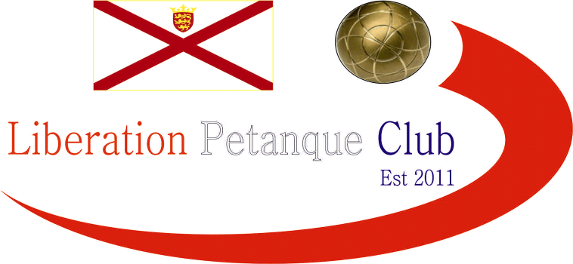

**SUMMER 2023 SEASON**

**2023**

**Club Doubles Cup**

# Twelve teams took part this year in one our usually most popular competitions.

# Round 1 saw a close win for Alice & Brigitte 7 – 6 over Alex & Jean and Kat & Paul beat Neil & Ross 13 – 11 and Geoffroy & Matt beat Alan & Mike 9 – 6.

# Big wins for Andrew & Callum 13 – 3 over Branden & Tim and Gary & Wendy beat Alan & Joey 13 – 2.

# A win also for the champions Laurent & Toby 13 – 6 over Keith & Mo.

# Round 2 saw the champions Laurent & Toby win big over Andrew & Callum 13 – 5 and Alice & Brigitte also made it two from two with a 13 -12 win over Kat & Paul.

# Two other close matches as Keith & Mo beat Branden & Tim 10 – 8 and Geoffroy & Matt won 6 – 4 over Gary & Wendy.

# Alex & Jean and Neil & Ross got their first wins.

# Round 3 saw the champions qualify for the quarter finals with a round to spare beating Alice & Brigitte 13 – 1. Geoffroy & Matt also won their third match beating Alex & Jean.

# A big 12 – 1 win for Gary & Wendy over Neil & Ross and another one 13 – 3 win for Andrew & Callum over Kat & Paul.

# Keith & Mo lost to Alan & Mike and Branden & Tim beat Alan & Joey!

# The final round saw the top two play each other with Geoffroy & Matt beating Laurent and Toby to top the rankings.

# Andrew & Callum lost to Gary & Wendy but still finished fifth with Gary & Wendy in third place.

# Alice & Brigitte finished fourth with a win over Alan & Joey who finished bottom and the only team not to win.

# Alex & Jean lost a close match to Keith & Mo who qualified for the quarter finals in eighth place. Kat & Paul beat Alan & Mike 10 – 9 to go through in sixth place whist Neil & Ross big 13 – 3 win gave them seveth place.

# FINAL SWISS RANKINGS

# QUARTER FINALS

# Ranked 1st Geoffroy & Matt v Keith & Mo Ranked 8th

# Ranked 2nd Laurent & Toby v Neil & Ross Ranked 7th

# Ranked 3rd Gary & Wendy v Kat & Paul Ranked 6th

# Ranked 4th Alice & Brigitte v Andrew & Callum Ranked 5th

# The Swiss curse struck again as ranked eight Keith & Mo shocked one of the best teams in the Island in Geoffroy & Matt winning 13 – 6.

# Alice & Brigitte also shocked Andrew & Callum taking their place in the semi finals winning 10 – 8.

# Laurent & Toby chances of retaining their title went with a 13 – 7 loss to Neil & Ross and Gary and Wendy beat Kat & Paul 10 – 4

# So the Semi-Finals were as follows:

# Ranked 8th Keith & Mo v Alice & Brigitte Ranked 4th

# Ranked 3rd Gary & Wendy v Neil & Ross Ranked 7th

# Gary & Wendy yet again beat Neil and Ross, this time 8 – 6 to make the final and Keith & Mo also made the final beating Alice & Brigitte 8 – 5.

# Third place for the second year running went to Neil Selby & Ross Payne who beat Alice Dilks & Brigitte Ibitson 13 – 12!

# The final was a surprisingly one way affair as exceptional pointing from Mo & Keith out did the shooting from Gary & Wendy with the result a 13 – 2 win for Keith White & Mo De Grucy a fantastic performance.

# 2023 LIBERATION CUP DOUBLES WINNERS

# KEITH WHITE & MO DE GRUCHY

# NEXT WEEK - SINGLES LEAGUE

# Club email address - [liberationpc@gmail.com](mailto:liberationpc@gmail.com)

# Club Website - [www.liberationpetanque.co.uk](http://www.liberationpetanque.co.uk)

# Kind Regards

# Toby Northern

# Chairman

# Liberation Petanque Club