The Propaganda Experiment Template

Propaganda has an awful reputation, as it is associated with unethical manipulation; as opposed to rhetoric (the art of persuasion), propaganda often deliberately omits essential information and/or uses heighten pathos to gloss over logical deficiencies. Techniques associated with propaganda include using loaded words (i.e. name calling and/or ad hominem attacks), transfer (an illogical association between positive/negative terms), or snob appeal (linking luxury with an act or priority) (Jowett). However, the traditional definition of propaganda carries no pejorative meaning, since the strategies can be applied for either ethical or unethical goals. The term only garnered a negative connotation with its association with Nazi war posters and rallies in WWII. The Catholic Church, in fact, created the concept as a means to attract wayward followers during the reformation/counter-reformation. Given this informing context, it is understandable that propaganda is being reconsidered by pedagogues as a legitimate and ethical means to achieve positive civic action. Advertisements aggressively dissuading smokers from smoking and the iconic Uncle Sam posters are notable examples.

In this semester-long project, you will engage in an assignment that explores whether propaganda can be used ethically. Please see the description of how to create a propaganda project in the declassified WWII spy manual linked below. The syllabus "Propaganda Presentation" begins on page 200.

(https://ironwolf008.files.wordpress.com/2010/07/the-wwii-soe-training-manual-rigden.pdf).

As a whole, the spy manual consists of all of the syllabi from a spy training camp in England during the war. Content includes counter-interrogation techniques, hand-to-hand combat, disguises, covers, counter-espionage methods, surveillance, burglary, agent management, passive resistance, subversion of troops, opinion sampling, communications, and propaganda construction. The trainees are being prepared to be dropped behind enemy lines in occupied France. Their goal is to disrupt the German forces; one aspect of this disruption involves creating a propaganda plan (with accompanying leaflet) to sabotage a German arms factory. The manual's explanation of the principles of propaganda is both clear and historically important. For example, the manual advises, "Speak up to an audience, never down" and "use concrete details" or "counter hyperbole with evidence."

You should come up with your own agenda item (a goal that you have been consistently denied) and follow the procedure in the spy manual to achieve your objective. All of the projects have to be approved by the class and can't be judged unethical/harmful (i.e., one student tried to get her boyfriend to attend yoga; another tried to get a helicopter parent to relax). At the end of the semester, you will present a narrative of your attempts to apply the spy manual strategies and answer two questions: 1) Did the propaganda strategies achieve results and 2) Did you feel the strategies were ethical? The results are compiled (i.e., how many projects resulted in full or partial success/how many participants felt the process was ethical/unethical) and will be published in an online undergraduate journal devoted to reform through research.

Some examples of class propaganda projects are below:

Securing a NYC trip for tennis team
Rejuvenating the Pink Ribbon campaign
Recruiting for a cross-country road trip
Getting friends to pay gas money
Recruiting Oprah for national election
Buying a water Purifier for the Commons
Stimulating charity donations
Purchasing a third family dog
Getting a boyfriend to attend yoga
Making a helicopter parent back off
Getting an iPhone 8
Building an Elizabeth Hall elevator
Acquiring a car for college
Orchestrating a grandparent Vegas trip
Receiving a pay Raise
Promoting a college service project for Appalachia
Obtaining a Jamaican destination wedding

Below is a synthesis of the process and strategies from the propaganda syllabus. You must introduce these into your narratives:
1. What is your Mission?
2. Who is your Audience?
3. Where is your Site?
4. What is your Timing?
5. Who is your Opposition?
6. How will you deliver your message?
7. What is your overall method?

Propaganda Strategies
1. Talk up, not down.
2. Use concrete details that underscore benefits. Appeal to selfish and unselfish self-interest.
3. Never expose your persuasive strategies.
4. Avoid abstract concepts, like "patriotism."
5. Stick to the mission - one main idea/purpose.
6. Use deep feeling/pathos to mask your agenda.
7. Repeat one general idea/purpose with many different methods (leaflet, broadcast, rumor) to gain a broader audience.
8. Associate your goal/mission with relevant actions that occurred, for example, precedents.
9. Make sure your narrative/story fits the facts.
10. Use short sentences and paragraphs.

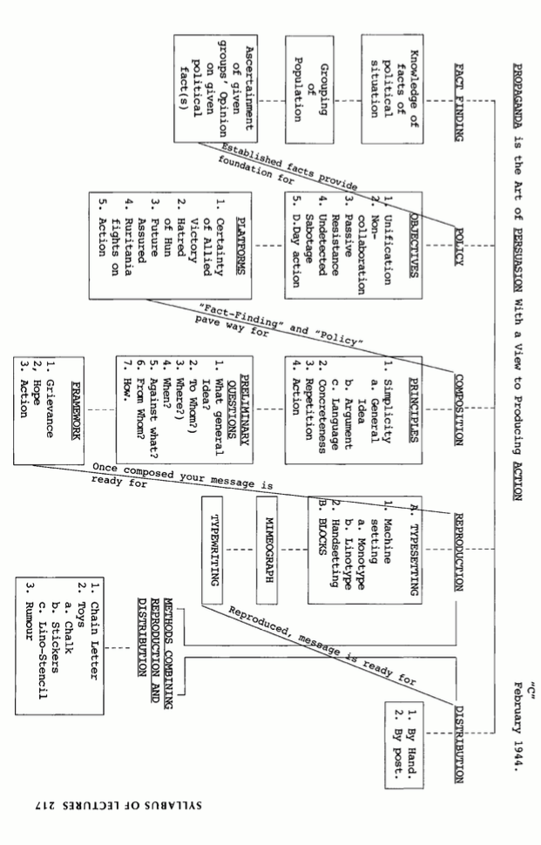

References

WW2 Spy Manual
https://ironwolf008.files.wordpress.com/2010/07/the-wwii-soe-training-manual-rigden.pdf

Elbow, P. & Belanoff, P. (2002). Being a writer: A community of writers revisited. NY: McGraw-Hill Education.

Eodice, M., Geller, A. E., & Lerner, N. (Winter 2017). What meaningful writing means for students. Peer Review, 19(1). Retrieved from http://www.aacu.org/peerreview/2017/Winter/Eodice

Haswell, R. (2005, April). NCTE/CCCC’s recent war on scholarship. Written Communication, 22 (2), 198-223. DOI: 10.1177/0741088305275367

Jowett, Garth. Propaganda and Persuasion. Newbury Park: Sage Publications, 1992.

