RSAI Position Paper: Teacher Quality in Rural Iowa 2017
Background: All students, regardless of their zip code, deserve and require access to a great education for future success, which has always depended on great teachers. Although rural Iowa schools have traditionally been full of excellent teachers with a strong work ethic, flexibility, and dedication to student success, conditions in rural Iowa are making it difficult to attract and retain great teachers for the future:
- Teacher shortage areas exist in many content areas, but especially at the secondary level (math, science, music, career and technical areas, foreign language and agriculture) and special education, school counselors and teacher librarians across the spectrum (PK-12). See the complete list on DE’s web site: https://www.educateiowa.gov/teacher-shortage-areas
- When there are shortages, the market tends to compel teachers from rural areas to move toward higher paying urban and suburban districts. Rural schools are finding fewer qualified candidates, and sometimes no candidates at all, to fill vacant and mandated positions.
- The implementation of the teacher leadership and compensation system, now in its third and final year of phase-in, has further increased demand for teachers to fill vacant positions to replace teacher leaders. This additional demand has made a difficult challenge even more so.
- Teachers in rural areas are very likely to have multiple preps, whereas teachers in urban centers may be able to focus on teaching one or two classes multiple times per day. For example, a teacher in a rural district may teach and prepare lessons and activities across an entire content area, such as Algebra I, Geometry, Algebra II, trigonometry, Calculus and a Statistics course. Even with sometimes lower class sizes, multiple preps increase the workload significantly.
- Some rural schools have been able to help a willing and capable teacher obtain certification in a shortage area of content, but the rules require provisional licensure status no longer than two years. With fewer colleges and universities within a short distance, it is a burden to complete the licensure requirements within two years. With student loans to pay, additional tuition and costs of coursework may be beyond the financial capacity of lower compensated rural teachers and nearly unattainable for new teachers given the starting pay of the new teacher in a rural area. Additionally, new rural teachers most likely will be learning their jobs for the first time as well as being saddled with nearly unmanageable multiple preparations.
- Some community members, dedicated to the rural area, may be willing to teach in areas of their expertise, but can’t afford to quit working for two years to obtain the appropriate degree and license required.
- Rural communities have much to offer, but may not be attractive to young teachers looking for amenities in a more urban setting.
- Additional transportation costs come off the top of the per pupil revenues, leaving even less revenue to pay teachers at the attractive rate needed to overcome the market shortages and amenity deficits.
Current Reality: The teacher pay gap, defined as the wage gap between public school teachers and similar workers, grew from a negative 5.5% in the 1979 to a record -17% in 2015, according to Education Week. “In their findings, authors Lawrence Mishel, who is president of the Economic Policy Institute, and labor economist Sylvia A. Allegretto, who is chair of the Center on Wage and Employment Dynamics at the Institute for Research on Labor and Employment at University of California, Berkeley, cite recruiting and retaining high-quality teachers as crucial issues in K-12 education today, and say that in order to draw new teachers to the profession, fair compensation is necessary.
"Continued budget austerity at all levels of government have created pressure to restrain teacher compensation," Mishel wrote in an email. "The consequence is greater difficulty to recruit and retain the teachers all policymakers say we need."

The following data helps policy makers understand the extremes as well as the averages:
- Iowa teacher pay is ranked in the middle of the pack at 25 (DE Annual Condition of Education Report 2016), and is now $4,673 below the USA average teacher pay for the 2013-14 school year. Iowa ranks 6th in the Midwest, behind neighboring states Wisconsin ($1,742), Minnesota ($2,815) and Illinois ($8,187). This data is from 2013-14, prior to TLC implementation, which may close the gap somewhat on an average basis with other states, but is not likely to have much impact on beginning teacher pay.
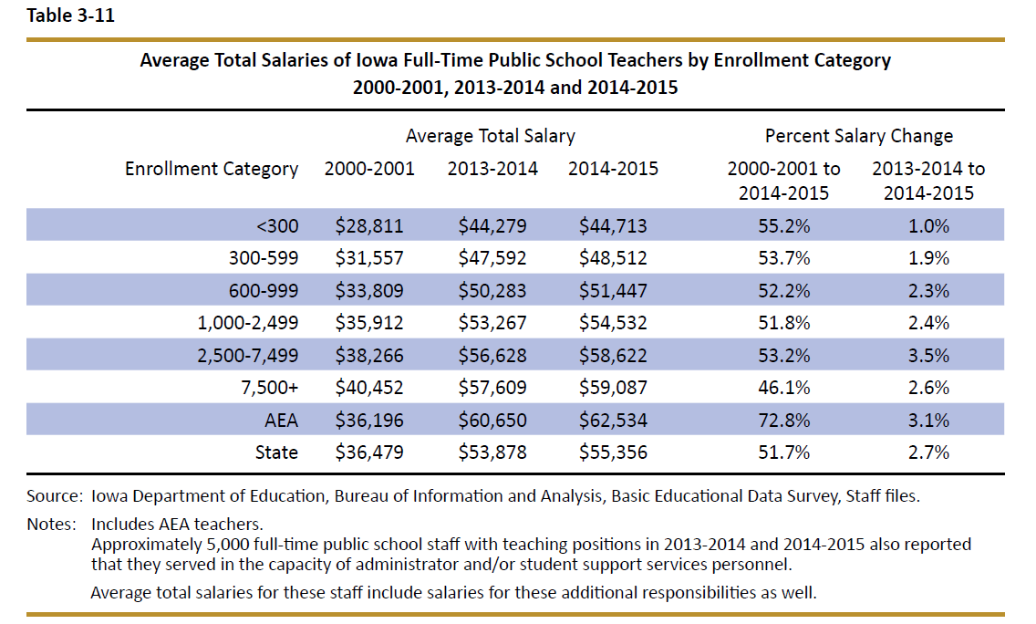
- Teacher pay variance between rural and urban/suburban schools is significant and worsening. In this table from the DE’s Annual Condition of Education Report, the gap is identified by school size (which is a good but not perfect predictor of rural districts), showing an almost $15K difference in pay between the averages of the smallest and largest category of school size.
- Continued budget pressures forcing whole grade sharing and consolidation typically require even more of the district cost per pupil spent on transportation, with less remaining to pay teachers at a sufficient level to eliminate the shortages and close the gap with larger districts.

Rural Teacher Quality Incentive Program: RSAI supports a new Rural Quality Teacher Incentive Program, to ensure students in rural Iowa have access to great instruction and support district compliance with accreditation standards. Suggested components of a program include:
1) Education Loan Forgiveness, to help new teachers offset student loan debt if they remain in rural school districts,
2) Expansion of temporary licensure to three years for teachers working for shortage area licensure to achieve the necessary credit hours,
3) Alternative models of licensure for shortage area teaching positions in rural Iowa,
4) Use of management fund to pay for certification course requirement costs for teachers working toward licensure in shortage area positions, and
5) Funding of transportation equity so rural education dollars may be spent on the classroom, including teachers.

