Disciplinary Literacy in the CATE Classroom
The What? The Why? The How?
What? Disciplinary Literacy in a Nutshell
Focuses on how reading and writing are used in the discipline being studied. It emphasizes the unique tools that the experts in a discipline use to participate in the work of that discipline.

Why CATE?
Students typically find their CATE courses to be directly connected to their future goals and are often more willing to engage in reading and writing within the context of their CATE program. Job-specific vocabulary and authentic work situations can inspire students to apply themselves to literacy tasks that lack meaning in other contexts.

How? Determining Disciplinary Literacy Strategies for Instructional Delivery
What types of reading, writing, speaking and listening will be the focus?
Types | Examples
Authentic Reading and Writing  Reading and writing a variety of text for “real-world” purposes. Reading and writing that professionals in the field would use that is meaningful. | Reading industry media publications (magazines, websites, etc.). Preparing written industry documents (correspondence, sales invoices, repair order, etc.).
Technical Reading and Writing  Reading and writing of related discipline technical/instruction manuals. | Reading cookbooks, repair manuals, diagrams, floor plans, instrument gauges, and specification documents. Writing recipes, instructions, product specifications, blueprints, financial statements or diagrams.
Learning of Specialized Vocabulary  Learning new career/technical terms before reading or application. | Pointing out and defining new career/technical terms before reading the textbook, industry media publication or technical documents. Demonstration of the concrete meanings of the terms by showing students the objects or activities the words represent.
Authentic Application  Reading, writing and application of critical thinking skills in authentic situations. | Creation of a written business plan for a new business, application of safety procedures based on Occupational Safety Health Administration, completion of an automobile body repair estimate using a crash estimating guide, and design the layout of a digital desktop application for readability and attractiveness.
How? Determining Disciplinary Literacy Strategies for Instructional Delivery
Select disciplinary literacy strategies that support the specific outcomes of the lesson. What do you want students to have learned and what strategy will support the learning outcome?
Will your strategy be used to prompt student thinking, pre-assess student understanding, help organize information or help summarize the information.
Will it be used at the prior, during or post instruction?

Prior to Instruction Strategy: I Think, We Think
Provide students with a focus question quick write: Can you identify five important business leadership characteristics and why each is important?
Ask students to respond to the question in writing independently. (I Think) Then have them collaborate with other students to generate a shared list of the five most important characteristics and why? (We Think)
Following the lesson the teacher can follow-up with a “used to think, but now I know” summarizing activity where students compare their initial lists to those presented in the lesson.

Prior to Instruction Strategy: Close Read - 3 Readings
Have students read 2-3 paragraphs from their textbook. Ask students to make notes of any words or phrases they have questions about. Ask them to identify the main idea of each paragraph. Have them turn and talk to a fellow student about their findings.
Have students re-read the paragraphs from their textbook. Ask students to dig a little deeper maybe providing them with some text dependent questions.
Have students synthesize information from the text with a content related article or video.

During Instruction Strategy: Two Points of View
http://agsci.psu.edu/magazine/articles/2015/spring-summer/the-science-of-gmos
Students read the article and generate the two opposing points of view.
Then they are asked to determine if the benefits outweigh the risks and why?

During Instruction Strategy: Collaboration Jigsaw with a CTE Authentic Document
Text dependent question cards in small (expert) groups:
  - What is the purpose or intent of this document?
  - What content on this document is critical and why?
  - How do the embedded pre-tailored checklists benefit the user?
  - Should this document contain additional information? If so what and for what purpose?
During Instruction Strategy: Using Technology with a CTE Authentic Document
Using Technology to explore a 3D Printer Manual.
- Using Adobe Acrobat Reader, have students review a portion of the technical manual and create annotations.
- Instruct students to underline words they don’t understand in the color green.
- Instruct students to highlight text they have questions about in the color yellow.
- Instruct students to add questions they have about the text using the comments tool.

Post Instruction Strategy: Concept Mapping
Have students create a visual map of complex content - Economic Concepts 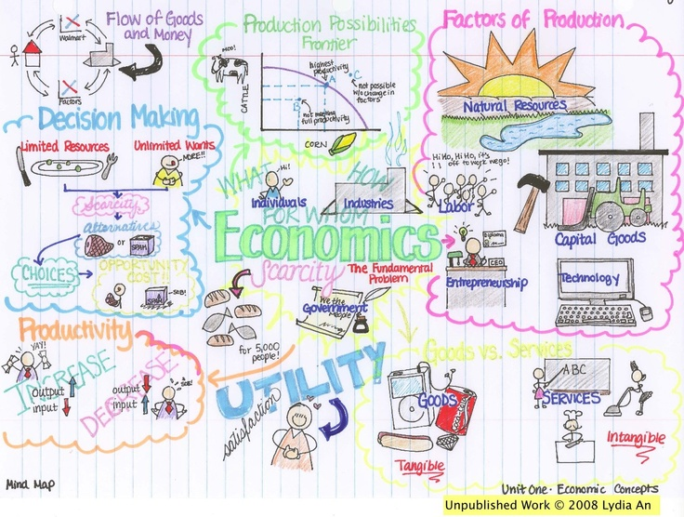

Post Instruction Strategy: Decoding an Authentic Industry Publication
Ask students to read an article and have them do the following:
- Circle words that are unknown or vague.
- Underline repeating words/phrases.
- Highlight main ideas and important phrases.
- Place question marks by concepts you wonder about.
- Place an exclamation mark by concepts that surprise you.
- With a partner, discuss who the intended audience might be for this article. Is it targeting the consumer or the advertising industry? How do you know?

More Literacy Ideas
Bellwork Bingo
Create a Bingo card with short literacy activities that students can do related to the unit content. For example one box may say to write a paragraph about a concept or to read an article and write a letter in response. Students must complete assignments in a row for Bingo.
Creative Writing - Poem
Have students create a poem that summarizes a particular business/industry concept or skill.
Gallery Walk
Write new vocabulary terms or new concepts on poster size paper around the room. Have students do a gallery walk around the classroom having them write what they think it means with sticky notes. Then visit each poster and read student notes to the class. Clarify any misconceptions about the vocabulary or concepts.
Contextual Redefinition
During a contextual redefinition activity, students are given a set of keywords from an upcoming unit of study. First, they predict the definition based on background knowledge and word parts. Then students are given sentences or passages and asked to use context clues to determine meanings. Finally, after instruction, meanings can be further clarified and/or extended.
Response Journal
Students are given a business ethics or other soft skills situation to respond to in 5-7 sentences. This can be followed with a class discussion about their responses.
Examples:
What do you consider the three most important things you can do to prepare for a job interview? Discuss why each is important.
You work at a local restaurant. Other employees give their friends who are customers free food. You know that this is against the restaurant’s policy; however, lately several of your friends have come in a pressured you to give them free food. What would you do and why?

