****The Waterline

**Arrowbear Park County Water District**

2365 Fir Dr., PO Box 4045 Arrowbear Lake, CA 92382-4045

(909) 867-2704 apcwdmail@gmail.com **January 2024**

**NEW BOARD MEMBER APPOINTED**

Arrowbear Park County Water District welcomes its newest Board member, Director Craig Carpenter. Mr. Carpenter was appointed to fill a vacancy at the October 2023 Board Meeting and was sworn in at the December 21, 2023 Regular Board Meeting. Mr. Carpenter is a long-time resident of Arrowbear and the **Board is pleased to have Mr. Carpenter aboard and welcomes his experience with having served on other Boards and community organizations. His extensive knowledge of GIS mapping systems and resource management will be a great asset to the District Operations**. Mr. Carpenter looks forward to serving the remaining term (Dec. 2024), and has expressed a strong desire to serve the community and to continue in the tradition of providing the highest levels of quality service to this community.

**Board Meeting Highlights**

**Regular Board Meetings are the Third Thursday at 6:00 PM (NEW TIME)**

**October** – Field Operations Supervisor Weber reported on the monthly maintenance issues for the month of September, discussed equipment that was delivered, and reported that Bacon Wagner did their last job for the District as Danny Wagner was retiring. Chief Lindley reviewed the calls for the month of September, announced the Open House on October 28, 2023, discussed the night time training the Fire Department did recently, and that he had located a Type 3 Brush Engine. General Manager Magaña reported that the Auditors were continuing with the Audit for FY 2022/2023, discussed sewer maintenance inspections and that the Engineer is continuing the work on the Highway 18 Project.

**November** – Field Operations Supervisor Weber reported on the monthly maintenance issues for the month of October and that the Technicians were working on Winter Projects. Chief Lindley reviewed the calls for the month of October, stated that he spoke with the County regarding moving the weather station, and that the department received a Service Award from Running- Springs Chamber of Commerce. General Manager Magana reported that the Auditors were continuing with the Audit for FY 2022/2023, that the Audit would be presented at the Regular December 2023 Board Meeting, and that he and the (2) Technicians attended the Water Sampling Class by Clinical Labs.

**December** – Newly-appointed Board member Craig Carpenter was sworn in and took his seat on the Board. Field Operations Supervisor Weber reported on the monthly maintenance issues for the month of November and that the District received the surplus equipment from Bacon Wagner. Chief Lindley reviewed the calls for the month of November and reviewed new staff coming to the department. General Manager Magana reported that the Auditors will be presenting the Audit for FY 2022/2023 at the January 18, 2024 Board Meeting, not December as previously reported and informed the Board of the USDA Grant he was attempting to obtain.

**Earthquake Brace + Bolt Retrofit Grants - Arrowbear Lake Residents Eligible!**

Online registration for EBB is now open**,** and it will remain open through February 21, 2024. Earthquake Brace+Bolt provides up to $3,000 toward a seismic retrofit for qualifying homes. EBB is offering an additional Supplemental Grant (SG) to income-eligible homeowners. If your household annual income is $87,360 or less, you may qualify for an SG that could pay up to 100 percent of your seismic retrofit. The maximum amount of the grant depends on the type of retrofit you are doing and where your house is located. For more information, visit their website at [EarthquakeBraceBolt.com](https://r20.rs6.net/tn.jsp?f=001lTR3E2UzZ3CluS4pyE1rjUOk9MJPrgm64I08NNfOOHRbjr8HbzWJaEgOIZCll9jWzHFipTb3EXaieYAFdPdltiBjuHMU1j9D0rzFSNJsEs9rkf9epjgw0qx7KduPHcztkPSat9TSMPfj1Orl3-BgCe8tpJRr0FdgzjjzVSxsImZvjdgRHcmxarKJkP7hgl-JYycg8vfJI0HFCPUlP6ttvnbE11OFE4Llx2ip_69thvQVvLtw8Mk09fT2IZw4IbV3cm1HJk56k1jxkb3T511YKXAgi_q2-sJZLdZQchfEecElsv3OzgBFHdHg6jeISrxZTSBrRcxt0YE=&c=NX3pDeYyj0sCMWizryIKKDlFoBWn4BrUSG-mrF5uSgBJkefniP3Ssw==&ch=CI98EOhbBnJWK7nGBDMgQCS8KaOrLxLvHE6w8XWOX0Gm3yMEOWlmFg==). If you have any questions, please contact Customer Service at [info@EarthquakeBraceBolt.com](mailto:info@EarthquakeBraceBolt.com)or at [(877) 232-4300](tel:877-232-4300).

**NOTE: THE MOST RECENT FULL MEETING AGENDAS, APPROVED MINUTES, AND INSTRUCTIONS ON HOW TO PARTICIPATE IN THE DISTRICT’S MEETINGS ARE AVAILABLE ON THE DISTRICT WEBSITE, ARROWBEARWATER.ORG**

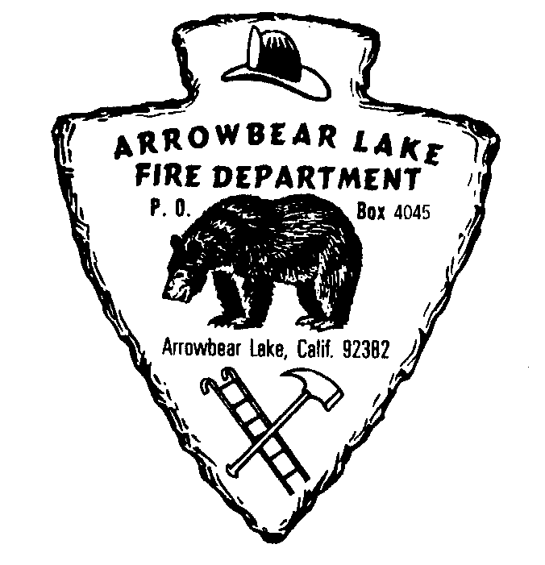

**arrowbear lake fire department**

**Winter Storms Bring Torrential Rains, Snow, and Ice**

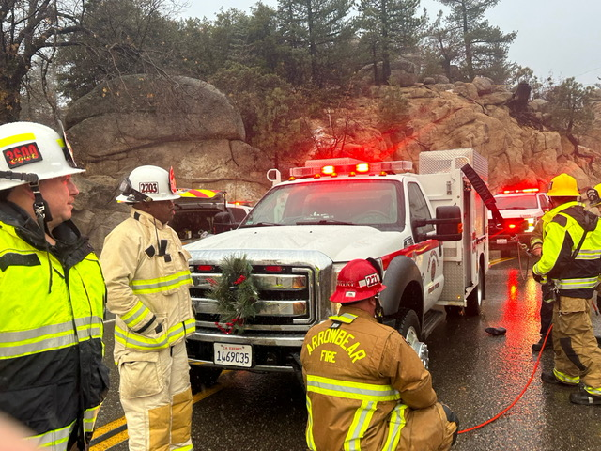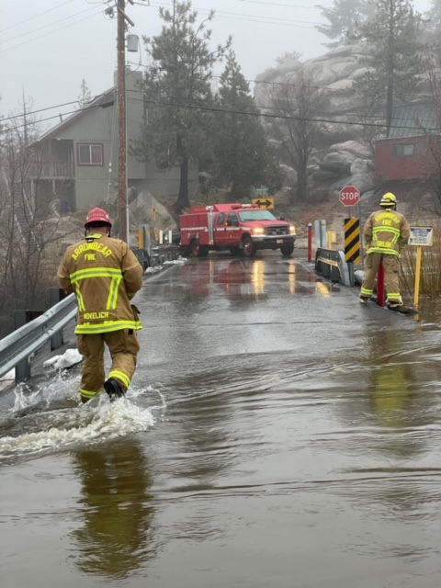The Arrowbear Lake Fire Department would like to wish everyone a happy, safe, and healthy New Year. This past month has brought several winter storms to our area with rain, flooding, snow, and ice. These storms have created driving conditions that are hazardous. There have been accidents, multiple reports of flooding, as well as rocks and debris in roadways. If there is a flooded roadway, ***turn around, don’t drown***. When temperatures are dropping there is always the possibility of ice on the roads. Please use caution while driving. We encourage everyone to please be prepared, expect traffic delays, take it slow, and watch for debris and ice in roadways. When you’re driving our roadways and come across something blocking a lane or lanes; a rock slide or mud slide, a downed tree or powerline, or other debris in the roadway, please call 911 and give the CHP the Hwy, street, or roadway and nearest intersection or a mile post marker. Stay safe out there!

**FIRE SAFETY AT HOME IN THE WINTER -** Your Fire Department would also like to remind you to be fire safe at home this winter. Home fires occur more in winter than in any other season. As you stay cozy and warm this winter, be fire smart! As temperatures continue to drop, we want to give you some tips to be fire safe at home in the winter. Always keep combustible items at least 3 feet away from any heating device(s), plug only one heating device into an electrical outlet at a time, keep portable generators outside, away from windows, and as far away from your home as possible, have a qualified professional clean and inspect your chimney and vents every year, store cooled ashes from your fireplace or stove in a tightly covered metal container and keep it outside at least 10 feet from your home and any nearby buildings, and finally, test your smoke and carbon monoxide detectors monthly. For more information on how to prevent winter fires at home, visit www.nfpa.org/winter.

**NEW NEWS INCLUDING OUR FIRE EXPLORER PROGRAM FOR HIGH SCHOOL STUDENTS** - As we start the year, we would like to invite teens to apply for our fire explorer program. This is for high school students 14 – 18 years old. Please contact Captain Ryan Brewart for additional information at [r.brewart@ablfd.org](mailto:r.brewart@ablfd.org). Be on the lookout for the latest addition to our fleet, a 1997 brush engine which was purchased to replace our 1984 fire engine. Refurbished equipment like our new brush engine is a great way to improve service to Arrowbear- Lake, while saving the district money. Please be sure to visit our website [www.ablfd.org](http://www.ablfd.org) for the latest and greatest information on the department and community events we are hosting.

Sincerely,

Paul Lindley, Fire Chief ARROWBEAR LAKE FIRE DEPARTMENT 909-867-3479

**Like ARROWBEAR LAKE FIREFIGHTERS Association on facebook!**