THIS IS A TRADITIONAL & OPTIONAL ASSIGNMENT… IT MUST BE PRINTED AND COMPLETED IN INK!

Name:_______________________________________ Class Period:____ Due Date:___/____/____

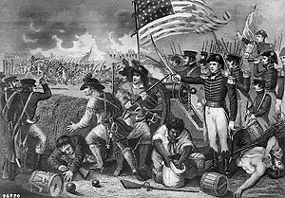
Guided Reading & Analysis: Jefferson Era, 1800-1816
Chapter 7- The Age of Jefferson, pp 130-143

Reading Assignment:
Ch. 7 AMSCO or other resource for content acquisition

Purpose:
This guide is not only a place to record notes as you read, but also to provide a place and structure
for reflections and analysis using higher level thinking skills with new knowledge gained from the
reading.

Basic Directions:
- Pre-Read: Read the prompts/questions within this guide before you read the chapter.
- Skim: Flip through the chapter and note the titles and subtitles. Look at images and
their read captions. Get a feel for the content you are about to read. (Image captured from wikipedia.org)
- Read/Analyze: Read the chapter. Remember, the goal is not to “fish” for a specific answer(s) to
reading guide questions, but to consider questions in order to critically understand what you read!
- Write Write your notes and analysis in the spaces provided.

Key Concepts FOR PERIOD 4:
Key Concept 4.1: The United States began to develop a modern democracy and celebrated a new national culture, while Americans sought to define the nation’s democratic ideals and change their society and institutions to match them.
Key Concept 4.2: Innovations in technology, agriculture, and commerce powerfully accelerated the American economy, precipitating profound changes to U.S. society and to national and regional identities.
Key Concept 4.3: The U.S. interest in increasing foreign trade and expanding its national borders shaped the nation’s foreign policy and spurred government and private initiatives.

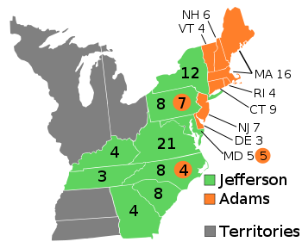
Section 1: The era begins with the Revolution of 1800!
The Election of 1800…aka The Revolution of 1800
Thomas Jefferson – 3rd President of the United States

Election of 1800
Political Party | Federalists | Democratic-Republican
Candidate | John Adams | Thomas Jefferson
From | Massachusetts | Virginia
Electoral Votes | 65 | 73
Outcome | Lost  & bitter | President with Aaron Burr as Vice President
Aaron Burr and Thomas Jefferson received identical electoral votes, so the election was sent to the House of Representatives, which selected T.J. To solve the problem revealed by this, the 12th Amendment was passed in 1804.

Read the quote from Jefferson’s inaugural Address and the first two paragraphs on page 131.
Explain the historical significance of the election and of his call to lead the nation into the next century?
Political/Defensive Mudslinging | Significance in the development of American politics
Jefferson is sleeping with his slave!  Sally Hemmings  Jefferson was under fire by the federalists. He was accused of having illegitimate mulatto children with his one of his slaves, Sally Hemings; His wife had died and he had promised her he would never remarry. (Sally was the half-sister of his wife) He did have a long relationship with Sally (proven with DNA and oral histories), but at the time it was more of a salacious story/rumor. The historical analysis of their relationship varies from true love to abusive master.  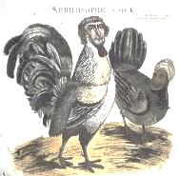  Caption: A Philosophic Cock  Most of the political attacks concerning Hemmings came after the election, but Adams did try to capitalize on the rumors by supporting “whispering campaigns” to further spread them. | How damaging do you think this sort of negative campaign was at the time?  Ross Perot once said,  "War has rules, mud wrestling has rules—politics has no rules."  What does this reality reveal about American liberty?  In the image at left, Jefferson is portrayed as a rooster (cock) and Hemmings as a hen. The rooster was a symbol of revolutionary France. What is the significance of France in the election campaign?
Jefferson is an ATHIEST!  Virginia Statute of Religious Freedom  Jefferson attempted to separate church and state in Virginia in 1777 and then later the Constitution established that separation for the entire nation. Many devout Christians (mainly in New England where most Federalists were from… mostly Congregationalists / Puritans) saw Jefferson as dangerous.  Jefferson was a deist, but that wasn’t publicly known at the time; otherwise he likely would not have been elected. | Why was Jefferson accused of being an atheist, and what does that reveal about politics and culture of the time?  When Jefferson won the election, many fearful Congregationalists hid their Bibles. Why would they do that? How did the political mudslinging create such a fear?

NOTE: The new framework does not emphasize the election of 1800 or Jefferson and Madison’s presidencies as other items later in this era… when reviewing his two terms as president, consider what it illustrates about politics and political parties (First Two Party System), geographic expansion (Louisiana Purchase), tensions with European powers (on the seas and in Ohio Valley as well as the War of 1812), the extent to which he continued Washington’s neutrality policy (trying to avoid war), and the power of the federal government (Marshall Court). Connect the main events to the ongoing themes from the Early Republic to the Era of Good Feelings.

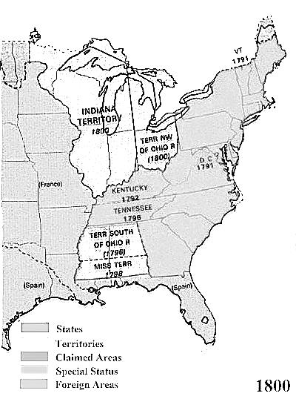
What did America look like in 1800?
Highlight British territory yellow,
Highlight Spanish Territory green,
Highlight French Territory blue,
Label the remaining states,
Label Atlantic Ocean & Gulf of Mexico,
Label Ohio River and Mississippi River.

France lost all of its Louisiana Territory in 1763.
Why did they lose it?

Why did Spain gain it?

Why did possession of Louisiana
transfer back to France? (Hint: Google Treaty of Ildefonso)

What did America Look Like in 1803?
Label the Pacific and Atlantic Oceans. Label the Gulf of Mexico.
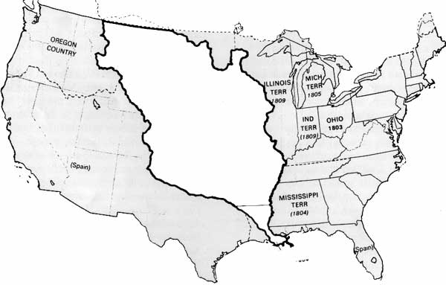
Label the Louisiana Territory and the remaining states, then highlight the United States[ in 1803] yellow.
How did the Haitian Revolution impact this purchase?
3 Cents an Acre!
Thanks, Napoleon!
“This accession of territory affirms forever the power of the United States,
and I have given England a maritime rival who sooner or later will humble her pride.” Napoleon Bonaparte, 1804
Section 2 Guided Reading, pp 130-143
As you read the chapter, jot down your notes in the middle column. Consider your notes to be elaborations on the Objectives and Main Ideas presented in the left column. When you finish the section, analyze what you read by answering the question in the right hand column.

- Overview and Alternate View p. 130

The New Republic Overview | The Alternate View
In what ways did the new republic grow and change?  1.  2.  3.  4.  5.  6.  7.  8. | In what ways did the new republic experience increased conflict?  1.  2.  3.  4.  To what extent were the changes in this era positive?

- The Age of Jefferson, 1800-1816, Jefferson’s Presidency, pp131-136

Key Concepts &  Main Ideas | Notes | Analysis
U.S. interest in increasing foreign trade, expanding its national borders, and isolating itself from European conflicts shaped the nation’s foreign policy and spurred government and private initiatives.  Struggling to create an independent global presence, U.S. policymakers sought to dominate the North American continent and to promote its foreign trade | Jefferson’s Presidency…  The Louisiana Purchase…  U.S. interest in the Mississippi River…  Negotiations…  Constitutional Predicament… | Explain the significance of Jefferson’s repeal of the whiskey tax.  Was the Louisiana Purchase Jeffersonian or Hamiltonian?  Strict or Loose?  Federalist or Democratic-Republican?  How did this purchase impact migration?

Are you using ink? Remember… no pencil!
…Jefferson’s Presidency Continued

Key Concepts & Main Ideas | Notes | Analysis
Following the Louisiana Purchase, the drive to acquire, survey, and open up new lands and markets led Americans into numerous economic, diplomatic, and military initiatives in the Western Hemisphere and Asia  Supreme Court decisions sought to assert federal power over state laws and the primacy of the judiciary in determining the meaning of the Constitution. | Consequences…  Lewis and Clark Expedition…  John Marshall and the Supreme Court…  John Marshall…  Case of Marbury v. Madison, 1803  Judicial Impeachments…  Jefferson’s Reelection… | How did this purchase impact the multi-ethnic and multi-racial make-up of the United States?  After being elected, what did Thomas Jefferson do to reduce the influence of “big government” Federalists?  1.  2.  3.  Who won the battle of political ideology, Jefferson and Madison (Democratic-Republicans) or John Marshall (Federalist)? Explain your reasoning.  Read “Historical Perspectives: What Caused Political Parties?” on pages 142-143. What are the two prevailing views on why parties formed in the early republic?  What evidence from Jefferson’s first term supports the Quids’ assertion that he had abandoned the Democratic-Republican Party?  1.  2.  3.

Jefferson’s Presidency Continued…

Key Concepts & Main Ideas | Notes | Analysis
Supreme Court decisions sought to assert federal power over state laws and the primacy of the judiciary in determining the meaning of the Constitution.  U.S. interest in increasing foreign trade, expanding its national borders, and isolating itself from European conflicts shaped the nation’s foreign policy and spurred government and private initiatives. | Aaron Burr…  Federalist Conspiracy…  Duel with Alexander Hamilton…  Trial for Treason…  Difficulties Abroad…  Barbary Pirates…  Challenges to U.S. Neutrality…  Chesapeake-Leopard Affair…  Embargo Act of 1807… | To what extent does the Burr controversy illustrate the impact of territorial expansion?  To what extent does it illustrate conflict over politics?  To what extent does it illustrate insanity?  From the Constitution:  Article III, section 3, of the Constitution provides that “Treason against the United States, shall consist only in levying War against them, or in adhering to their Enemies, giving them Aid and Comfort. No Person shall be convicted of Treason unless on the Testimony of two Witnesses to the same overt Act, or on Confession in open Court.”  Explain why Burr was not guilty of treason in Marshall’s view.  To what extent was Jefferson’s foreign policies similar to those of Washington? Explain.  To what extent was Jefferson’s foreign policy successful in keeping the United States neutral.?  What does the graph show on page 137?  Does the graph support your answer?

- Madison’s Presidency, pp 137-142

Key Concepts & Main Ideas | Notes | Analysis
U.S. interest in increasing foreign trade, expanding its national borders, and isolating itself from European conflicts shaped the nation’s foreign policy and spurred government and private initiatives  Whites living on the frontier tended to champion expansion efforts, while resistance by American Indians led to a sequence of wars and federal efforts to control American Indian populations. | Madison’s Presidency…  The Election of 1808…  Commercial Warfare…  Nonintercourse Act of 1809…  Macon’s Bill No. 2…  Napoleon’s Deception…  The War of 1812…  Causes of War…  Free Seas and Trade…  Frontier Pressures…  War Hawks…  Declaration of War… | Was Madison’s foreign policy more successful than Jefferson’s? Why or why not?  Explain the British and French viewpoint that neutrality does not guarantee freedom of the seas.  Of the 3 main causes of the War of 1812, which was the most significant? Explain your answer.  Was the United States justified in declaring war against Great Britain? Why or why not?

Madison’s Presidency Continued…

Key Concepts & Main Ideas | Notes | Analysis
Struggling to create an independent global presence, U.S. policymakers sought to dominate the North American continent and to promote its foreign trade.  Following the Louisiana Purchase, the drive to acquire, survey, and open up new lands and markets led Americans into numerous economic, diplomatic, and military initiatives in the Western Hemisphere and Asia. | A Divided Nation…  Election of 1812…  Opposition to the War…  Military Defeats and Naval Victories…  1.  2.  Invasion of Canada…  Naval Battles…  Chesapeake Campaign…  Southern Campaign… | What does the map on page 139 reveal about who supported the war?  Which point of opposition to “Mr. Madison’s War” was the most significant to growing sectionalism?  Why did so many Americans, going back to the Declaration of Independence and Revolution, believe annexing Canada was a natural expectation?  What impact did battles and heroes and song lyrics have on national identity?  Explain.

Madison’s Presidency Continued…

Key Concepts & Main Ideas | Notes | Analysis
U.S. interest in increasing foreign trade, expanding its national borders, and isolating itself from European conflicts shaped the nation’s foreign policy and spurred government and private initiatives. | The Treaty of Ghent…  The Hartford Convention…  The War’s Legacy…  1.  2.  3.  4.  5.  6.  7.  8. | Who won the war?  Give three specific pieced of evidence that support your view:  1.  2.  3.  Give one specific piece of evidence to support the opposing view:  Why is the War of 1812 sometimes called “The Second War for Independence?”

Reading Guide written by Rebecca Richardson, Allen High School
Sources include but are not limited to: 2015 edition of AMSCO’s United States History Preparing for the Advanced Placement Examination, College Board Advanced Placement United States History Framework,
UShistory.org, Wkipedia.org, 12th edition of American Pageant, and other sources as cited in document and collected/adapted over 20 years of teaching and collaborating..

