Guide By Your Side TM Stakeholder Agenda
Thank you so much for joining us to learn about our new Guide By Your Side™ Program.

8:30 – 9:00 Registration and Pre-Test for Parent Guides
9:00 - 9:15 Welcome and Introductions /Communication Ground Rules
9:15 –10:45 We Are Hands & Voices Guide By Your Side, Sara Kennedy
10:45 - 11:45 Supporting Families Without Bias, Candace Lindow-Davies
11:45 –12:00 Local Program Level Implementation, Kellie Thorman

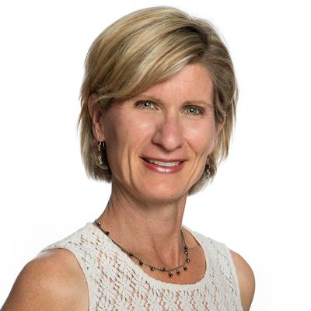
Candace Lindow-Davies
Candace is the proud mother of an adult son who is profoundly deaf plus other health concerns and an adult daughter who is typically hearing. Candace has been married to her husband for over 27 years.
For 16+ years, she developed and coordinated parent-to-parent support services for MN Hands & Voices at Lifetrack. For 15 years, she served as a parent consultant for the MN Dept. of Health’s Newborn Hearing Screening Program, and is a past Chair of the MN Newborn Hearing Screening Advisory Committee. She also served on the statewide Education Collaborative and its Steering Committee.

Candace is a past Board member and past President of Hands & Voices HQ Board. As of May 2017, she became the Director of Outreach for Hands & Voices HQ and is on the core management team of the “Family Leadership in Language and Learning” (FL3) Cooperative Agreement. She has developed materials for and provided technical assistance and training to family-based organizations in the United States, US territories and China.

Candace is passionate about supporting the needs of children who are deaf/hh plus other health issues as well as ensuring families have access to adults who are deaf and hard of hearing.

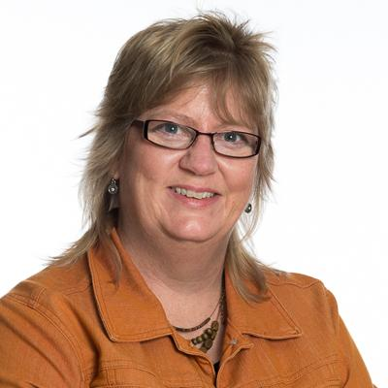
Sara Kennedy
Sara is a mom of four children, including a nearly-launched daughter who was late identified after a homebirth. Maddie, Sara’s daughter, has had a progressive loss and is now profoundly deaf, using bilateral cochlear implants, and working as a CNA in a hospital ICU setting. An occupational therapist by training, Sara has worked with Hands & Voices since 2001. She is the editor of The Hands & Voices Communicator and Director for the Colorado Chapter.

Sara has a special interest in practical ideas that work for families. She was a coauthor for the manual Bridge to Preschool: Navigating a Successful Transition, she coordinates the Colorado Resource Guide, and has written or presented on various topics including navigating the IEP/IFSP system, safety from abuse and neglect, giftedness, itinerant and interpreting services, why families move, the decision process regarding cochlear implants and transition from high school.

For Hands & Voices HQ, Sara has trained chapters in Advocacy Support and Training (ASTra) and GBYS (Guide By Your Side) programs since both programs began. Sara has mentored new parent leaders and board members in Colorado toward legislative and policy change.

Sarah enjoys reading, hiking, refinishing furniture, and skiing when she can with her family. Contact her at Sara@handsandvoices.org or Sara@cohandsandvoices.org.

