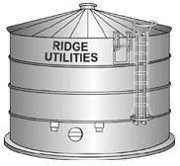
2020 Annual Water Quality Report
R I D G E U T I L I T I E S ,
I N C O R P O R A T E D
S P E C I A L P O I N T S O F I N T E R E S T :

Introduction

General Infor- mation
Sources & Treat- ment of Your Drinking Water

Source Water As- sessments
Quality of Your Drinking Water
How Can I Get Involved
Description of Wa- ter Treatment Pro- cess

Information on Lead
Water Conserva- tion Tips
Water Quality Re- sults

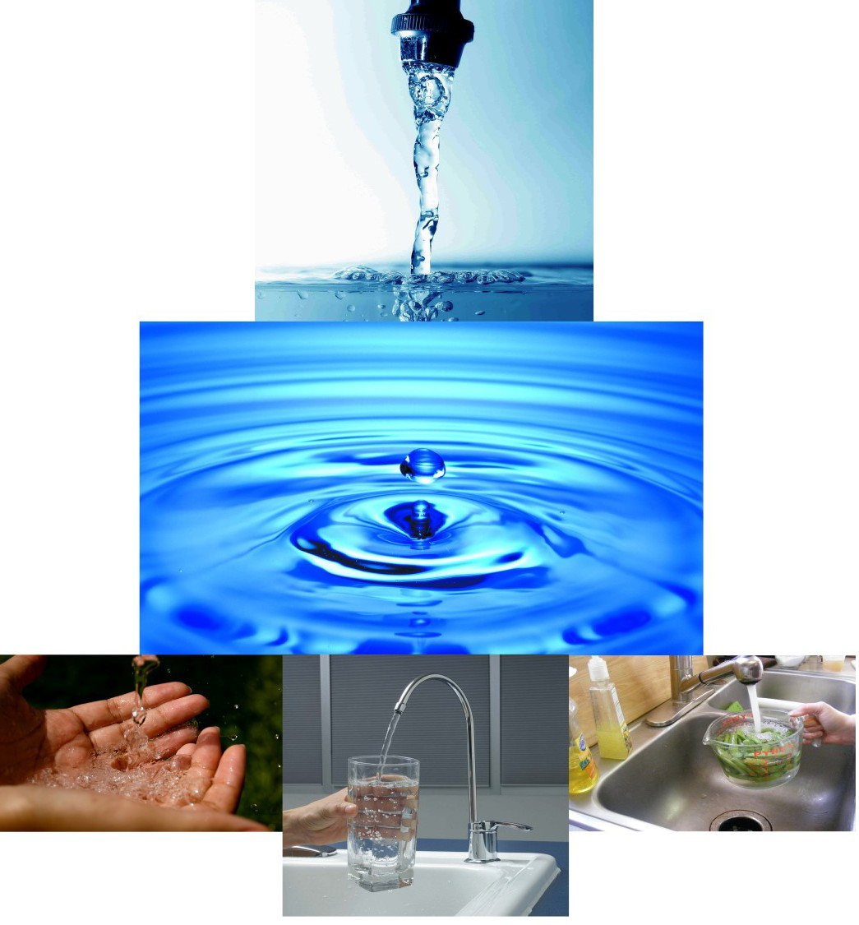

Providing drinking water services to the residents of Blue Ridge Shores.

Ridge Utilities, Inc.

924 South Lakeshore Drive Louisa, VA 23093
(540) 967-1408 (Telephone Number)

(540) 967-4899 (Fax Number)

www.ridgeutilities.com

P A G E 2 2 0 2 0 A N N U A L W A T E R Q U A L I T Y R E P O R T

INTRODUCTION

This Annual Drinking Water Quality Report for calendar year 2020 is designed to provide you with valuable infor- mation about your drinking water quality. Our goal is to provide you with a safe and dependable supply of drinking wa- ter, and we want you to understand the efforts we make to protect your water supply. The quality of your drinking water must meet state and federal requirements administered by the Virginia Department of Health (VDH).

If you have questions about this report or want additional information about any aspect of your drinking water or want to know how to participate in decisions that may affect the quality of your drinking water, please contact:

Mr. Curt Heidel General Manager, at (540) 967-1408

GENERAL INFORMATION

The sources of drinking water (both tap and bottled water) include rivers, lakes, streams, ponds, reservoirs, springs, and wells. As water travels over the surface of the land or through the ground, it dissolves naturally occurring minerals and, in some cases, radioactive materials, and can pick up substances resulting from the presence of animals or from human activity. Contaminants that may be present in source water include: (i) microbial contaminants, such as viruses and bacteria, which may come from sewage treatment plants, septic systems, agricultural livestock operations, and wildlife;
(ii) inorganic contaminants, such as salts and metals, which can be naturally occurring or result from urban stormwater runoff, industrial or domestic wastewater discharges, oil and gas production, mining, or farming; (iii) pesticides and herbicides, which may come from a variety of sources such as agriculture, urban stormwater runoff, and residential uses;
- organic contaminants, including synthetic and volatile organic chemicals, which are byproducts of industrial pro- cesses and petroleum production, and can also come from gas stations, urban stormwater runoff, and septic systems; (v) radioactive contaminants, which can be naturally occurring or be the result of oil and gas production and mining activi- ties. In order to ensure that tap water is safe to drink, EPA prescribes regulations that limit the amount of certain con- taminants in water provided by public water systems. FDA regulations establish limits for contaminants in bottle water which must provide the same protection for public health.

Drinking water, including bottled drinking water, may reasonably be expected to contain at least small amounts of some contaminants. The presence of contaminants does not necessarily indicate that water poses a health risk. More infor- mation can be obtained by calling the Environmental Protection Agency's Safe Drinking Water Hotline (800-426-4791).

Some people may be more vulnerable to contaminants in drinking water than the general population. Immune- compromised persons such as persons with cancer undergoing chemotherapy, persons who have undergone organ trans- plants, people with HIV/AIDS or other immune system disorders, some elderly, and infants can be particularly at risk from infections. These people should seek advice about drinking water from their health care providers. EPA/CDC guidelines on appropriate means to lessen the risk of infection by cryptosporidium and other microbial contaminants are available from the Safe Drinking Water Hotline (800-426-4791).

SOURCES AND TREATMENT OF YOUR DRINKING WATER

The source of your drinking water at Blue Ridge Shores is groundwater obtained from nine (9) drilled wells. They are treated with chlorine for disinfection. Treatment is provided to reduce the natural acidity of the groundwater and make it non-corrosive to our plumbing system.

SOURCE WATER ASSESSMENTS

The Virginia Department of Health conducted a source water assessment of our system in 2019. The assessment report consists of maps showing the source water assessment area, an inventory of known land use activities of concern, and documentation of any known contamination within the last five years. The report is available by contacting Mr. Curt Heidel, at the phone number or address given elsewhere in this drinking water quality report.

DESCRIPTON OF THE WATER TREATMENT PROCESS

Your water is treated by disinfection. Disinfection involves the addition of chlorine and other disinfectant to kill danger- ous bacteria and microorganisms that may be found in the water. Disinfection is considered to be one of the major pub- lic health advances of the 21st century.

P A G E 3 2 0 2 0 A N N U A L W A T E R Q U A L I T Y R E P O R T

HOW CAN I GET INVOLVED

Ridge Utilities, Inc. encourages members to attend the regularly scheduled board meetings of Ridge Utilities, Inc. in February, May, July, and November. Additionally, the Joint Annual Meeting of the Ridge Utilities, Inc. Board of Direc- tors is held the third week of May annually. Members are also encouraged to run for the Board of Directors. Our bi- monthly newsletter, The Shore Line will provided additional information concerning Ridge Utilities, Inc. and drinking water-related issues. For additional information please contact our office at (540) 967-1408.

ADDITIONAL HEALTH INFORMATION

If present, elevated levels of lead can cause serious health problems, especially for pregnant women and young children. Lead in drinking water is primarily from materials and components associated with service lines and home plumbing. Ridge Utilities, Inc. is responsible for providing high quality drinking water to Blue Ridge Shores, but cannot control the variety of materials used in plumbing components. When your water has been sitting for several hours, you can min- imize the potential for lead exposure by flushing your tap for 30 seconds to 2 minutes before using water for drinking or cooking. If you are concerned about lead in your water, you may wish to have your water tested. Information on lead in drinking water, testing methods, and steps you can take to minimize exposure is available from the Safe Drinking Water Hotline or at http://www.epa.gov/safewater/lead.

WATER CONSERVATION TIPS

Did you know that the average U.S. household uses approximately 400 gallons of water per day or 100 gallons per per- son per day? Luckily, there are many low-cost and no-cost ways to conserve water. Small changes can make a big dif- ference – try one today and soon it will become second nature.

  - Take short showers - a 5 minute shower uses 4 to 5 gallons of water compared to up to 50 gallons for a bath.
  - Shut off water while brushing your teeth, washing your hair and shaving and save up to 500 gallons a month.
  - Use a water-efficient showerhead. They're inexpensive, easy to install, and can save you up to 750 gallons a month.
  - Thaw in the refrigerator overnight rather than using a tap of hot water.
  - Use only full loads of laundry or use the appropriate water level or load size selection on the washing ma- chine.
  - Sweep driveways, sidewalks, and steps rather than hosing off.
  - Wash the car with water from a bucket, or consider using a commercial car wash that recycles water.
  - Visit www.epa.gov/watersense for more information and helpful tips on water conservation.

QUALITY OF YOUR DRINKING WATER

Your drinking water is routinely monitored according to Federal and State regulations for a variety of contaminants. The table on Page 5 shows the results of our monitoring for the period of January 31st through December 31st, 2020.

The state allows us to monitor for some contaminants less than once a year because the concentrations of these contami- nants do not change frequently. Some of our data presented in the tables, though accurate, is more than one year old.

The U.S. Environmental Protection Agency sets MCL’s at very stringent levels. In developing the standards, EPA as- sumes that the average adult drinks 2 liters of water each day throughout a 70-year life span. EPA generally sets MCLs at levels that will result in no adverse health effects for some contaminants or a one-in-ten thousand to one-in-a-million chance of having the described health effect for other contaminants.
P A G E 4 2 0 2 0 A N N U A L W A T E R Q U A L I T Y R E P O R T

DEFINITIONS
Contaminants in your drinking water are routinely monitored according to Federal and State regulations. The table on the next page shows the results of our monitoring for the period of January 1, 2020 to December 31, 2020. In the table and elsewhere in this report you will find many terms and abbreviations you might not be familiar with. The following definitions are provided to help you better understand these terms:

Maximum Contaminant Level, or MCL - the highest level of a contaminant that is allowed in drinking water. MCLs are set as close to the MCLGs as feasible using the best available treatment technology.

Maximum Contaminant Level Goal, or MCLG– the level of a contaminant in drinking water below which there is non known or expected risk to health. MCLGs allow for a margin of safety.

Maximum Residual Disinfection Level Goal, or MRDLG - the level of a drinking water disinfectant below which there is no known or expected risk to health. MRDLGs do not reflect the benefits of the use of disinfectants to control microbial contaminants.

Maximum Residual Disinfectant Level, or MRDL - the highest level of a disinfectant allowed in drinking water. There is convincing evidence that addition of a disinfectant is necessary for control of microbial contaminants.

Non-detects (ND) – lab analysis indicates that the contaminant is not present.

Parts per million (ppm) or Milligrams per liter (mg/l) – one part per million corresponds to one minute in two years or a single penny in $10,000.

Parts per billion (ppb) or Micrograms per liter – one part per billion corresponds to one minute in 2,000 years, or a sin- gle penny in $10,000,000.

Parts per trillion (ppt) or Nanograms per liter (nanograms/1) - one part per trillion corresponds to one minute in 2,000,000 years, or a single penny in $10,000,000,000.

Picocuries per liter (pCi/L) - picocuries per liter is a measure of the radioactivity in water.

Nephelometric Turbidity Unit (NTU) - nephelometric turbidity unit is a measure of the clarity of water. Turbidity in ex- cess of 5 NTU is just noticeable to the average person.

Action Level - the concentration of a contaminant, which if exceeded, triggers treatment or other requirements which a water system must follow.

Treatment Technique (TT) - a required process intended to reduce the level of a contaminate in drinking water.

Variances and exemptions– state or EPA permission not to meet an MCL or a treatment technique under certain condi- tions.

Level 1 Assessment—A Level 1 assessment is a study of the water system to identify potential problems and determine (if possible) why total coliform bacteria have been found in our water system.

Level 2 Assessment—A Level 2 assessment is a very detailed study of the water system to identify potential problems and determine (if possible) why an E.coli PMCL violation has occurred and/or why total coliform bacteria have been found in our water system on multiple occasions.
P A G E 5 2 0 2 0 A N N U A L W A T E R Q U A L I T Y R E P O R T

WATER QUALITY RESULTS

Microbiological Contaminants

Contaminant | MCLG | MCL | No. of Samples Indicating Presence of Bacteria | Violation (Y/N) | Month of Sampling | Typical Source of Contamination
E. coli | 0 | I routine sample and a re- peat sample are total coli- form positive and 1 is also  E. coli positive | 0 | N | NA | Human and animal fecal waste

Regulated Contaminants

Contaminant (units) | MCLG | MCL | Level Detected | Violation (Y/N) | Sampling Year | Typical Source of Contamination
Nitrate (mg/1) | 10 | 10 | 2.14  Range: 1.14-2.14 | N | 2020 | Runoff from fertilizer use; leaching from septic tanks, sewage, erosion of natural deposits.
Fluroide (mg/1) | 4 | 4 | 0.24  Range: ND-0.24 | N | 2019 | Erosion of natural deposits; water additive which pro- motes strong teeth; discharge from fertilizer and alumi- num factories.
Sodium (mg/1) | - | - | 16.7  Range: 14.1-16.7 | N | 2019 | Erosion of natural deposits; de-icing salt runoff; water softeners
Alpha Emitters (pCi/l) | 0 | 15 | 19.1  Range: 10.0-19.1 | N | 2018 | Erosion of Natural Deposits
Beta Particle and Photon Radioactivi- ty (pCi/l) | 0 | 50 | 7.4  Range: 5.9-7.4 | N | 2018 | Decay of natural and man-made deposits
Combined Radium (pCi/l) | 0 | 5 | 0.7  Range: 0.1-0.7 | N | 2018 | Erosion of Natural Deposits

*Analysis frequency for radiologicals is every 3 to 6 years. ***The PMCL for beta particles is 4 mrem/year. EPA considers 50 pCi/l to be the level of concern for beta particles.

Lead and Copper Contaminants

Contaminant (Units) | MCLG | MCL or TT | 90th Percentile | AL Exceeded | Samples  >AL | Sampling Year | Typical Source of Contamination
Lead (ppb) | 0 | AL = 15 | ND | No | 0 of 10 | 2019 | Corrosion of household plumbing system; Erosion of natural deposits
Copper (ppm) | 1.3 | AL = 1.3 | 0.513 | No | 0 of 10 | 2019 | Corrosion of household plumbing; Erosion of natu- ral deposits

Disinfectant Residual

Contaminant (Units) | MRDLG | MRDL | Level Found Aver- age & Range | Violation (Y/N) | Sampling Year | Typical Source of Contamination
Chlorine (mg/l) | 4 | 4 | 0.74  Range: 0.60—0.80 | N | 2020 | Water additive used to control microbes

Organic Contaminants

Contaminant (Units) | MCLG | MCL | Level Found | Violation | Sampling Year | Typical Source of Contamination
TTHMs-Total Trihalome- thanes | NA | 80 | 0.6 | No | 2020 | By-product of drinking water chlorination
P A G E | 6 | 2 0 2 0 A N N U A L W A T E R |  | Q U A L I T Y | R E | P O R T
2020 VIOLATION INFORMATION
Did any PMCL or TT violation occur during the year? |  |  | ( ) Yes | (X) No
Did any monitoring, reporting, or other violations occur during the year? |  |  | ( ) Yes | (X) No
No drinking water violations in 2020.

This Drinking Water Quality Report was prepared by Ridge Utilities, Inc. with the assistance and approval of the Virginia Department of Health. Please call or email any questions you may have. Contact information for Ridge Utilities, Inc. is listed below.
Contact Name :Curt Heidel, General Manager
924 South Lakeshore Drive Louisa, VA 23093
Phone: 540-967-1408
Fax: 540-967-4899
E-Mail:cheidel.brs@comcast.net
Website: www.ridgeutilities.com

