REGULAR MEETING
JUNE 17, 2015

A Regular Meeting of the Town Board of the Town of Hampton, County of Washington and the State of New York was held at the Town Hall, 2629 State Route 22A, Hampton, New York on the 17th day of June, 2015.

PRESENT: David K. O’Brien------------Supervisor
Tamme Taran---------------Councilwoman
David Jensen-----------------Councilman
Donald Sady-----------------Councilman
Andrea Sweeney------------Councilwoman
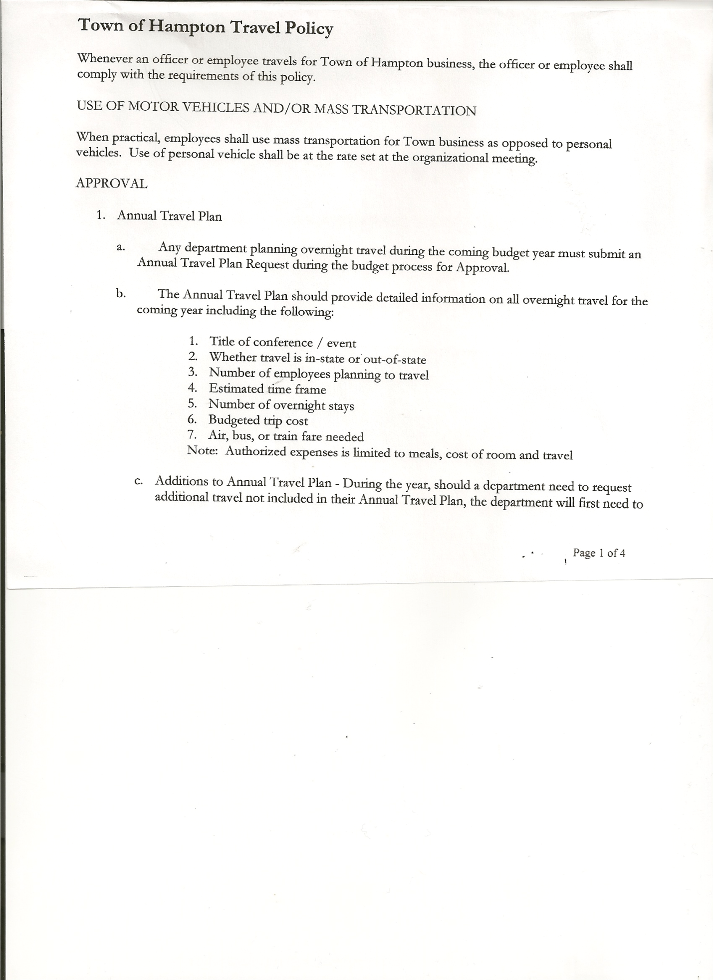
Rebecca Jones---------------Town Clerk
Camilla Shaw----------------Tax Collector/Deputy Town Clerk
Herbert Sady, Jr.-------------Highway Superintendent

Planning Board Member(s): Bonnie Hawley, Chair and Francis Baker

Also present: See attached sheet

The meeting was called to order by Supervisor O’Brien at 7:30pm followed by the Pledge of Allegiance. Locations of Fire Exits were given.

Supervisor O’Brien asked for a moment of silence in memory of Walter Perry, III, (former Councilman and longtime resident of Hampton).

RESOLUTION NO. 43-2015
APPROVAL OF THE MINUTES
On a motion of Councilwoman Taran, seconded by Councilman Jensen, the following resolution was ADOPTED: Ayes 5 O’Brien, Taran, Jensen, Sady, Sweeney
Nays 0
RESOLVED that the Regular Town Board Minutes for May 20th, 2015 are approved.

Congratulations to Hannah S. Jones, daughter of Town Clerk Rebecca Jones and David Jones, she was awarded the Rotarian Student of the Year and she will be the Valedictorian for the Granville Jr Sr High School for 2015.

Welcome new residents Jerry & Lisa Loeber, County Route 21.

Supervisor O’Brien received information that the house on Greenfield Lane, owned by Myers’ that had previously burnt down, that the remainder of the buildings would be removed by Joe Williams.

Permits/Subdivisions
RESOLUTION NO. 44-2015
SHORT ENVIRONMENTAL ASSESSMENT FORM
On a motion of Councilman Sady, seconded by Councilwoman Taran, the following resolution was ADOPTED: Ayes 5 O’Brien, Taran, Jensen, Sady, Sweeney
Nays 0
RESOLVED, that the Short Environmental Assessment Form, Parts 1 and 2 were completed regarding the Hampton Fire Department Building.

TOWN BOARD MEETING
JUNE 17, 2015 PAGE 2

Camilla Shaw, Tax Collector submitted her report to the Town Board with a check for interest of $3.70 , she also had board members sign and date bank reconciliation statement dated May30th, 2015.

Larry Carman, Dog Control Officer-no report submitted.

Planning Board Report….Bonnie Hawley, Chair gave the report:
- Mobile home park/campground law was sent back to Town Attorney for review
- Next Planning Board meeting will be at 7:00pm at the Town Hall on June 23rd, 2015

Herbert Sady, Jr., Highway Superintendent gave his report: (a copy is attached)
- Cleaning up brush and mowing roadsides
- New skids on the Flail Mower and repaired hydraulic leaks
- ’97 International still at Turunen’s for brake job
- Highway Garage received first coat of paint
- Apologized to Board for not obtaining permission regarding the brake job, asked for three quotes, only received one for work that he wanted done.

RESOLUTION NO. 45-2015
APPROVAL OF SUPERVISOR’S MONTHLY REPORT
On a motion of Councilman Sady, seconded by Councilwoman Sweeney, the following resolution was ADOPTED : Ayes 5 O’Brien, Taran, Jensen, Sady, Sweeney
Nays 0
RESOLVED that the Supervisor’s Monthly report be accepted as submitted for MAY 2015
4/30/15 5/31/15
ACCOUNT BALANCE RECEIPTS DISBURSEMENTS BALANCE
General Fund $ 78813.50 $ 7384.22 $ 7587.88 $ 78609.84
Highway Fund $ 138250.06 $ 5.79 $ 6962.54 $131293.31
Equipment Reserve $ 100175.09 $ 4.25 $ 0.00 $100179.34
Fire #1 $ 34010.90 $ 1.65 $ 0.00 $ 34012.55
Fire #2 $ 4754.00 $ 0.00 $ 0.00 $ 4754.00
Totals $ 356003.55 $ 7395.91 $ 14550.42 $348849.04

All Board Members present signed Supervisor’s Report.

County Updates/Communications
- Efficiency Plan has been sent in by the County
- Sales Tax Distribution….we should receive approximated $7000.00 more this year
- Full Value Tax Rates for Hampton regarding school districts….info handed out
- Notice from New York State Dept. of Taxation and Finance…Equalization rate is 100%
- County Administrative position…. interviewing four (4) candidates
- County looking at intersection of 18 and 21 and what can be done there

TOWN BOARD MEETING
JUNE 17, 2015 PAGE 3

Discussion regarding County Route 18…changing speed limit, will also speak with Whitehall Supervisor to request speed limit change on their end.

RESOLUTION NO. 46-2015
SPEED LIMIT REDUCTION LETTER
On a motion of Councilman Sady, seconded by Councilwoman Sweeney, the following resolution was ADOPTED : Ayes 5 O’Brien, Taran, Jensen, Sady, Sweeney
Nays 0
RESOLVED, to send the following letter requesting speed limit reduction on County Route 18.

TOWN OF HAMPTON
PO Box 125
2629 State Route 22A
Hampton, NY 12837

June 18, 2015

Regional Traffic Engineer
Region One
Department of Transportation
50 Wolf Road, Suite 1s50
Albany, NY 12232

Gentlemen:

The Town Board of the Town of Hampton, by a resolution adopted June 17, 2015, and the County Superintendent of Highways of the County of Washington, hereby request the Department of Transportation, pursuant to Section 1622.1 of the Vehicle and Traffic Law, to establish a lower maximum speed at which vehicles may proceed on County Route 18, a County Road between the Town Line on County Route 18 and the intersection of County Route 18 at State Route 22A in the Town of Hampton. This road is a windy road full of curves and dips and hills.

The Town of Hampton and the County of Washington has seen an influx of Amish people and they travel this road frequently. Due to the contour of the road it is hard to see slow moving horse and carriages when approaching or coming up behind them and there have been several close calls with cars and trucks not being able to see the slow moving horse and carriages. There have been two accidents with Amish vehicles which fortunately were not serious. This is complicated by several intersections on curves which present a danger both to the Amish in their carriages as well as passenger trucks, cars, tractors pulling farm equipment, and larger trucks entering or exiting the roadway. Also in some areas there is little or no shoulder or the road may be bordered by steep drop offs or cliffs which does not allow room to pull off the road thereby increasing the danger to all vehicles.

TOWN BOARD MEETING
JUNE 17, 2015 PAGE 4

Due to the dangerous road conditions, the Town of Hampton has requested this change several times. This has been based on reports of close calls which have increased due to the influx of the Amish and we request the speed limit be reduced to 40 MPH on this roadway.

Upon receipt of the notice that the regulation herein requested has been established, the County of Washington, will provide, install, and maintain signs in accordance with the Vehicle and Traffic Law and conforming to the Manual of Uniform Traffic Control Devices of the Department of Transportation.

Dated: Town Clerk

Dated:
County Superintendent

Comments by County Superintendent:
TE9a Form

OLD BUSINESS
Cemeteries….Per the NYS Historical Society and NYS Museum, GPR not as reliable… their suggestion is to use a pole, if the ground has been disturbed it will go down easily, if it hasn’t been disturbed previously it won’t go down easily.

PUBLIC/COUNCIL COMMENTS
The 1997 International is at Turunen’s for brake job, not the 2000 International as stated in Highway Superintendent’s Report for last month.

Questioned how often cemeteries are being mowed….Superintendent Sady responded that they were being done at least once a month and fellas were bagging the grass.

The Town Clerk’s report for May 2015 was submitted to the Board. The Town Clerk had Board Members review and sign bank reconciliation statements for the Town Clerk Account and Special Town Clerk Account dated May 31st, 2015.

TOWN BOARD MEETING
JUNE 17, 2015 PAGE 5

RESOLUTION NO. 47 -2015

AUDIT OF CLAIMS
On a motion of Councilwoman Taran, seconded by Councilman Jensen the following resolution was ADOPTED Ayes 5 O’Brien, Taran, Jensen, Sady, Sweeney
Nays 0
RESOLVED that the bills have been reviewed by the Town Board and are authorized for payment in the following amounts.
General Fund No. 75 through No. 88 $ 21130.29
Highway Fund No. 54 through No. 63 $ 7973.83
Total both funds $ 29104.12

On a motion of Councilman Sady, seconded by Councilman Jensen , the meeting adjourned at 8:24pm. All in favor Aye.

Respectfully submitted,

Rebecca S. Jones, RMC
Town Clerk

