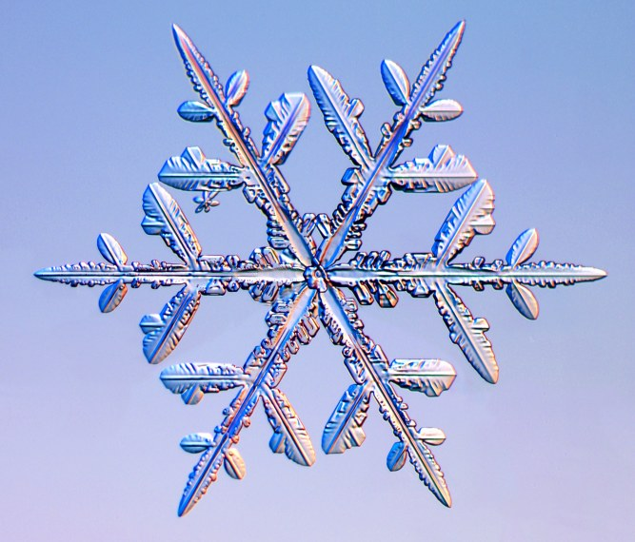

26th Annual don Rowe antique
snowmobile show

January 15, 2022
Starts 8 AM
Awards 1 PM

Sponsored By: Square Valley Trail Blazers
Hosted By: Two Guys from Italy, State Route 49, West Monroe NY

Since the 25th show Don started, we are going back to the first show format that he set up.
FREE Admission
Sled Registration $5.00 per sled and Vendors $10.00
Dash Plaque to the 50 people to register
ALL SLEDS MUST RUN TO COMPETE FOR AWARDS

PRIZES – Wall Plaques
ANTIQUE CONTEST CLASSIC CONTEST
1968 or OLDER 1969 TO 1996
Best Looking Best Looking
Most Unusual Most Unusual
Oldest Sled

There will be an Antique snowmobile ride following the show
(Weather Dependent)

For More Information:
Linda (Rowe) Middleton 315-668-2127
Ken Robarge 315-751-1842
Rich Schaad 315-456-9981

